How to Apply for or Access your VPK Certificate (DEL Family Portal) Account:

1. Access your family portal account by clicking the link below:

<https://familyservices.floridaearlylearning.com/>

It should bring you to this page. 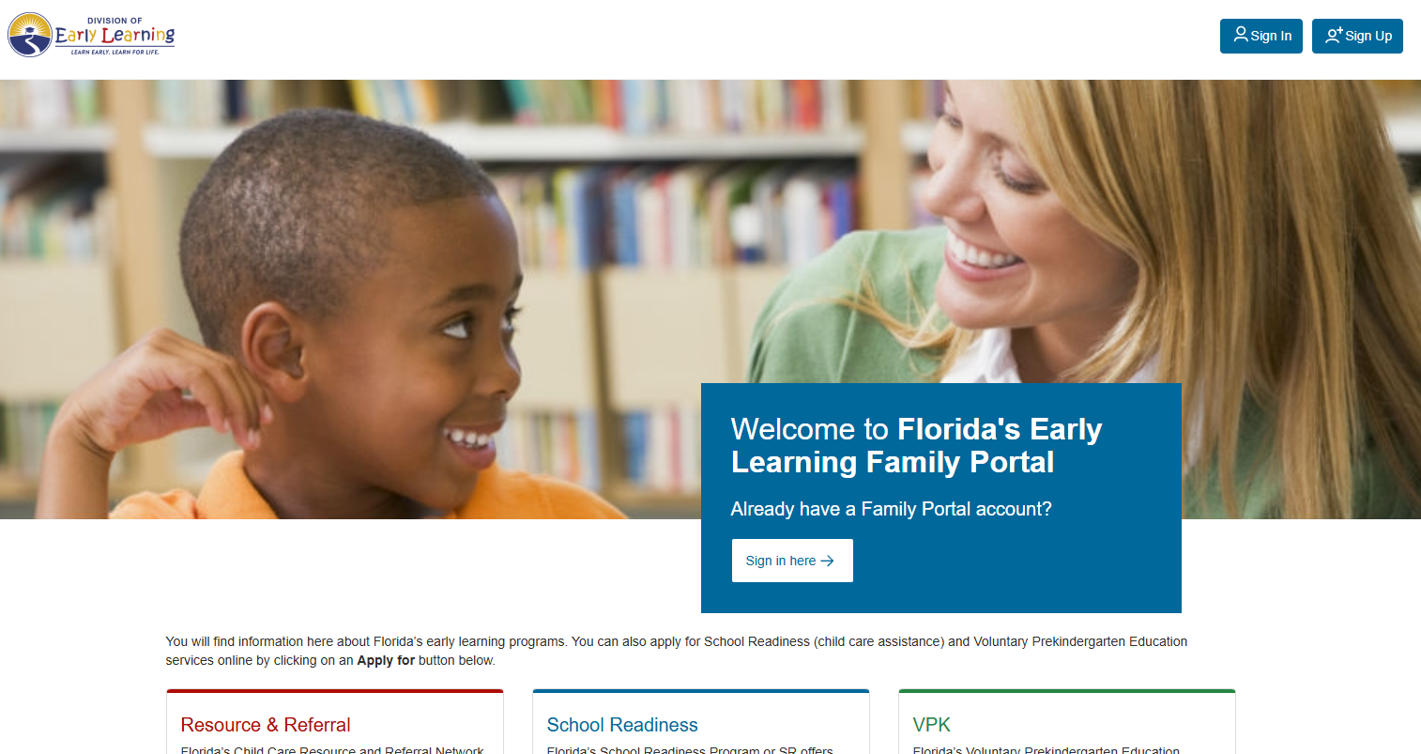

1. If you are applying for a VPK certificate for the first time and have not created an account before, click the “Sign Up” button in the top right corner.
2. If you have already applied for a VPK certificate and are trying to log into your account, since the new update, to access the certificate, click the “Sign Up” button in the top right corner.

1. After clicking “Sign Up” You will receive a pop-up message, select the blue button that says “Proceed to Single Sign-On (SSO).

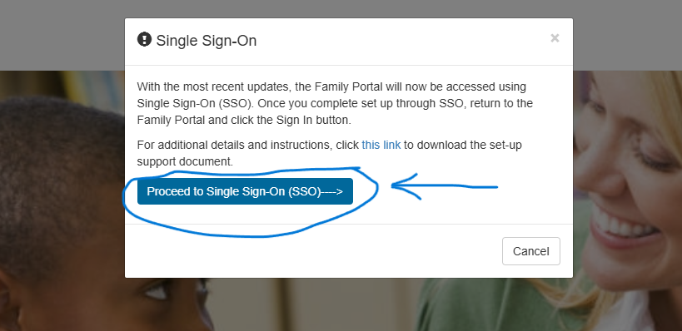

1. Enter the email address you originally used or email you want to use when creating a new account. Then click, SEND VERIFICATION CODE. 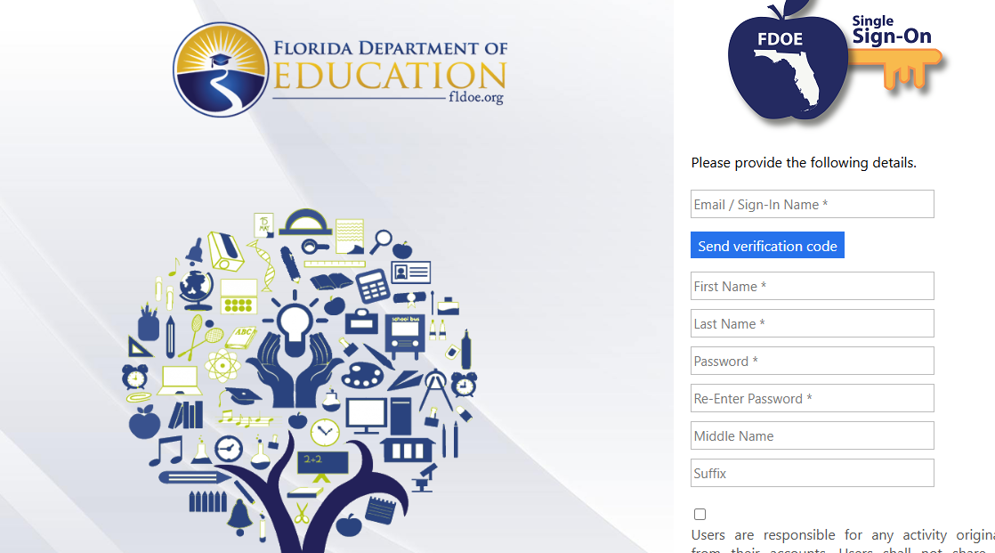
2. Once you have received the verification code, fill in the remaining information and follow all other prompts. DO NOT COPY AND PASTE.

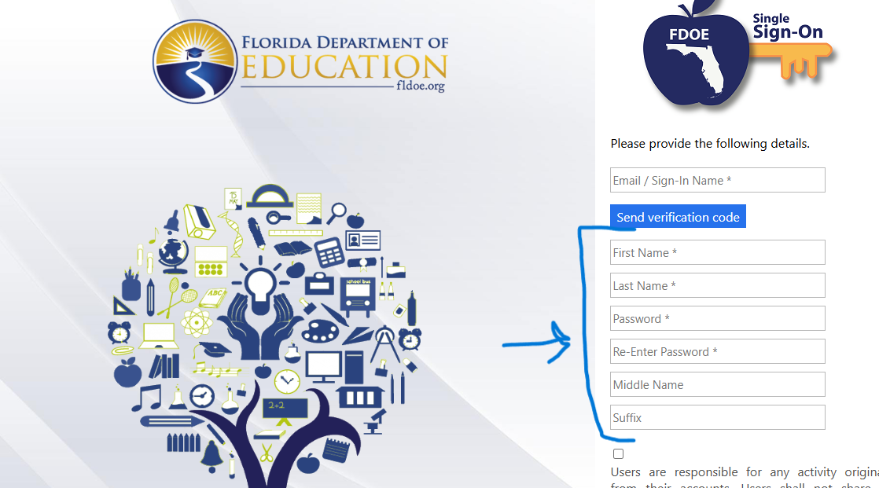

1. You will receive a confirmation email with your username from [DONOTREPLY@fldoe.org](mailto:DONOTREPLY@fldoe.org)

This email may end up in your inbox, spam or junk folder. Your username is 0-“emailaddress”

1. Once you have created a new account and go back to log-in <https://familyservices.floridaearlylearning.com/> click SIGN-IN.

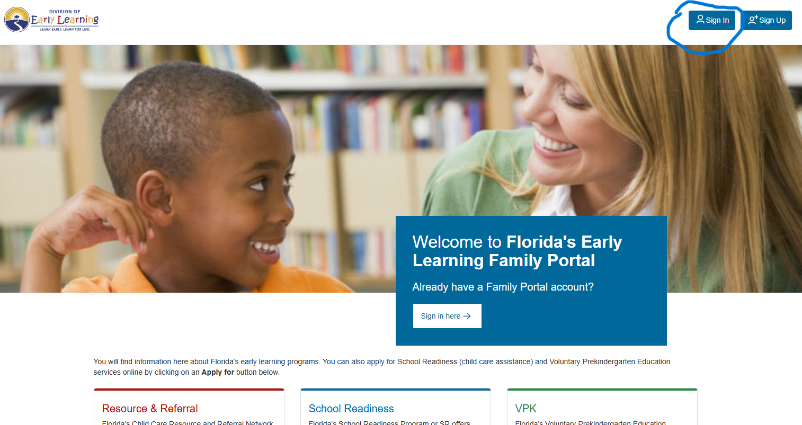

1. Select HOSTED/Self-Registered login. DO NOT SELECT PASCO COUNTY SCHOOLS. Follow the log in prompts based on the email and password you determined when “Signing Up”. Follow prompts for verification code. Once complete, you will be logged into your Family Portal and Profile. A screen shot of a logo

   AI-generated content may be incorrect.

\*\*If you still have difficulty logging in, please contact the Early Learning Coalition of Pasco & Hernando. <https://elcph.org/> 727-233-8291