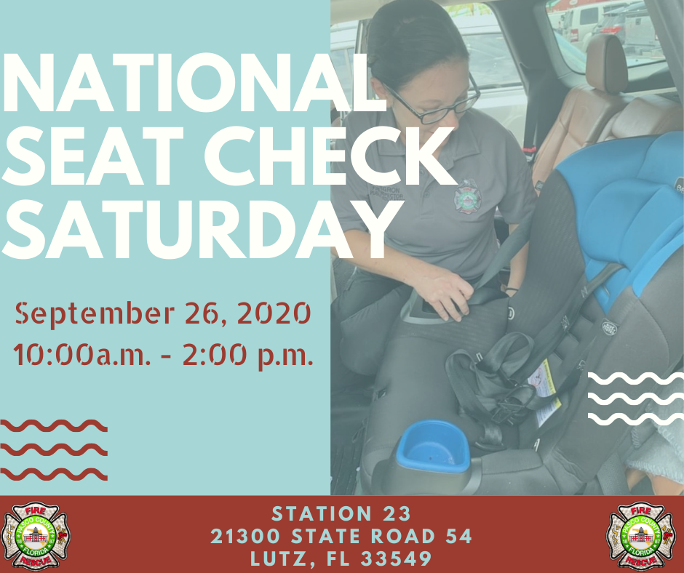
Is your car seat installed correctly? Come by Station 23 on Saturday, Sept. 26th anytime between 10am and 2pm to have one of our certified car seat techs take a look. Social distancing and sanitation measures will be in place.
We also have 24 Evenflo Titan 65 convertible car seats available for free to those in need. You must meet the following qualifications, provide documentation and pre-register for a seat as they are limited.
In order to be eligible for a seat you must:
1) Self-certify that you are 100% poverty level as defined by the U.S. Department of Health and Human Services' Poverty Guidelines here:
Person(s) in family/household Poverty Guideline
1/ $12,760 5/ $30,680
2/ $17,240 6/ $35,160
3/ $21,720 7/ $39,640
4/ $26,200 8/ $44,120
2) Provide either a tax return from last year or proof of enrollment in the Department of Children and Families' Access Florida Benefits document.
If you are eligible, please call our Public Education team at 813-929-2750 to register. They will be available at a first come, first serve basis and all seats must be installed on site.

