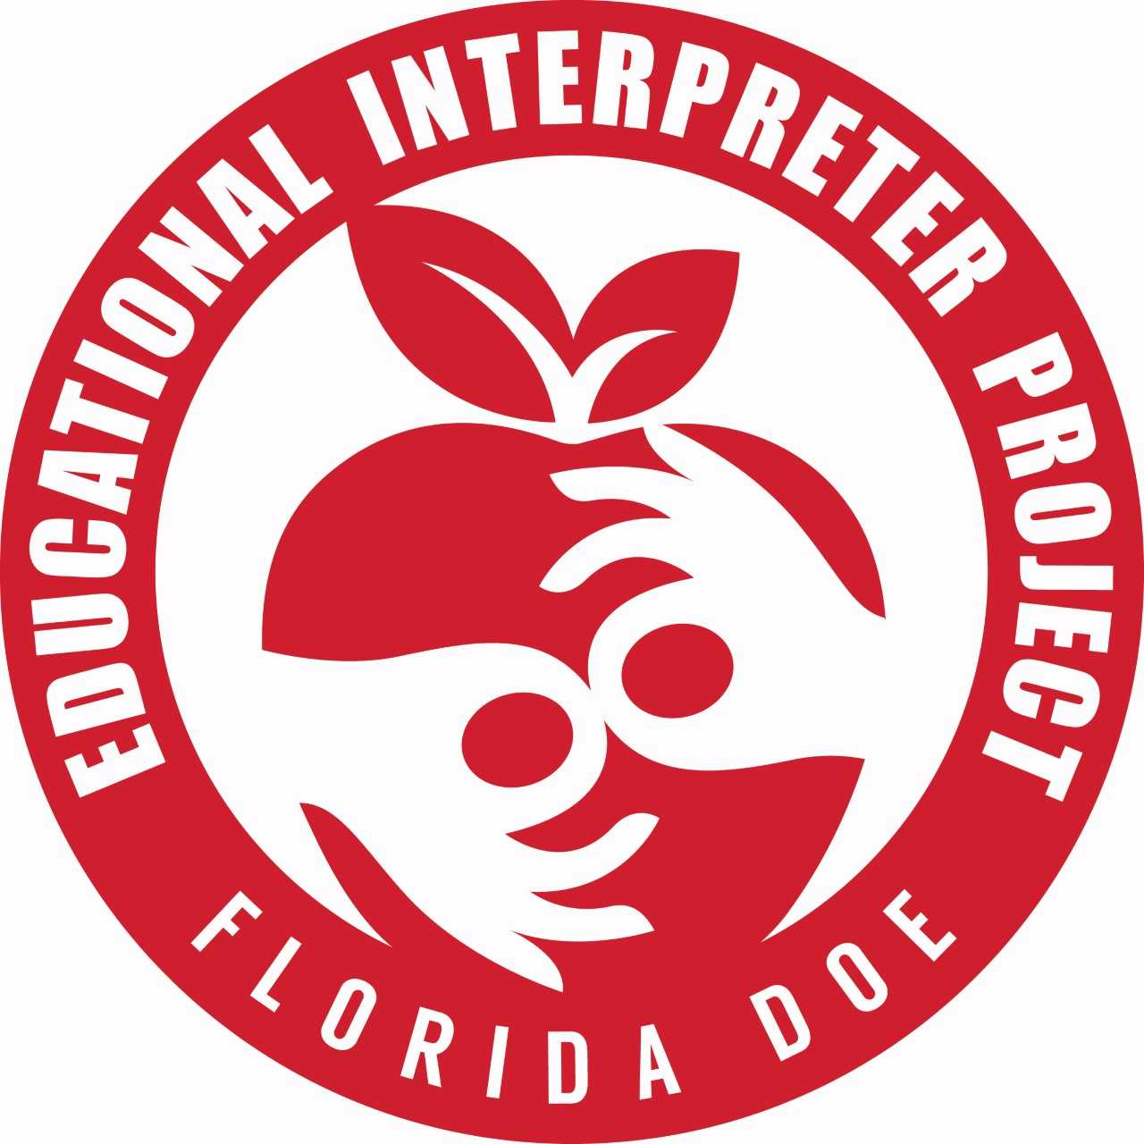
Educational Interpreter Project
Jennifer Francisco, Coordinator, M. Ed
jfrancis@pasco.k12.fl.us
7227 Land O’Lakes Boulevard, Land O’Lakes, Florida 34638

Agency Verification of Educational Interpreter Assignment

TO: Educational Interpreter Project
FDOE/Pasco County Schools
7227 Land O' Lakes Blvd.
Land O’Lakes, FL 34638-2827

FROM:
Agency name:
Contact email:
Phone number:

Date:

RE: Verification of long-term/full time position in K-12 educational settings

This document verifies that _____________________________________________ currently works through this agency in K-12 educational settings in a long-term/full time position. This assignment is expected to continue for the school year, 2019 – 2020. The interpreter works in ________________________ County.

Signed:_______________________________________

Printed name:_______________________________

Title:__________________________________________

Send by email to: khuntzin@pasco.k12.fl.us

