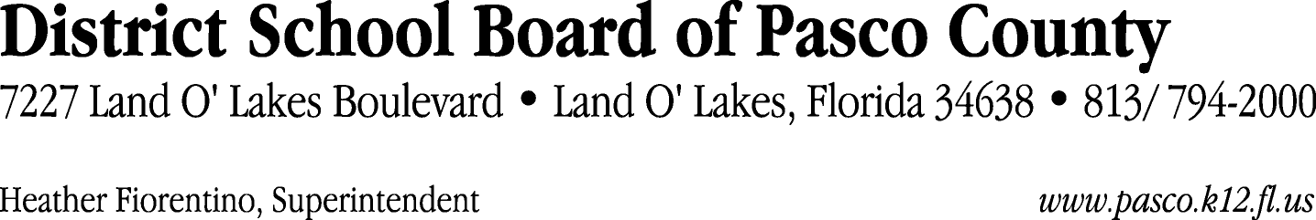

Finance Services Department
813/ 794-2294 Fax: 813/ 794-2266
727/ 774-2294 TDD: 813/ 794-2484
352/ 524-2294
MEMORANDUM

Date: July 8, 2013
To: School Board Members
From: Joanne Millovitsch, Director of Finance
Re: Attached Warrant List for July 2, 2013

Please review the current computerized list. These totals include computer generated, handwritten and cancelled checks.

Warrant numbers 864518 through 864797 4,512,336.19

Amounts disbursed in Fund 1100 453,402.05
Amounts disbursed in Fund 3108 14,493.56
Amounts disbursed in Fund 3611 99,336.86
Amounts disbursed in Fund 3709 19,642.95
Amounts disbursed in Fund 3710 21,500.00
Amounts disbursed in Fund 3713 36,452.15
Amounts disbursed in Fund 3900 11,665.02
Amounts disbursed in Fund 3904 6,504.13
Amounts disbursed in Fund 4100 27,937.49
Amounts disbursed in Fund 4210 162,831.90
Amounts disbursed in Fund 4220 1,169.16
Amounts disbursed in Fund 4260 23,301.00
Amounts disbursed in Fund 7111 3,485,009.33
Amounts disbursed in Fund 7130 1,273.48
Amounts disbursed in Fund 7140 4,680.00
Amounts disbursed in Fund 7921 100,330.81
Amounts disbursed in Fund 7922 17,712.57
Amounts disbursed in Fund 7923 11,411.29
Amounts disbursed in Fund 9210 13,682.44

Confirmation of the approval of the July 2, 2013 warrants will be requested at the July 23, 2013 School Board meeting.

