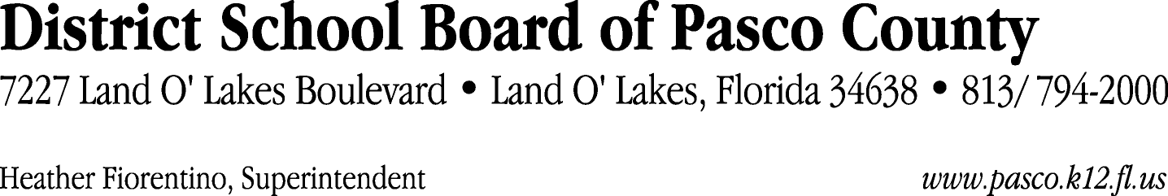

Finance Services Department
813/ 794-2268 Fax: 813/ 794-2266
727/ 774-2268 TDD: 813/ 794-2484
352/ 524-2268

MEMORANDUM

Date: April 18, 2012
To: School Board Members
From: Judith Zollo, Acting Director of Finance Services
Re: Attached Warrant List for the Week of April 17, 2012

Please review the current computerized list. These totals include computer generated, handwritten and cancelled checks.

Warrant numbers 841418 through 841675 1,638,959.21

Amounts disbursed in Fund 110 772,820.25
Amounts disbursed in Fund 421 40,731.77
Amounts disbursed in Fund 921 2,593.14
Amounts disbursed in Fund 349 2,290.00
Amounts disbursed in Fund 422 2,805.80
Amounts disbursed in Fund 410 269,864.51
Amounts disbursed in Fund 715 256,935.04
Amounts disbursed in Fund 370 67,840.07
Amounts disbursed in Fund 390 170,892.62
Amounts disbursed in Fund 423 924.50
Amounts disbursed in Fund 713 5,638.07
Amounts disbursed in Fund 372 1,873.14
Amounts disbursed in Fund 711 3,000.00
Amounts disbursed in Fund 130 3,090.00
Amounts disbursed in Fund 398 17,726.22
Amounts disbursed in Fund 425 14,828.88
Amounts disbursed in Fund 795 654.20
Amounts disbursed in Fund 424 4,451.00

Direct Deposit to Retirees:
ACH Numbers 6313 through 6494 61,574.13
Total amount disbursed 1,700,533.34

Confirmation of the approval of the April 17, 2012 warrants will be requested at the May 1, 2012 School Board meeting.

