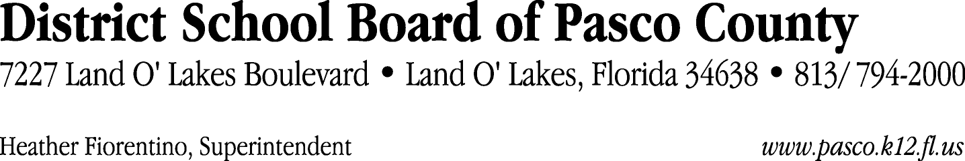

Finance Services Department
813/ 794-2268 Fax: 813/ 794-2266
727/ 774-2268 TDD: 813/ 794-2484
352/ 524-2268

MEMORANDUM

Date: February 16,2012
To: School Board Members
From: Judith Zollo, Acting Director of Finance Services
Re: Attached Warrant List for the Week of February 21, 2012

Please review the current computerized list. These totals include computer generated, handwritten and cancelled checks.

Warrant numbers 838090 through 838520 2,361,312.66

Amounts disbursed in Fund 421 182,785.08
Amounts disbursed in Fund 110 698,148.34
Amounts disbursed in Fund 410 431,808.45
Amounts disbursed in Fund 398 100,466.34
Amounts disbursed in Fund 390 156,867.35
Amounts disbursed in Fund 432 15,918.00
Amounts disbursed in Fund 422 1,488.94
Amounts disbursed in Fund 792 252,391.49
Amounts disbursed in Fund 921 1,177.87
Amounts disbursed in Fund 349 854.98
Amounts disbursed in Fund 715 227,287.35
Amounts disbursed in Fund 370 5,157.02
Amounts disbursed in Fund 821 150.00
Amounts disbursed in Fund 714 17,084.42
Amounts disbursed in Fund 793 31,178.06
Amounts disbursed in Fund 372 23,782.79
Amounts disbursed in Fund 713 129,659.30
Amounts disbursed in Fund 379 33,059.93
Amounts disbursed in Fund 371 1,000.00
Amounts disbursed in Fund 318 3,025.00
Amounts disbursed in Fund 423 725.00
Amounts disbursed in Fund 393 33,500.00
Amounts disbursed in Fund 711 11.56
Amounts disbursed in Fund 795 13,458.54
Amounts disbursed in Fund 39C 326.85

Direct Deposit to Retirees:
ACH Numbers 5951 through 6131 60,867.76
Total amount disbursed 2,422,180.42

Confirmation of the approval of the February 21, 2012 warrants will be requested at the March 6, 2012 School Board meeting.

