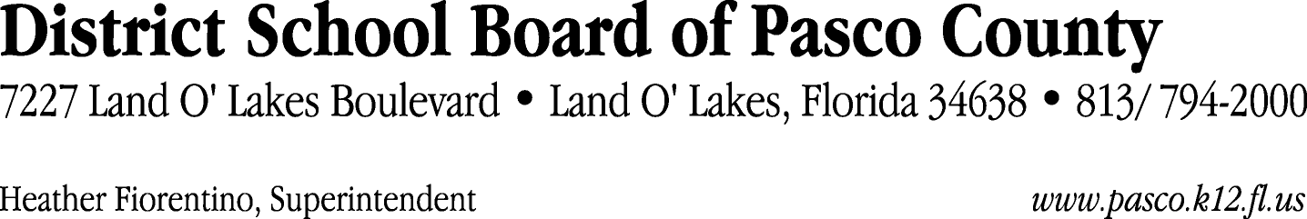

Finance Services Department
813/ 794-2294 Fax: 813/ 794-2266
727/ 774-2294 TDD: 813/ 794-2484
352/ 524-2294
MEMORANDUM

Date: November 12, 2012
To: School Board Members
From: Joanne Millovitsch, Director of Finance
Re: Attached Warrant List for November 9, 2012

Please review the current computerized list. These totals include computer generated, handwritten and cancelled checks.

Warrant numbers 853976 through 854059 76,372.09

Amounts disbursed in Fund 426 76,372.09

Confirmation of the approval of the November 9, 2012 warrants will be requested at the December 4, 2012 School Board meeting.

