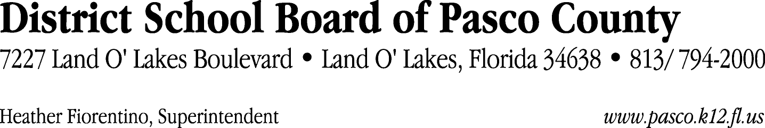

Finance Services Department
813/ 794-2268 Fax: 813/ 794-2266
727/ 774-2268 TDD: 813/ 794-2484
352/ 524-2268

MEMORANDUM

Date: November 14, 2011
To: School Board Members
From: Judith Zollo, Acting Director of Finance Services
Re: Attached Warrant List for the Week of November 15, 2011

Please review the current computerized list. These totals include computer generated, handwritten and cancelled checks.

Warrant numbers 833132 through 833551 2,039,689.61

Amounts disbursed in Fund 110 708,685.04
Amounts disbursed in Fund 421 66,439.55
Amounts disbursed in Fund 921 2,196.63
Amounts disbursed in Fund 341 6,097.38
Amounts disbursed in Fund 370 336,426.56
Amounts disbursed in Fund 398 33,296.50
Amounts disbursed in Fund 422 2,161.88
Amounts disbursed in Fund 434 3,648.52
Amounts disbursed in Fund 372 23,717.00
Amounts disbursed in Fund 39C 32,474.98
Amounts disbursed in Fund 410 366,218.07
Amounts disbursed in Fund 793 56,190.76
Amounts disbursed in Fund 713 7,207.90
Amounts disbursed in Fund 390 99,346.10
Amounts disbursed in Fund 379 49.70
Amounts disbursed in Fund 432 86.60
Amounts disbursed in Fund 130 1,020.00
Amounts disbursed in Fund 795 1,034.17
Amounts disbursed in Fund 792 286,488.23
Amounts disbursed in Fund 794 136.54
Amounts disbursed in Fund 391 1,800.00
Amounts disbursed in Fund 371 4,967.50

Direct Deposit to Retirees:
ACH Numbers 5412 through 5591 60,421.45
Total amount disbursed 2,100,111.06

Confirmation of the approval of the November 15, 2011 warrants will be requested at the December 6, 2011 School Board meeting.

