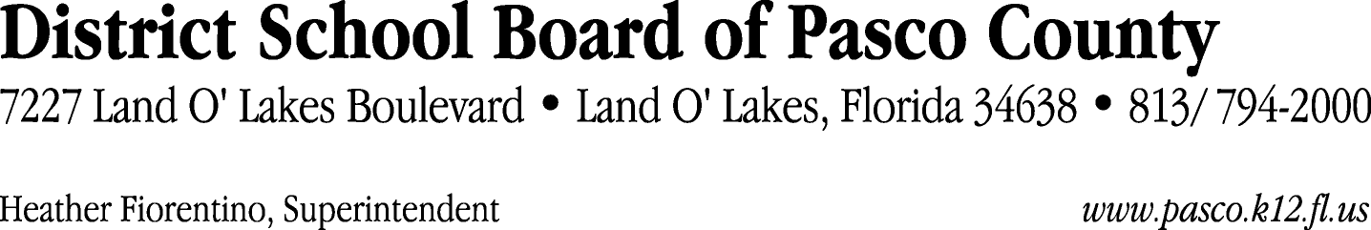

Finance Services Department
813/ 794-2294 Fax: 813/ 794-2266
727/ 774-2294 TDD: 813/ 794-2484
352/ 524-2294
MEMORANDUM

Date: December 8, 2011
To: School Board Members
From: Judith Zollo, Acting Director of Finance Services
Re: Attached Warrant List for December 13, 2011

Please review the current computerized list. These totals include computer generated, handwritten and cancelled checks.

Warrant numbers 834710 through 835140 9,008,776.47

Amounts disbursed in Fund 110 557,321.70
Amounts disbursed in Fund 421 58,404.80
Amounts disbursed in Fund 130 920,980.00
Amounts disbursed in Fund 713 75,635.01
Amounts disbursed in Fund 410 324,108.52
Amounts disbursed in Fund 371 12,430.05
Amounts disbursed in Fund 341 11,213.61
Amounts disbursed in Fund 378 8,832.86
Amounts disbursed in Fund 372 135,687.28
Amounts disbursed in Fund 921 3,901.04
Amounts disbursed in Fund 370 128,729.16
Amounts disbursed in Fund 398 43,561.26
Amounts disbursed in Fund 715 5,862,250.45
Amounts disbursed in Fund 422 5,471.49
Amounts disbursed in Fund 391 1,562.22
Amounts disbursed in Fund 795 2,225.00
Amounts disbursed in Fund 792 215,915.83
Amounts disbursed in Fund 793 83,703.31
Amounts disbursed in Fund 390 510,455.39
Amounts disbursed in Fund 432 8,121.75
Amounts disbursed in Fund 433 169.16
Amounts disbursed in Fund 318 9,507.00
Amounts disbursed in Fund 393 5,888.34
Amounts disbursed in Fund 434 107.54
Amounts disbursed in Fund 379 11,462.20
Amounts disbursed in Fund 821 31.50
Amounts disbursed in Fund 298 1,100.00
Amounts disbursed in Fund 425 10,000.00

Confirmation of the approval of the December 13, 2011 warrants will be requested at the January 24, 2012 School Board meeting.

