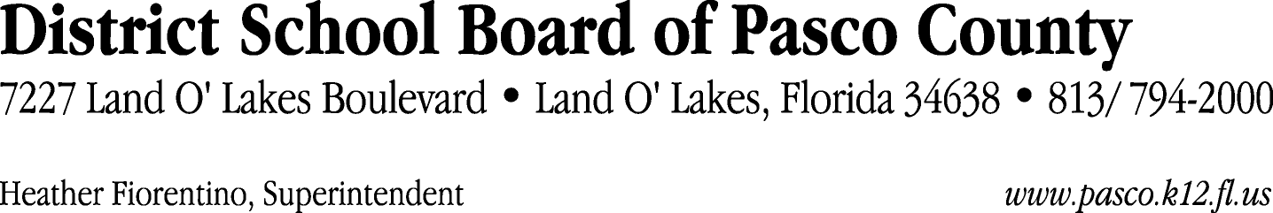

Finance Services Department
813/ 794-2294 Fax: 813/ 794-2266
727/ 774-2294 TDD: 813/ 794-2484
352/ 524-2294
MEMORANDUM

Date: December 1, 2011
To: School Board Members
From: Judith Zollo, Acting Director of Finance Services
Re: Attached Warrant List for December 6, 2011

Please review the current computerized list. These totals include computer generated, handwritten and cancelled checks.

Warrant numbers 834422 through 834707 1,938,060.92

Amounts disbursed in Fund 421 576,289.69
Amounts disbursed in Fund 372 48,115.97
Amounts disbursed in Fund 341 2,351.27
Amounts disbursed in Fund 110 641,668.35
Amounts disbursed in Fund 921 1,004.97
Amounts disbursed in Fund 792 349.52
Amounts disbursed in Fund 370 130,011.39
Amounts disbursed in Fund 398 8,279.48
Amounts disbursed in Fund 410 264,848.44
Amounts disbursed in Fund 422 3,702.47
Amounts disbursed in Fund 715 69.00
Amounts disbursed in Fund 390 251,611.82
Amounts disbursed in Fund 793 499.41
Amounts disbursed in Fund 713 6,968.75
Amounts disbursed in Fund 310 1,358.75
Amounts disbursed in Fund 424 210.72
Amounts disbursed in Fund 130 317.21
Amounts disbursed in Fund 821 403.71

Confirmation of the approval of the December 6, 2011 warrants will be requested at the December 20, 2011 School Board meeting.

