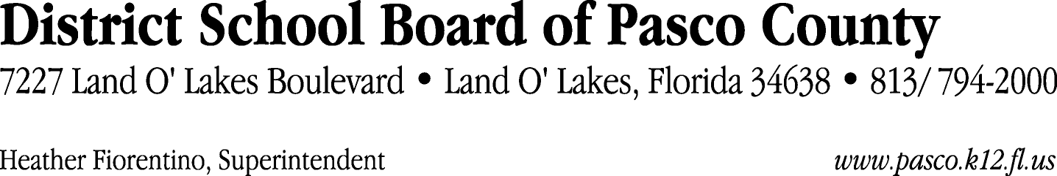

Finance Services Department
813/ 794-2294 Fax: 813/ 794-2266
727/ 774-2294 TDD: 813/ 794-2484
352/ 524-2294
MEMORANDUM

Date: November 17, 2011
To: School Board Members
From: Judith Zollo, Acting Director of Finance Services
Re: Attached Warrant List for November 22, 2011

Please review the current computerized list. These totals include computer generated, handwritten and cancelled checks.

Warrant numbers 833632 through 833902 2,508,167.11

Amounts disbursed in Fund 110 647,499.88
Amounts disbursed in Fund 349 15,421.81
Amounts disbursed in Fund 341 123,222.06
Amounts disbursed in Fund 421 66,796.45
Amounts disbursed in Fund 422 3,550.60
Amounts disbursed in Fund 921 3,135.76
Amounts disbursed in Fund 370 109,880.59
Amounts disbursed in Fund 391 3,008.10
Amounts disbursed in Fund 390 317,430.32
Amounts disbursed in Fund 792 260,347.52
Amounts disbursed in Fund 379 7,545.80
Amounts disbursed in Fund 410 206,727.49
Amounts disbursed in Fund 372 91,159.21
Amounts disbursed in Fund 793 11,672.12
Amounts disbursed in Fund 398 132,889.12
Amounts disbursed in Fund 713 5,050.93
Amounts disbursed in Fund 432 1,364.35
Amounts disbursed in Fund 39C 448,955.08
Amounts disbursed in Fund 393 6,962.00
Amounts disbursed in Fund 378 26,069.08
Amounts disbursed in Fund 821 673.95
Amounts disbursed in Fund 795 16,656.14
Amounts disbursed in Fund 371 2,328.75

Confirmation of the approval of the November 22, 2011 warrants will be requested at the December 6, 2011 School Board meeting.

