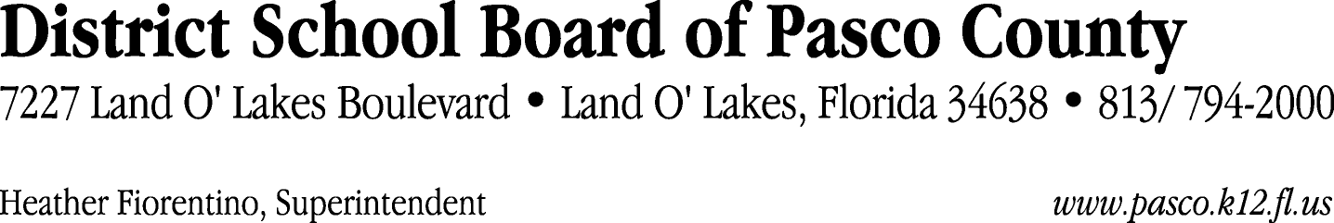

Finance Services Department
813/ 794-2294 Fax: 813/ 794-2266
727/ 774-2294 TDD: 813/ 794-2484
352/ 524-2294
MEMORANDUM

Date: November 3, 2011
To: School Board Members
From: Judith Zollo, Acting Director of Finance Services
Re: Attached Warrant List for November 8, 2011

Please review the current computerized list. These totals include computer generated, handwritten and cancelled checks.

Warrant numbers 832799 through 833126 3,033,450.82

Amounts disbursed in Fund 110 525,454.40
Amounts disbursed in Fund 130 1,034,891.65
Amounts disbursed in Fund 372 16,637.32
Amounts disbursed in Fund 421 77,510.21
Amounts disbursed in Fund 390 595,311.76
Amounts disbursed in Fund 713 87,527.37
Amounts disbursed in Fund 921 2,929.08
Amounts disbursed in Fund 370 55,472.81
Amounts disbursed in Fund 410 315,226.55
Amounts disbursed in Fund 422 11,307.55
Amounts disbursed in Fund 824 66.00
Amounts disbursed in Fund 792 185,770.94
Amounts disbursed in Fund 793 6,196.85
Amounts disbursed in Fund 794 5,220.00
Amounts disbursed in Fund 398 98,675.37
Amounts disbursed in Fund 378 2,010.00
Amounts disbursed in Fund 349 1,344.42
Amounts disbursed in Fund 433 754.96
Amounts disbursed in Fund 298 4,000.00
Amounts disbursed in Fund 715 393.60
Amounts disbursed in Fund 434 45.98
Amounts disbursed in Fund 341 1,344.00
Amounts disbursed in Fund 299 2,000.00
Amounts disbursed in Fund 432 285.00
Amounts disbursed in Fund 714 3,075.00

Confirmation of the approval of the November 8, 2011 warrants will be requested at the November 22, 2011 School Board meeting.

