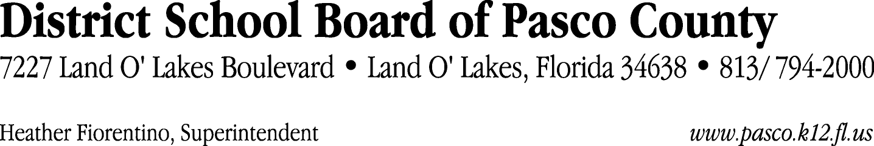

Finance Services Department
813/ 794-2294 Fax: 813/ 794-2266
727/ 774-2294 TDD: 813/ 794-2484
352/ 524-2294
MEMORANDUM

Date: October 28, 2011
To: School Board Members
From: Judith Zollo, Acting Director of Finance Services
Re: Attached Warrant List for November 1, 2011

Please review the current computerized list. These totals include computer generated, handwritten and cancelled checks.

Warrant numbers 832788 through 832793 593,366.64

Amounts disbursed in Fund 715 434,399.36
Amounts disbursed in Fund 110 134,403.56
Amounts disbursed in Fund 921 3,183.81
Amounts disbursed in Fund 130 57.84
Amounts disbursed in Fund 140 625.04
Amounts disbursed in Fund 410 7,683.03
Amounts disbursed in Fund 421 10,518.29
Amounts disbursed in Fund 422 2,064.43
Amounts disbursed in Fund 424 19.28
Amounts disbursed in Fund 425 20.64
Amounts disbursed in Fund 432 28.92
Amounts disbursed in Fund 434 77.04
Amounts disbursed in Fund 711 138.80
Amounts disbursed in Fund 713 72.34
Amounts disbursed in Fund 714 28.92
Amounts disbursed in Fund 792 26.06
Amounts disbursed in Fund 795 19.28

Confirmation of the approval of the November 1, 2011 warrants will be requested at the November 22, 2011 School Board meeting.

