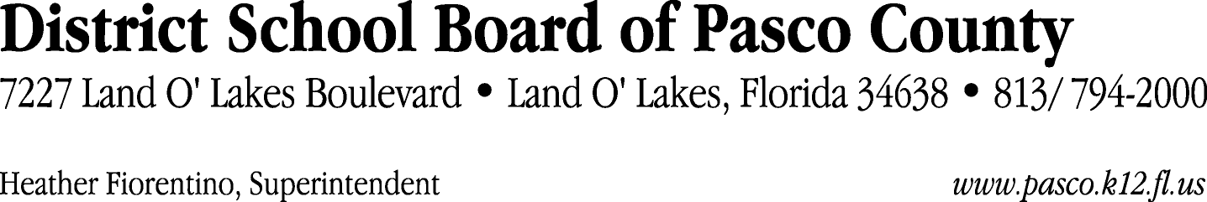

Finance Services Department
813/ 794-2294 Fax: 813/ 794-2266
727/ 774-2294 TDD: 813/ 794-2484
352/ 524-2294
MEMORANDUM

Date: October 27, 2011
To: School Board Members
From: Judith Zollo, Acting Director of Finance Services
Re: Attached Warrant List for November 1, 2011

Please review the current computerized list. These totals include computer generated, handwritten and cancelled checks.

Warrant numbers 832220 through 832497 2,804,472.54

Amounts disbursed in Fund 379 50,211.27
Amounts disbursed in Fund 110 752,342.92
Amounts disbursed in Fund 421 264,911.23
Amounts disbursed in Fund 921 3,354.66
Amounts disbursed in Fund 410 304,312.10
Amounts disbursed in Fund 398 2,908.59
Amounts disbursed in Fund 390 198,865.14
Amounts disbursed in Fund 372 20,108.35
Amounts disbursed in Fund 371 605.00
Amounts disbursed in Fund 349 1,308.18
Amounts disbursed in Fund 713 28,585.24
Amounts disbursed in Fund 432 118.60
Amounts disbursed in Fund 370 125,027.59
Amounts disbursed in Fund 29C 2,168.18
Amounts disbursed in Fund 393 17,178.81
Amounts disbursed in Fund 715 286,622.02
Amounts disbursed in Fund 39C 301,902.94
Amounts disbursed in Fund 792 300,026.77
Amounts disbursed in Fund 793 46,078.36
Amounts disbursed in Fund 711 4,092.82
Amounts disbursed in Fund 714 16,214.34
Amounts disbursed in Fund 422 113.35
Amounts disbursed in Fund 130 300.00
Amounts disbursed in Fund 425 891.00
Amounts disbursed in Fund 378 76,225.08

Confirmation of the approval of the November 1, 2011 warrants will be requested at the November 22, 2011 School Board meeting.

