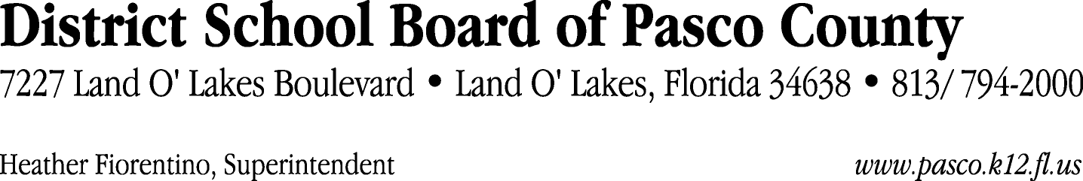

Finance Services Department
813/ 794-2294 Fax: 813/ 794-2266
727/ 774-2294 TDD: 813/ 794-2484
352/ 524-2294
MEMORANDUM

Date: October 6, 2011
To: School Board Members
From: Judith Zollo, Acting Director of Finance Services
Re: Attached Warrant List for October 11, 2011

Please review the current computerized list. These totals include computer generated, handwritten and cancelled checks.

Warrant numbers 831074 through 831414 8,054,455.08

Amounts disbursed in Fund 110 817,601.16
Amounts disbursed in Fund 130 969,674.56
Amounts disbursed in Fund 378 151,511.71
Amounts disbursed in Fund 421 159,827.44
Amounts disbursed in Fund 921 5,686.01
Amounts disbursed in Fund 390 907,295.27
Amounts disbursed in Fund 349 250.31
Amounts disbursed in Fund 372 387,158.31
Amounts disbursed in Fund 422 2,861.01
Amounts disbursed in Fund 410 362,404.91
Amounts disbursed in Fund 715 4,014,536.68
Amounts disbursed in Fund 398 6,214.48
Amounts disbursed in Fund 425 15,225.00
Amounts disbursed in Fund 793 15,663.85
Amounts disbursed in Fund 433 6,737.52
Amounts disbursed in Fund 713 4,381.00
Amounts disbursed in Fund 370 7,281.24
Amounts disbursed in Fund 39C 31,123.52
Amounts disbursed in Fund 792 146,199.12
Amounts disbursed in Fund 341 1,917.47
Amounts disbursed in Fund 432 9,460.55
Amounts disbursed in Fund 711 550.00
Amounts disbursed in Fund 340 20,846.04
Amounts disbursed in Fund 393 9,740.50
Amounts disbursed in Fund 795 307.42

Confirmation of the approval of the October 11, 2011 warrants will be requested at the November 1, 2011 School Board meeting.

