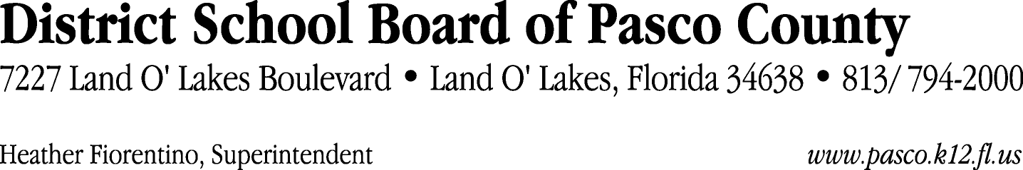

Finance Services Department
813/ 794-2294 Fax: 813/ 794-2266
727/ 774-2294 TDD: 813/ 794-2484
352/ 524-2294
MEMORANDUM

Date: September 29, 2011
To: School Board Members
From: Judith Zollo, Acting Director of Finance Services
Re: Attached Warrant List for October 4, 2011

Please review the current computerized list. These totals include computer generated, handwritten and cancelled checks.

Warrant numbers 830566 through 830918 2,658,321.97

Amounts disbursed in Fund 110 972,595.55
Amounts disbursed in Fund 130 65,561.48
Amounts disbursed in Fund 711 150.00
Amounts disbursed in Fund 421 147,776.97
Amounts disbursed in Fund 391 127,356.58
Amounts disbursed in Fund 341 91,104.70
Amounts disbursed in Fund 821 208.02
Amounts disbursed in Fund 410 434,144.32
Amounts disbursed in Fund 371 141,761.98
Amounts disbursed in Fund 349 1,170.00
Amounts disbursed in Fund 432 11,901.10
Amounts disbursed in Fund 715 21,100.80
Amounts disbursed in Fund 294 3,750.00
Amounts disbursed in Fund 291 3,250.00
Amounts disbursed in Fund 292 1,750.00
Amounts disbursed in Fund 296 1,500.00
Amounts disbursed in Fund 434 876.10
Amounts disbursed in Fund 422 3,774.89
Amounts disbursed in Fund 921 5,404.08
Amounts disbursed in Fund 370 16,038.69
Amounts disbursed in Fund 372 7,516.89
Amounts disbursed in Fund 792 206,094.40
Amounts disbursed in Fund 793 22,552.85
Amounts disbursed in Fund 39C 240,798.01
Amounts disbursed in Fund 713 105,020.12
Amounts disbursed in Fund 390 23,112.00
Amounts disbursed in Fund 379 932.00
Amounts disbursed in Fund 433 481.50
Amounts disbursed in Fund 398 638.94

Confirmation of the approval of the October 4, 2011 warrants will be requested at the October 18, 2011 School Board meeting.

