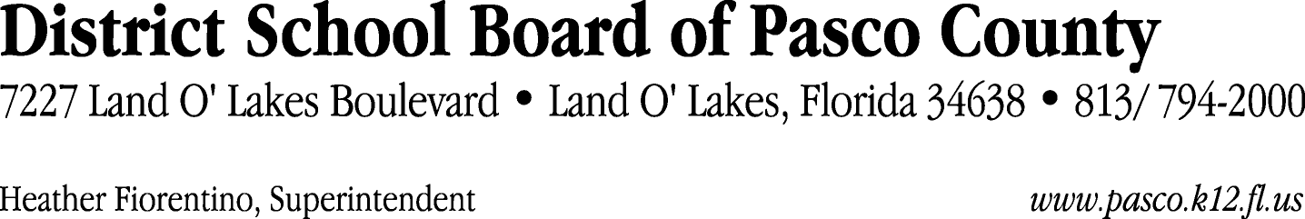

Finance Services Department
813/ 794-2294 Fax: 813/ 794-2266
727/ 774-2294 TDD: 813/ 794-2484
352/ 524-2294
MEMORANDUM

Date: August 25, 2011
To: School Board Members
From: Judith Zollo, Acting Director of Finance Services
Re: Attached Warrant List for August 30, 2011

Please review the current computerized list. These totals include computer generated, handwritten and cancelled checks.

Warrant numbers 828675 through 828922 3,678,750.21

Amounts disbursed in Fund 110 1,945,736.65
Amounts disbursed in Fund 349 44,716.39
Amounts disbursed in Fund 390 959,843.96
Amounts disbursed in Fund 921 9,945.68
Amounts disbursed in Fund 422 33,646.32
Amounts disbursed in Fund 391 10,371.00
Amounts disbursed in Fund 421 134,022.82
Amounts disbursed in Fund 792 166,870.02
Amounts disbursed in Fund 793 42,313.08
Amounts disbursed in Fund 398 1,392.90
Amounts disbursed in Fund 370 1,089.24
Amounts disbursed in Fund 410 3,387.55
Amounts disbursed in Fund 397 463.50
Amounts disbursed in Fund 378 3,675.00
Amounts disbursed in Fund 372 67,152.03
Amounts disbursed in Fund 713 114,446.08
Amounts disbursed in Fund 371 407.68
Amounts disbursed in Fund 294 4,500.00
Amounts disbursed in Fund 296 1,500.00
Amounts disbursed in Fund 379 131,830.31
Amounts disbursed in Fund 433 1,440.00

Confirmation of the approval of the August 30, 2011 warrants will be requested at the September 13, 2011 School Board meeting.

