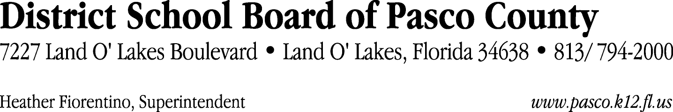

Finance Services Department
813/ 794-2294 Fax: 813/ 794-2266
727/ 774-2294 TDD: 813/ 794-2484
352/ 524-2294
MEMORANDUM

Date: July 21, 2011
To: School Board Members
From: Judith Zollo, Acting Director of Finance Services
Re: Attached Warrant List for July 26, 2011

Please review the current computerized list. These totals include computer generated, handwritten and cancelled checks.

Warrant numbers 827266 through 827484 2,060,697.41

Amounts disbursed in Fund 110 607,680.35
Amounts disbursed in Fund 421 21,938.12
Amounts disbursed in Fund 341 24,304.60
Amounts disbursed in Fund 371 541,793.56
Amounts disbursed in Fund 378 29,292.32
Amounts disbursed in Fund 390 166,023.80
Amounts disbursed in Fund 39C 310,160.42
Amounts disbursed in Fund 422 1,734.02
Amounts disbursed in Fund 396 4,884.00
Amounts disbursed in Fund 318 3,422.36
Amounts disbursed in Fund 921 6,952.78
Amounts disbursed in Fund 792 359.02
Amounts disbursed in Fund 397 22,411.57
Amounts disbursed in Fund 393 9,554.99
Amounts disbursed in Fund 410 4,078.48
Amounts disbursed in Fund 715 237,566.47
Amounts disbursed in Fund 379 40,781.30
Amounts disbursed in Fund 433 219.90
Amounts disbursed in Fund 793 3,076.26
Amounts disbursed in Fund 713 7,858.67
Amounts disbursed in Fund 711 1,682.81
Amounts disbursed in Fund 795 14,921.61

Confirmation of the approval of the July 26, 2011 warrants will be requested at the August 16, 2011 School Board meeting.

