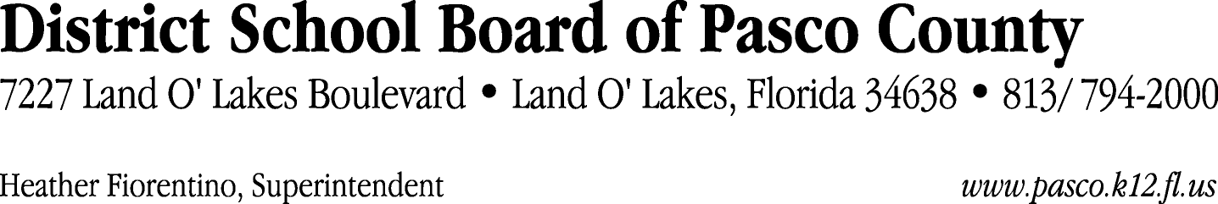

Finance Services Department
813/ 794-2294 Fax: 813/ 794-2266
727/ 774-2294 TDD: 813/ 794-2484
352/ 524-2294
MEMORANDUM

Date: June 8, 2012
To: School Board Members
From: Judith Zollo, Acting Director of Finance Services
Re: Attached Warrant List for June 12, 2012

Please review the current computerized list. These totals include computer generated, handwritten and cancelled checks.

Warrant numbers 845014 through 845099 3,146,436.45

Amounts disbursed in Fund 410 22,005.15
Amounts disbursed in Fund 110 2,958,576.85
Amounts disbursed in Fund 421 121,529.12
Amounts disbursed in Fund 714 246.54
Amounts disbursed in Fund 921 8,543.15
Amounts disbursed in Fund 140 8,414.86
Amounts disbursed in Fund 422 19,187.28
Amounts disbursed in Fund 434 2,252.94
Amounts disbursed in Fund 432 1,745.74
Amounts disbursed in Fund 792 231.03
Amounts disbursed in Fund 425 448.25
Amounts disbursed in Fund 424 57.24
Amounts disbursed in Fund 711 1,391.09
Amounts disbursed in Fund 713 615.53
Amounts disbursed in Fund 130 1,165.48
Amounts disbursed in Fund 795 26.20

Confirmation of the approval of the June 12, 2012 warrants will be requested at the July 3, 2012 School Board meeting.

