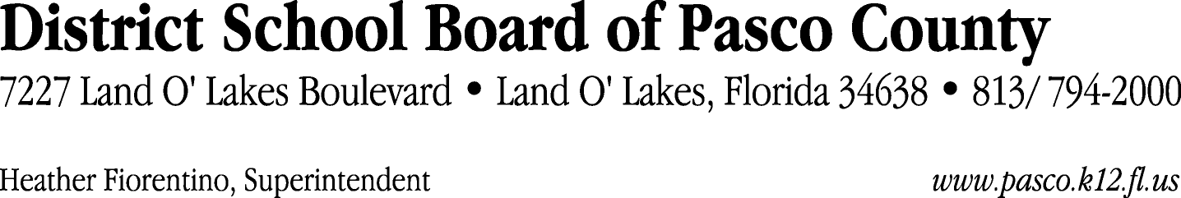

Finance Services Department
813/ 794-2294 Fax: 813/ 794-2266
727/ 774-2294 TDD: 813/ 794-2484
352/ 524-2294
MEMORANDUM

Date: May 31, 2012
To: School Board Members
From: Judith Zollo, Acting Director of Finance Services
Re: Attached Warrant List for June 5, 2012

Please review the current computerized list. These totals include computer generated, handwritten and cancelled checks.

Warrant numbers 844283 through 844563 2,192,647.72

Amounts disbursed in Fund 110 689,455.04
Amounts disbursed in Fund 130 47,672.31
Amounts disbursed in Fund 421 66,281.96
Amounts disbursed in Fund 921 3,951.51
Amounts disbursed in Fund 422 465.34
Amounts disbursed in Fund 410 261,982.86
Amounts disbursed in Fund 398 6,769.08
Amounts disbursed in Fund 793 21,453.11
Amounts disbursed in Fund 372 29,182.09
Amounts disbursed in Fund 713 20,958.61
Amounts disbursed in Fund 390 645,742.99
Amounts disbursed in Fund 370 3,479.75
Amounts disbursed in Fund 715 213,447.23
Amounts disbursed in Fund 714 30,160.00
Amounts disbursed in Fund 792 146,731.10
Amounts disbursed in Fund 423 414.74
Amounts disbursed in Fund 292 4,500.00

Confirmation of the approval of the June 5, 2012 warrants will be requested at the June 19, 2012 School Board meeting.

