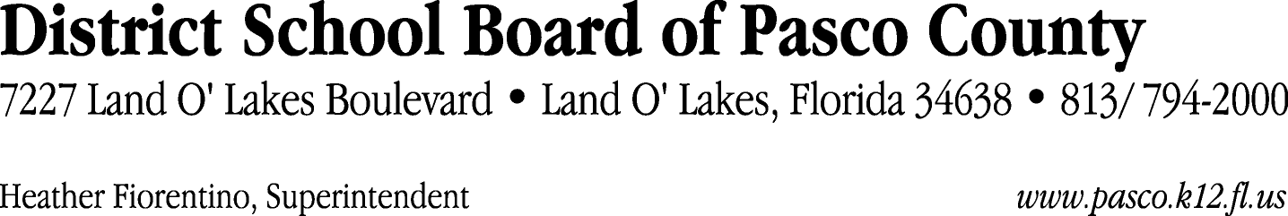

Finance Services Department
813/ 794-2294 Fax: 813/ 794-2266
727/ 774-2294 TDD: 813/ 794-2484
352/ 524-2294
MEMORANDUM

Date: May 24, 2012
To: School Board Members
From: Judith Zollo, Acting Director of Finance Services
Re: Attached Warrant List for May 29, 2012

Please review the current computerized list. These totals include computer generated, handwritten and cancelled checks.

Warrant numbers 843742 through 843744 2,738,241.69

Amounts disbursed in Fund 421 54,284.24
Amounts disbursed in Fund 398 285,734.37
Amounts disbursed in Fund 110 921,580.49
Amounts disbursed in Fund 792 279,551.45
Amounts disbursed in Fund 390 216,221.88
Amounts disbursed in Fund 422 7,665.08
Amounts disbursed in Fund 921 2,852.30
Amounts disbursed in Fund 410 298,392.67
Amounts disbursed in Fund 370 56,718.88
Amounts disbursed in Fund 715 426,028.71
Amounts disbursed in Fund 793 46,166.94
Amounts disbursed in Fund 795 14,357.39
Amounts disbursed in Fund 397 14,901.00
Amounts disbursed in Fund 713 69,086.12
Amounts disbursed in Fund 372 22,067.24
Amounts disbursed in Fund 39C 16,029.66
Amounts disbursed in Fund 423 260.07
Amounts disbursed in Fund 711 5.78
Amounts disbursed in Fund 310 3,250.00
Amounts disbursed in Fund 425 2,500.00
Amounts disbursed in Fund 130 587.42

Confirmation of the approval of the May 29, 2012 warrants will be requested at the June 19, 2012 School Board meeting.

