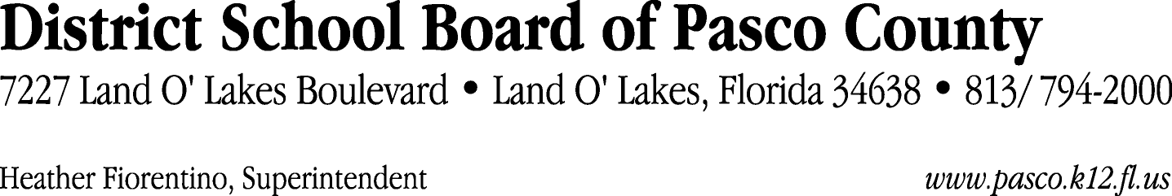

Finance Services Department
813/ 794-2294 Fax: 813/ 794-2266
727/ 774-2294 TDD: 813/ 794-2484
352/ 524-2294
MEMORANDUM

Date: May 17, 2012
To: School Board Members
From: Judith Zollo, Acting Director of Finance Services
Re: Attached Warrant List for May 22, 2012

Please review the current computerized list. These totals include computer generated, handwritten and cancelled checks.

Warrant numbers 843381 through 843739 1,606,087.08

Amounts disbursed in Fund 110 637,541.95
Amounts disbursed in Fund 421 105,908.41
Amounts disbursed in Fund 372 28,733.35
Amounts disbursed in Fund 422 51,970.68
Amounts disbursed in Fund 410 262,515.71
Amounts disbursed in Fund 792 217,965.49
Amounts disbursed in Fund 715 224,616.31
Amounts disbursed in Fund 370 8,438.39
Amounts disbursed in Fund 921 3,885.21
Amounts disbursed in Fund 795 1,710.00
Amounts disbursed in Fund 39C 16,602.00
Amounts disbursed in Fund 390 8,997.88
Amounts disbursed in Fund 713 14,399.28
Amounts disbursed in Fund 793 8,988.62
Amounts disbursed in Fund 130 3,270.00
Amounts disbursed in Fund 425 3,750.00
Amounts disbursed in Fund 432 6,793.80

Confirmation of the approval of the May 22, 2012 warrants will be requested at the June 5, 2012 School Board meeting.

