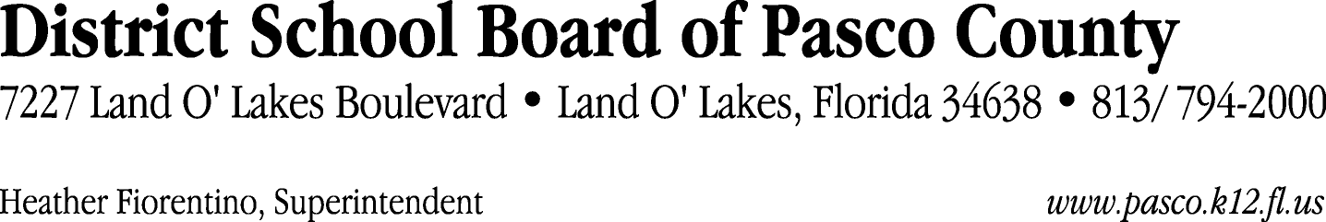

Finance Services Department
813/ 794-2294 Fax: 813/ 794-2266
727/ 774-2294 TDD: 813/ 794-2484
352/ 524-2294
MEMORANDUM

Date: May 3, 2012
To: School Board Members
From: Judith Zollo, Acting Director of Finance Services
Re: Attached Warrant List for May 8, 2012

Please review the current computerized list. These totals include computer generated, handwritten and cancelled checks.

Warrant numbers 842580 through 842924 3,125,780.74

Amounts disbursed in Fund 421 168,810.56
Amounts disbursed in Fund 110 540,882.09
Amounts disbursed in Fund 130 981,898.35
Amounts disbursed in Fund 390 580,296.84
Amounts disbursed in Fund 713 19,569.55
Amounts disbursed in Fund 921 5,945.01
Amounts disbursed in Fund 410 399,950.00
Amounts disbursed in Fund 349 45,800.00
Amounts disbursed in Fund 871 1,600.00
Amounts disbursed in Fund 370 13,842.46
Amounts disbursed in Fund 423 5,314.67
Amounts disbursed in Fund 793 27,802.71
Amounts disbursed in Fund 715 180,969.40
Amounts disbursed in Fund 371 3,045.00
Amounts disbursed in Fund 378 619.80
Amounts disbursed in Fund 422 761.79
Amounts disbursed in Fund 379 666.53
Amounts disbursed in Fund 398 533.49
Amounts disbursed in Fund 711 293.24
Amounts disbursed in Fund 792 131,704.42
Amounts disbursed in Fund 372 8,374.83
Amounts disbursed in Fund 293 3,500.00
Amounts disbursed in Fund 432 525.00
Amounts disbursed in Fund 714 3,075.00

Confirmation of the approval of the May 8, 2012 warrants will be requested at the June 5, 2012 School Board meeting.

