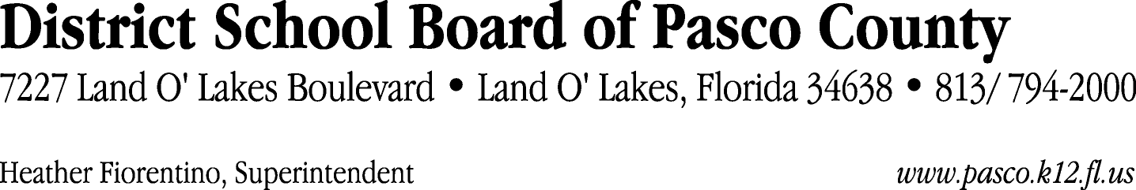

Finance Services Department
813/ 794-2294 Fax: 813/ 794-2266
727/ 774-2294 TDD: 813/ 794-2484
352/ 524-2294
MEMORANDUM

Date: April 18, 2012
To: School Board Members
From: Judith Zollo, Acting Director of Finance Services
Re: Attached Warrant List for April 10, 2012

Please review the current computerized list. These totals include computer generated, handwritten and cancelled checks.

Warrant numbers 841407 through 841412 600,117.86

Amounts disbursed in Fund 715 440,086.36
Amounts disbursed in Fund 110 135,213.10
Amounts disbursed in Fund 410 7,778.45
Amounts disbursed in Fund 130 57.84
Amounts disbursed in Fund 140 615.14
Amounts disbursed in Fund 421 10,636.69
Amounts disbursed in Fund 422 2,047.50
Amounts disbursed in Fund 424 3.39
Amounts disbursed in Fund 425 20.64
Amounts disbursed in Fund 432 28.92
Amounts disbursed in Fund 434 77.04
Amounts disbursed in Fund 711 138.80
Amounts disbursed in Fund 713 72.34
Amounts disbursed in Fund 714 28.92
Amounts disbursed in Fund 792 26.06
Amounts disbursed in Fund 795 38.48
Amounts disbursed in Fund 921 3,248.19

Confirmation of the approval of the April 10, 2012 warrants will be requested at the May 1, 2012 School Board meeting.

