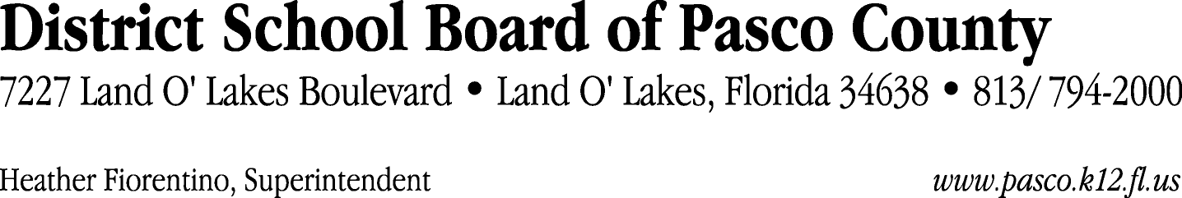

Finance Services Department
813/ 794-2294 Fax: 813/ 794-2266
727/ 774-2294 TDD: 813/ 794-2484
352/ 524-2294
MEMORANDUM

Date: March 26, 2012
To: School Board Members
From: Judith Zollo, Acting Director of Finance Services
Re: Attached Warrant List for March 22, 2012

Please review the current computerized list. These totals include computer generated, handwritten and cancelled checks.

Warrant numbers 840742 through 840812 717,522.60

Amounts disbursed in Fund 410 20,479.40
Amounts disbursed in Fund 110 636,933.85
Amounts disbursed in Fund 421 38,073.21
Amounts disbursed in Fund 714 239.21
Amounts disbursed in Fund 921 8,850.79
Amounts disbursed in Fund 140 2,024.26
Amounts disbursed in Fund 422 6,628.19
Amounts disbursed in Fund 434 352.38
Amounts disbursed in Fund 432 329.32
Amounts disbursed in Fund 792 231.03
Amounts disbursed in Fund 424 57.74
Amounts disbursed in Fund 425 133.19
Amounts disbursed in Fund 711 1,394.75
Amounts disbursed in Fund 713 621.53
Amounts disbursed in Fund 130 1,145.55
Amounts disbursed in Fund 795 28.20

Confirmation of the approval of the March 22, 2012 warrants will be requested at the April 17, 2012 School Board meeting.

