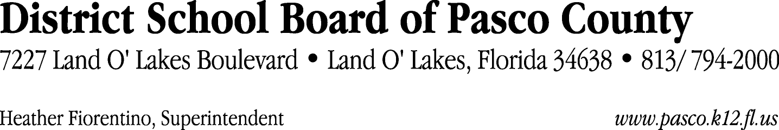

Finance Services Department
813/ 794-2294 Fax: 813/ 794-2266
727/ 774-2294 TDD: 813/ 794-2484
352/ 524-2294
MEMORANDUM

Date: March 13, 2012
To: School Board Members
From: Judith Zollo, Acting Director of Finance Services
Re: Attached Warrant List for March 13, 2012

Please review the current computerized list. These totals include computer generated, handwritten and cancelled checks.

Warrant numbers 839414 through 839789 4,988,049.79

Amounts disbursed in Fund 421 160,519.56
Amounts disbursed in Fund 110 749,168.95
Amounts disbursed in Fund 130 916,483.24
Amounts disbursed in Fund 372 22,879.56
Amounts disbursed in Fund 422 6,844.40
Amounts disbursed in Fund 921 988.90
Amounts disbursed in Fund 390 14,501.27
Amounts disbursed in Fund 370 29,601.01
Amounts disbursed in Fund 410 367,346.12
Amounts disbursed in Fund 715 2,454,237.31
Amounts disbursed in Fund 398 535.65
Amounts disbursed in Fund 423 542.30
Amounts disbursed in Fund 793 58,275.92
Amounts disbursed in Fund 713 12,143.18
Amounts disbursed in Fund 426 17,406.19
Amounts disbursed in Fund 432 11,480.95
Amounts disbursed in Fund 795 414.54
Amounts disbursed in Fund 792 164,680.74

Confirmation of the approval of the March 13, 2012 warrants will be requested at the April 17, 2012 School Board meeting.

