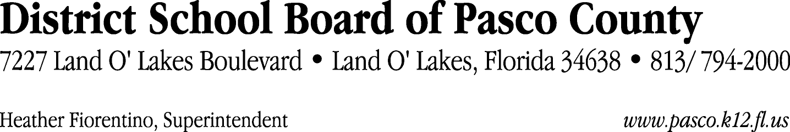

Finance Services Department
813/ 794-2294 Fax: 813/ 794-2266
727/ 774-2294 TDD: 813/ 794-2484
352/ 524-2294
MEMORANDUM

Date: March 1, 2012
To: School Board Members
From: Judith Zollo, Acting Director of Finance Services
Re: Attached Warrant List for March 6, 2012

Please review the current computerized list. These totals include computer generated, handwritten and cancelled checks.

Warrant numbers 839019 through 839332 1,755,825.68

Amounts disbursed in Fund 110 543,196.39
Amounts disbursed in Fund 130 57,320.00
Amounts disbursed in Fund 421 36,972.71
Amounts disbursed in Fund 378 130,579.16
Amounts disbursed in Fund 379 33,824.67
Amounts disbursed in Fund 390 98,885.21
Amounts disbursed in Fund 370 25,669.63
Amounts disbursed in Fund 349 12,009.08
Amounts disbursed in Fund 426 5,074.33
Amounts disbursed in Fund 921 7,899.99
Amounts disbursed in Fund 410 194,271.21
Amounts disbursed in Fund 715 202,213.28
Amounts disbursed in Fund 792 125,372.21
Amounts disbursed in Fund 793 10,972.42
Amounts disbursed in Fund 795 1,751.31
Amounts disbursed in Fund 39C 172,295.15
Amounts disbursed in Fund 371 3,076.24
Amounts disbursed in Fund 713 7,223.26
Amounts disbursed in Fund 423 5,303.11
Amounts disbursed in Fund 398 35,327.42
Amounts disbursed in Fund 422 384.13
Amounts disbursed in Fund 372 34,559.39
Amounts disbursed in Fund 434 127.30
Amounts disbursed in Fund 291 5,000.00
Amounts disbursed in Fund 348 5,118.08
Amounts disbursed in Fund 794 1,400.00

Confirmation of the approval of the March 6, 2012 warrants will be requested at the March 20, 2012 School Board meeting.

