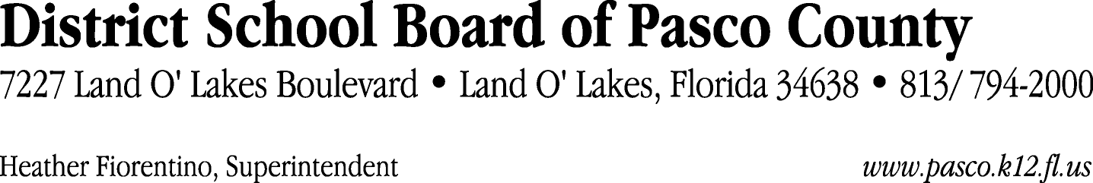

Finance Services Department
813/ 794-2294 Fax: 813/ 794-2266
727/ 774-2294 TDD: 813/ 794-2484
352/ 524-2294
MEMORANDUM

Date: February 23, 2012
To: School Board Members
From: Judith Zollo, Acting Director of Finance Services
Re: Attached Warrant List for February 28, 2012

Please review the current computerized list. These totals include computer generated, handwritten and cancelled checks.

Warrant numbers 838679 through 839002 2,907,999.78

Amounts disbursed in Fund 421 234,216.00
Amounts disbursed in Fund 110 372,681.85
Amounts disbursed in Fund 372 4,531.56
Amounts disbursed in Fund 398 28,488.39
Amounts disbursed in Fund 422 1,196.57
Amounts disbursed in Fund 370 201,588.26
Amounts disbursed in Fund 410 256,417.67
Amounts disbursed in Fund 349 34,644.60
Amounts disbursed in Fund 921 3,249.99
Amounts disbursed in Fund 715 478,898.29
Amounts disbursed in Fund 390 240,982.27
Amounts disbursed in Fund 792 209,228.79
Amounts disbursed in Fund 793 26,810.26
Amounts disbursed in Fund 713 4,868.12
Amounts disbursed in Fund 391 463.50
Amounts disbursed in Fund 39C 807,122.21
Amounts disbursed in Fund 130 388.00
Amounts disbursed in Fund 711 2,183.37
Amounts disbursed in Fund 794 40.08

Confirmation of the approval of the February 28, 2012 warrants will be requested at the March 20, 2012 School Board meeting.

