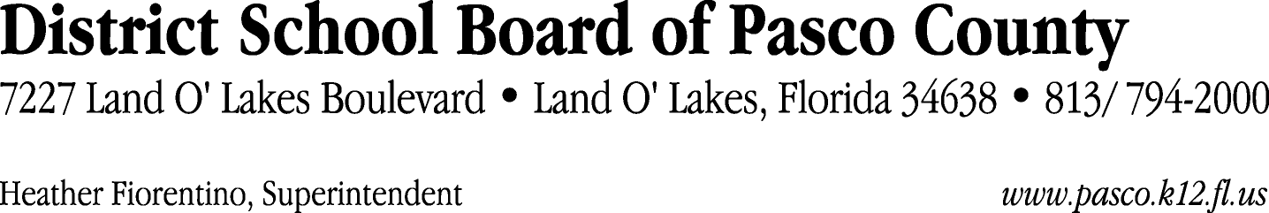

Finance Services Department
813/ 794-2294 Fax: 813/ 794-2266
727/ 774-2294 TDD: 813/ 794-2484
352/ 524-2294
MEMORANDUM

Date: February 3, 2012
To: School Board Members
From: Judith Zollo, Acting Director of Finance Services
Re: Attached Warrant List for February 7, 2012

Please review the current computerized list. These totals include computer generated, handwritten and cancelled checks.

Warrant numbers 837334 through 837663 3,588,017.76

Amounts disbursed in Fund 110 431,897.24
Amounts disbursed in Fund 130 79,139.50
Amounts disbursed in Fund 370 174,705.42
Amounts disbursed in Fund 421 66,530.55
Amounts disbursed in Fund 390 1,662,242.75
Amounts disbursed in Fund 921 1,848.11
Amounts disbursed in Fund 410 233,456.86
Amounts disbursed in Fund 379 16,058.35
Amounts disbursed in Fund 432 874.47
Amounts disbursed in Fund 398 238,925.38
Amounts disbursed in Fund 422 2,786.06
Amounts disbursed in Fund 434 314,568.76
Amounts disbursed in Fund 714 3,173.61
Amounts disbursed in Fund 793 26,689.84
Amounts disbursed in Fund 715 170,152.63
Amounts disbursed in Fund 372 63,791.27
Amounts disbursed in Fund 713 8,381.97
Amounts disbursed in Fund 39C 18,019.50
Amounts disbursed in Fund 792 73,012.01
Amounts disbursed in Fund 29B 1,500.00
Amounts disbursed in Fund 794 263.48

Confirmation of the approval of the February 7, 2012 warrants will be requested at the February 21, 2012 School Board meeting.

