Office for Professional Development and School Supports
Chris Christoff, Director
813/794-2644
E-MAIL: christof@pasco.k12.fl.us

Joel DiVincent, Supervisor
813/794-2710
E-MAIL: jdivince@pasco.k12.fl.us

March 12th, 2014

To: All Instructional Staff

From: Chris Christoff, Director, Office for Professional Development and School Supports
Joel DiVincent, Supervisor, Office for Professional Development and School Supports

Subject: National Educator Program – International Leadership Fellows Institute

Please find included an application, principal verification form, and information (FAQ) for the NEP – International Leadership Fellows Institute. This application is intended for all hopeful assistant principals with an Educational Leadership Degree or Certification. This is an excellent, required program for all future AP’s employed with the District School Board of Pasco County. Twenty future assistant principals will be accepted into this professional development program for the 2014-2015 year. The deadline for submitting the completed application to our office is Friday, April 18th, 2014. Please provide your principal with a copy of the verification form and ask them to complete and submit by the deadline.

Please note the required training dates listed in this information letter.
- July 21st through 25th and July 28th through August 1st, 2014, 8:00 am to 4:00 pm
- PLC residency sessions scheduled monthly during the school year from 5:00 pm to 7:00 pm
- One week in late July, 2015; dates TBD, 8:00am to 4:00 pm

A voluntary conference call to answer any questions will be held on the dates and times listed below:

Monday, March 24th, 2014 8:00 AM 4-2777
Monday, March 31st, 2014 3:30 PM 4-2777

Thank you for your interest in this amazing program.

cc: Principals/Directors
Learning Community Executive Directors
Superintendent Staff

Application for NEP - International Leadership Fellows Institute

Name: | Work Site: | Date:
Phone: | Email:
Principal or Direct Supervisor (if other than Principal):
Number of Years of Education/Teaching Experience:

List the schools in which
you have taught or served

Master’s Degree
in Educational Leadership

College/University Date Conferred
or

Certification in
Educational Leadership
College/University Date Completed

FLDOE FELE Passed: YES NO

Directions: Please write complete answers to the following 15 questions. The text boxes will expand.

Part 1: Applicant Statement

1. Please describe, in 100 words or less, your reason for wanting to participate in this program and for wanting to become an Assistant Principal.

Part 2: Leadership Experience Please describe your;

2. Experience in developing and facilitating professional development.

3. Experience facilitating and leading school-based teams.

4. Experience mentoring beginning teachers or teacher interns.

5. Experience with curriculum development.

Part 3: Planning for a new initiative
6. Please describe an in-depth plan to introduce and incorporate a new initiative such as

the Common Core Standards in either your team, PLC, grade level, or school.

7. What are the most important characteristics of an effective school?

Part 4: Please list the professional development experience(s) that you have completed during the last 5 years in the area(s) of
8. Communication and conferencing skills

9. Standards-based curriculum development, planning for instruction, delivery of instruction, and/or assessment of student performance

10. Classroom management

11. Leadership development

Part 5: Additional Questions

12. What do you see is the major role of the school-based administrator in 21st century schools?

13. As an instructional leader, it will be imperative to demonstrate effective collaboration with colleagues. Describe your idea of collaboration and what you envision it to look like in relation to supporting professional educators.

14. Please describe our district’s MTSS Integrated Framework and how the 3 areas connect to our work as educators and within our system.

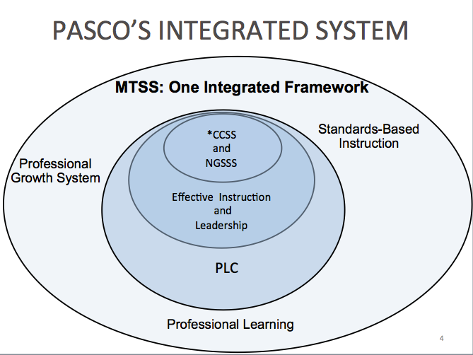

15. When leading in tough times, what leadership practices are most important to achieve school goals?

Principal Verification Form

Name of Applicant:

Principal or Director Name:

- The applicant is considered an effective or highly effective teacher?

Yes No I would like to discuss

- The applicant has my permission to participate in a significant leadership role (facilitator or co-facilitator) in a school wide student achievement project?

Yes No I would like to discuss

- I would be willing to hire this applicant as an Assistant Principal in July 2015?

Yes No I would like to discuss

Signature of Principal or Director: ____________________________________________________________

Date: ________________________

*Please return this verification form to the Office for Professional Development and School Supports by April 18th, 2014.

International Leadership Fellow Institute Frequent Questions and Answers

- Q: Is there still an Assistant Principal (AP) pool?
A: Yes. There will always be a list of qualified applicants who will be eligible to apply for open positions.
- Q: Is successful completion of the Institute the only way for Pasco employees to be admitted into the AP pool?
A: Yes. Moving forward, this will be the only way district teachers can be admitted into the AP pool. The traditional Human Resource process has been eliminated.
- Q: How often does the Institute become available?
A: This training program becomes open for participants once per school year. The application will be available in March of each school year.
- Q: How close do applicants have to be to degree conferment to be eligible to apply for the Institute?
A: Applicants must have all course work completed by the end of summer for which they are applying to be eligible.
- Q: Can chosen participants miss any or all of the required three-week (2 weeks this summer; 1 week next summer) and required PLC Residency meetings throughout the year?
A: Selected participants must be willing to commit to all required training in the program. Aside from exigent/emergency circumstances, there are no exceptions to this requirement.
- Q: Do participants earn a stipend and/or in-service points for program completion?
A: The district is providing this extensive training program for each participant. Stipends are not included. Participants will earn 80 inservice points for successful completion.
- Q: Will admittance into the Institute automatically place a person in the AP pool, therefore allowing them to apply to open positions?
A: No. Institute Fellows will be placed in the AP pool and be eligible to apply for open positions after successfully completing HALF of the program.
- Q: How does this program affect those people that are currently in the AP pool?
A: It does not affect people in the pool in any way. They are free to apply to open positions as they become available and are not required to apply to the Institute. This is the new process moving forward and does not impact past practice.
- Q: Where can I access the application documents?
A: The application packet will be sent out via e-mail yearly and can be downloaded from the Office for Professional Development and School Supports website.

