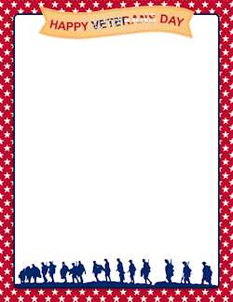

Dear Families,

Veterans Day is a holiday we celebrate to show thanks for our Veterans. Veterans are men and women who served in the armed forces in our country. This means that they are a part of the U.S. military. Veterans include those who were in the Army, Navy, Coast Guard, Air Force, or Marines.
It takes bravery and honor to serve in the U.S. military. Many people in our military need to travel far from their families for long periods of time. They miss holidays, birthdays, and special family events. The members of our military also risk their lives as their work is very dangerous. They do it because they know that their job is important to keeping our country safe!
Veterans Day is celebrated on November 11th. The reason it is celebrated on the 11th is because fighting in World War I ended on the 11th day of the 11th month at the 11th hour. On Veterans Day, many people choose to honor veterans in different ways. Schools, post offices, banks and many other businesses close and take a day off to honor Veterans Day. Some people write letters to thank veterans for their service.
In honor of our veterans, we will be having a BBQ at Veterans Elementary on Friday November 10, 2017 from 11:30 a.m.-1:30 p.m. for all the veterans in our community. If you are a veteran or know a neighbor, community member, or family member who is, please call 813-346-1400 to RSVP or email Sharon Zurita at szurita@pasco.k12.fl.us. Please RSVP by November 3rd. Thank you.
