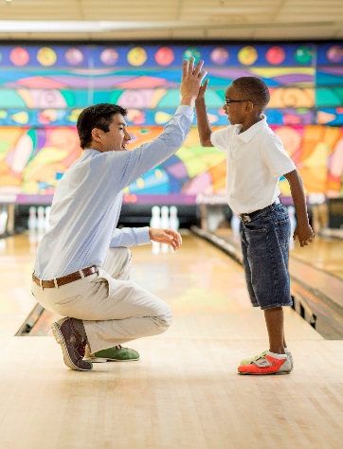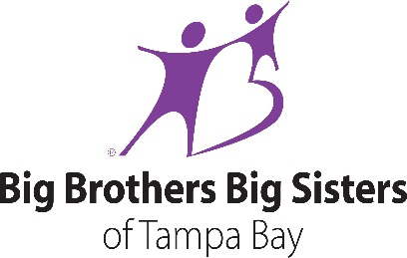

Being a Big often means including your Little in things you already like to do — going to a game, taking a bike ride, or reading books. You can help change the lives of children facing adversity for the better, forever.

*The first step is to attend a Big Orientation & Training session.*

*(Pasco County Dates)*

For more information, contact Deb Kristol-Irwin at – [DebK@bbbstampabay.org](mailto:DebK@bbbstampabay.org) (or) 813-997-6881

No RSVP required to attend any of our orientations –

**BBBSTAMPABAY.ORG**

***June 3rd (Saturday)* Starts at 10:30am – noon**

**New Port Richey Recreation & Aquatic Center - 6630 Van Buren, New Port Richey**

***June 12th (Monday)* Starts at 5:30pm-7pm**

**Rasmussen College- 18600 Fernview Street, Land O’ Lakes**

***June 27th (Tuesday)* Starts at 5:30pm -7 pm**

**Wesley Chapel Honda -27750 Wesley Chapel Blvd., Wesley Chapel**

**July 1st (Saturday) Starts at 10:30am - noon**

**New Port Richey Public Library - 5939 Main Street, New Port Richey**

**July 10th (Monday) Starts at 5:30-7p.m.**

**WellCare, 5113 US Highway 19, New Port Richey, FL 34652**

**July 25th (Tuesday) Starts at 5:30-7 p.m**

**Wesley Chapel Honda -27750 Wesley Chapel Blvd., Wesley Chapel**

Have you ever thought about becoming a Big Brother or Big Sister?