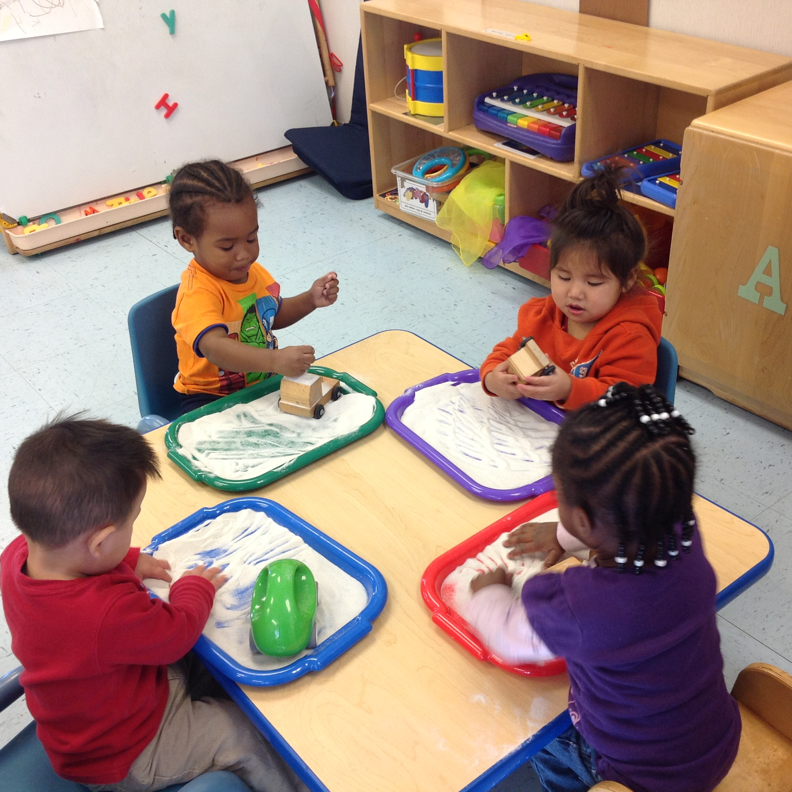
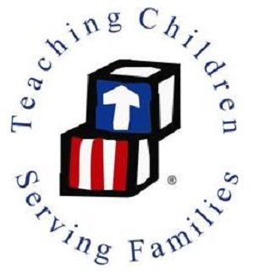
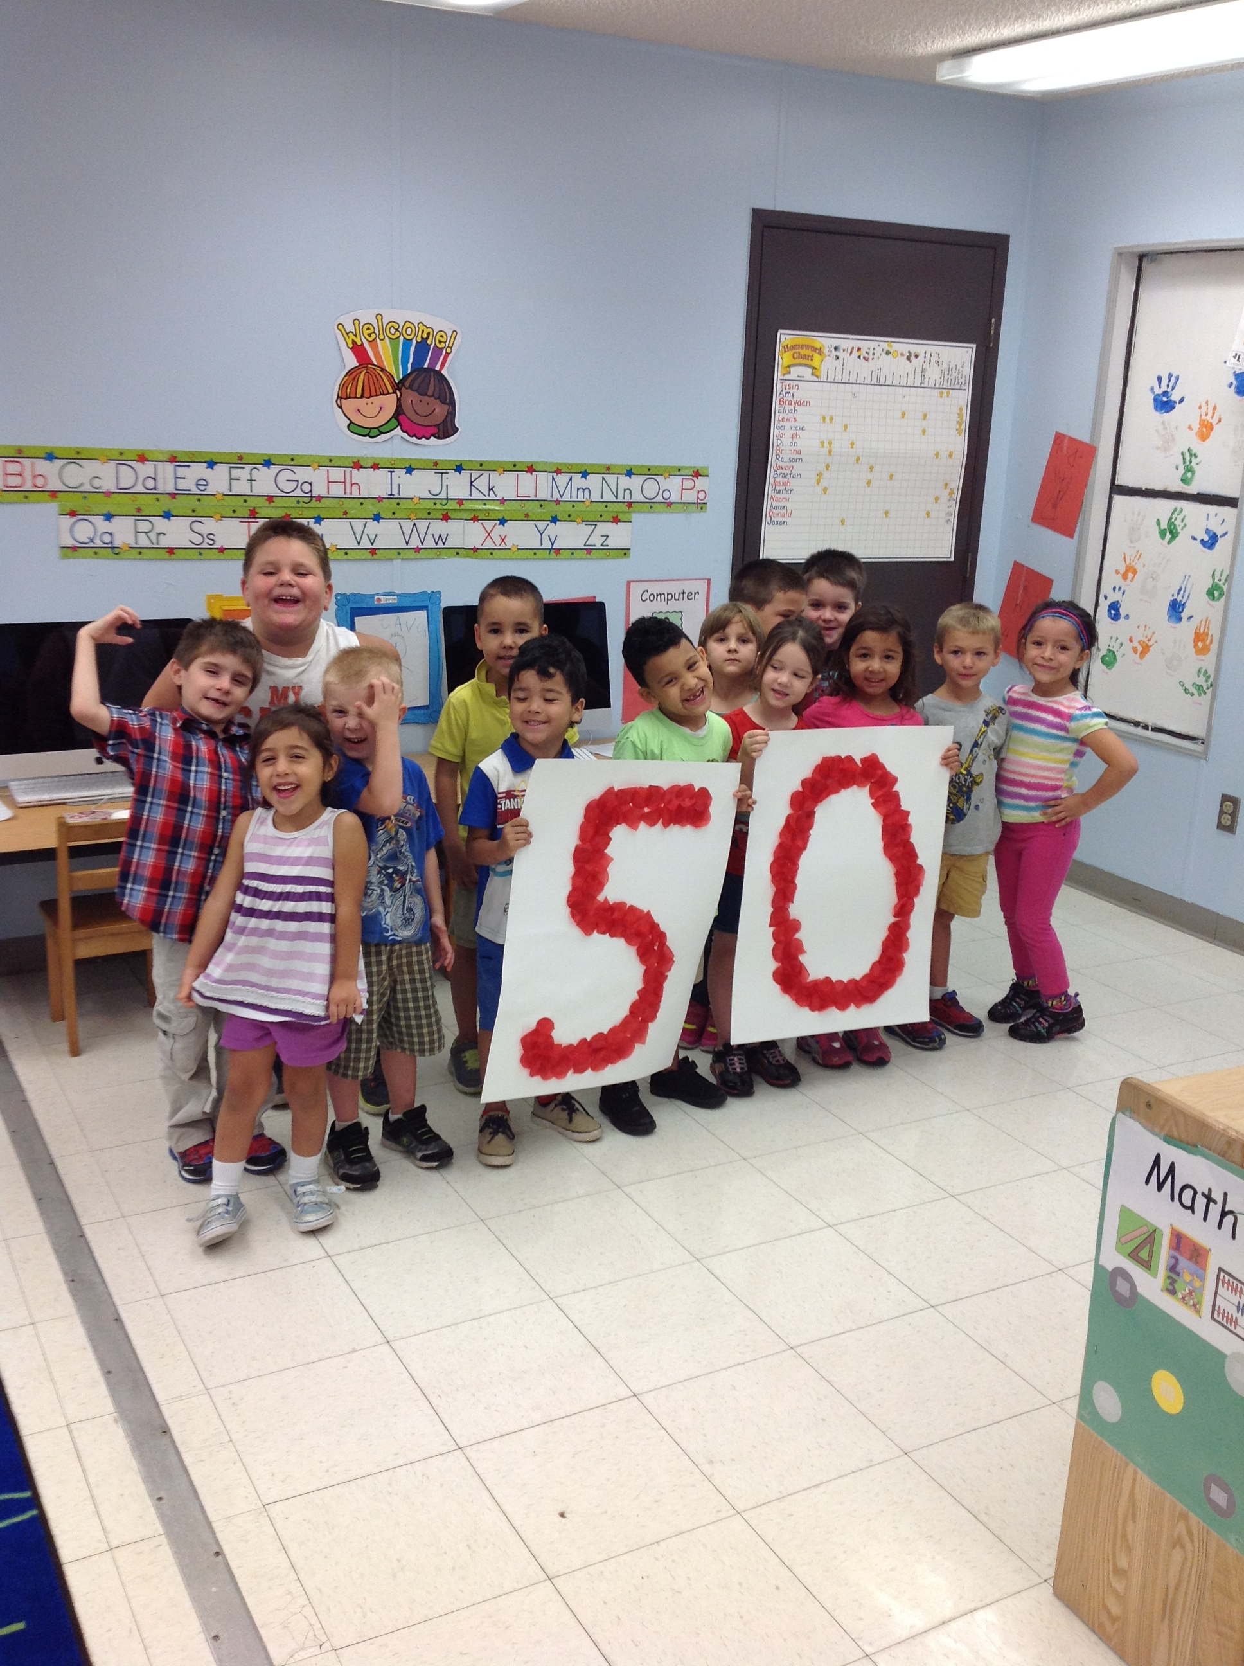
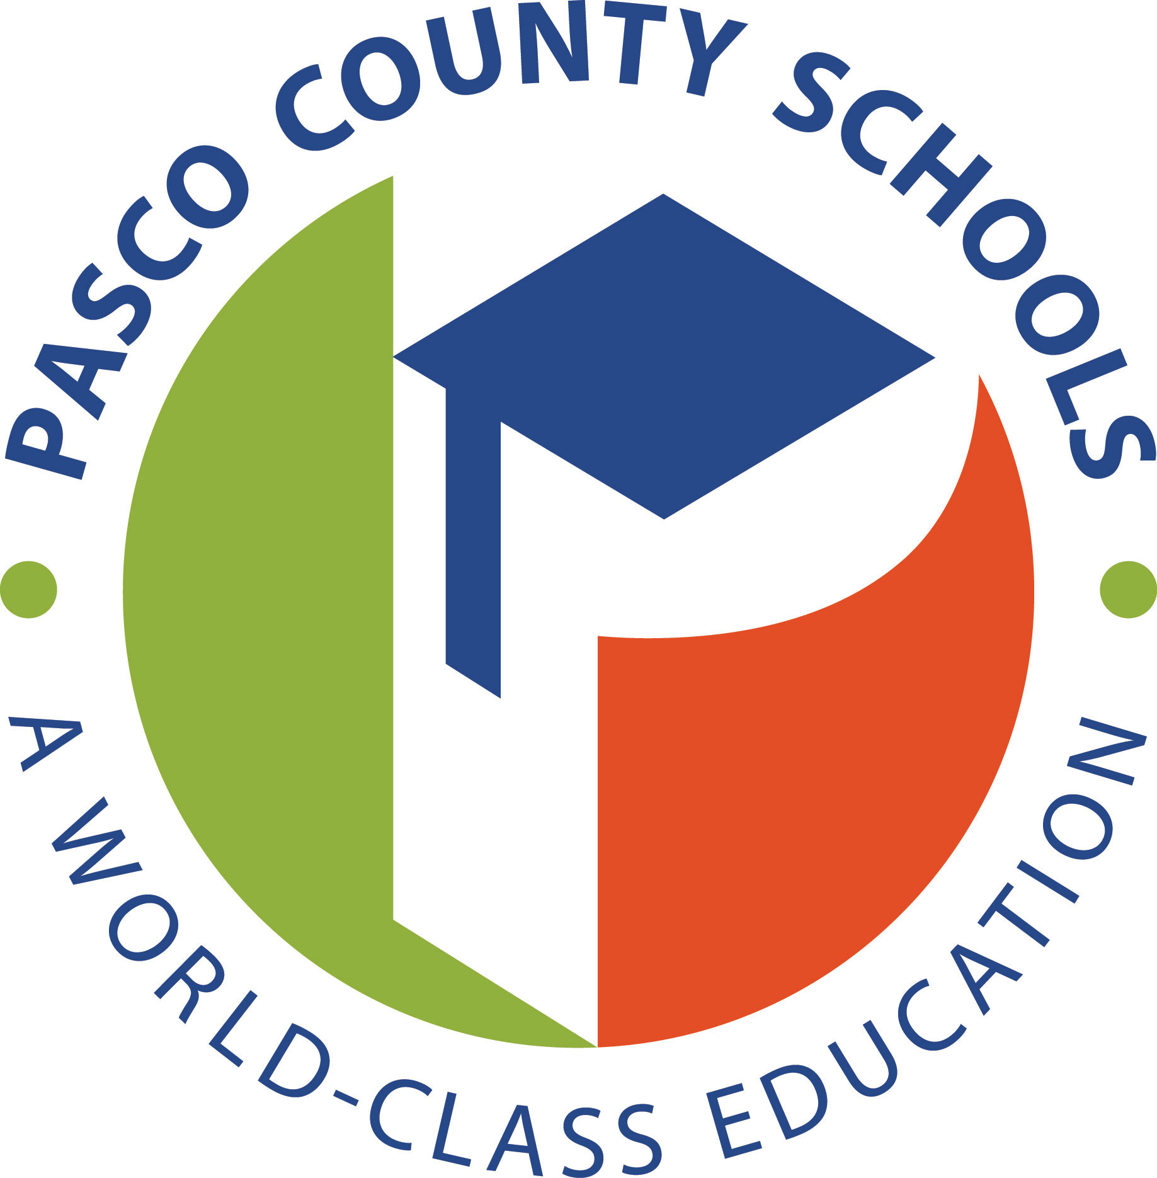

Early Childhood Programs

Annual Report

2014-2015

Angela Porterfield, Director
aanglinp@pasco.k12.fl.us

727-774-2730, 813-794-2730, 352-524-2730

Our School District’s Mission:
Providing a world-class education for all students.

Our Head Start/Early Head Start Mission:
To serve families so that all children can learn and grow in a healthy, nurturing environment.

Program Overview

HEAD START / EARLY HEAD START
The District School Board of Pasco County is a Head Start / Early Head Start grantee. Through this federally funded grant, high quality early childhood services promoting school readiness are offered to enrolled children and families from pre-birth through age 5.
PROGRAM DESCRIPTION
The federal Office of Head Start provides grants to local public and private non-profit and for-profit agencies to provide comprehensive child development services to economically disadvantaged children and families, with a special focus on helping preschoolers develop School Readiness in the areas of early reading, mathematics and social skills. In FY 1995, the Early Head Start program was established to serve children from birth to three years of age in recognition of the mounting evidence that the earliest years matter a great deal to children's growth and development. In 2003, the District School Board of Pasco County was awarded the Early Head Start grant.

Head Start programs promote school readiness by enhancing the social and cognitive development of children through the provision of educational, health, nutritional, mental health and disabilities and other services to enrolled children and families. They engage parents in their children's learning and help them in making progress toward their educational, literacy and employment goals. Significant emphasis is placed on the involvement of parents in the governance of local Head Start programs.

PROGRAM SERVICES

Early Childhood Development and Health
The Office of Head Start’s commitment to wellness embraces a comprehensive vision of health for children, families, and staff to support school readiness. The objective of our program is to ensure that, through collaboration among families, staff, and health professionals, all child health and developmental concerns are identified, and children and families are linked to an ongoing source of continuous, accessible care to meet their basic health needs.

The objective of education and early childhood development is to provide all children with a safe, nurturing, engaging, enjoyable, and secure learning environment, in order to help them gain the awareness, skills, and confidence necessary to succeed in their present environment, and to deal with later responsibilities in school and in life. Each child is treated as an individual in an inclusive community that values, respects, and responds to diversity within the program’s communities. The varied experiences provided by the program support the continuum of children’s growth and development, which includes the physical, social, emotional, and cognitive development of each child.

Family and Community Engagement
Head Start offers parents opportunities and support for growth, so that they can identify their own strengths, needs and interests, and find their own solutions. The objective of Family Partnerships is to support parents as they identify and meet their own goals, nurture the development of their children in the context of their family and culture, and advocate for communities that are supportive of children and families of all cultures. The building of trusting, collaborative relationships between parents and staff allows them to share with and to learn from one another. Our program follows Head Start’s Parent, Family and Community Engagement Framework as a model of meeting the needs of our families to support self-resiliency and -sufficiency.

Head Start serves families within the context of the community, and recognizes that many other agencies and groups work with the same families. The objective of Community Partnerships is to ensure that grantee and delegate agencies collaborate with partners in their communities, in order to provide the highest level of services to children and families, to foster the development of a continuum of family centered services, and to advocate for a community that shares responsibility for the healthy development of children and families of all cultures.

VOLUNTARY PREKINDERGARTEN (VPK)
VPK is a state funded early learning program designed to prepare children for success in kindergarten. Prekindergarten Services offers VPK during the school year to Head Start children as part of a blended funding model, which includes 540 hours of instruction. Eligible Pasco County children who do not participate in any school year VPK program have an opportunity to attend Summer VPK offered through Early Childhood Programs or private providers.
Annual Performance Indicators
2014 - 2015

Highly Qualified Staff
- 100% of Head Start teachers hold Florida State Teacher Certificates in Early Childhood Education
- 100% of Head Start teachers hold a minimum of a Bachelor’s Degree
- 82% Teacher Retention
- 99% of Head Start instructional assistants have a Child Development Associate (CDA) equivalency, AA, or BA degree. The remaining 1% are enrolled in programs to complete a CDA, AA, or BA.
- 100% of Early Head Start Caregivers have a CDA equivalency, AA, or BA degree.

Early Head Start
Funded enrollment | 128
Total Number of Children/Families served | 172
Average Monthly Enrollment  (% funded enrollment) | 100%
Children who received dental exams | 67%
Children who received medical exams | 84%
Children up-to-date on immunizations | 84%
Children with Individual Education Plan or Individual Family Service Plan | 7%
Volunteer & Meeting hours | 1,104
Meals Served | 35,549
Head Start
Funded Enrollment | 696
Total Number of Children/Families served | 747
Average Monthly Enrollment  (% funded enrollment) | 100%
Children who received dental exams | 98%
Children who received medical exams | 96%
Children up-to-date on immunizations | 98%
Children with Individual Education Plans (IEP) | 18%
Volunteer & Meeting Hours | 11,097
Meals Served | 320,119
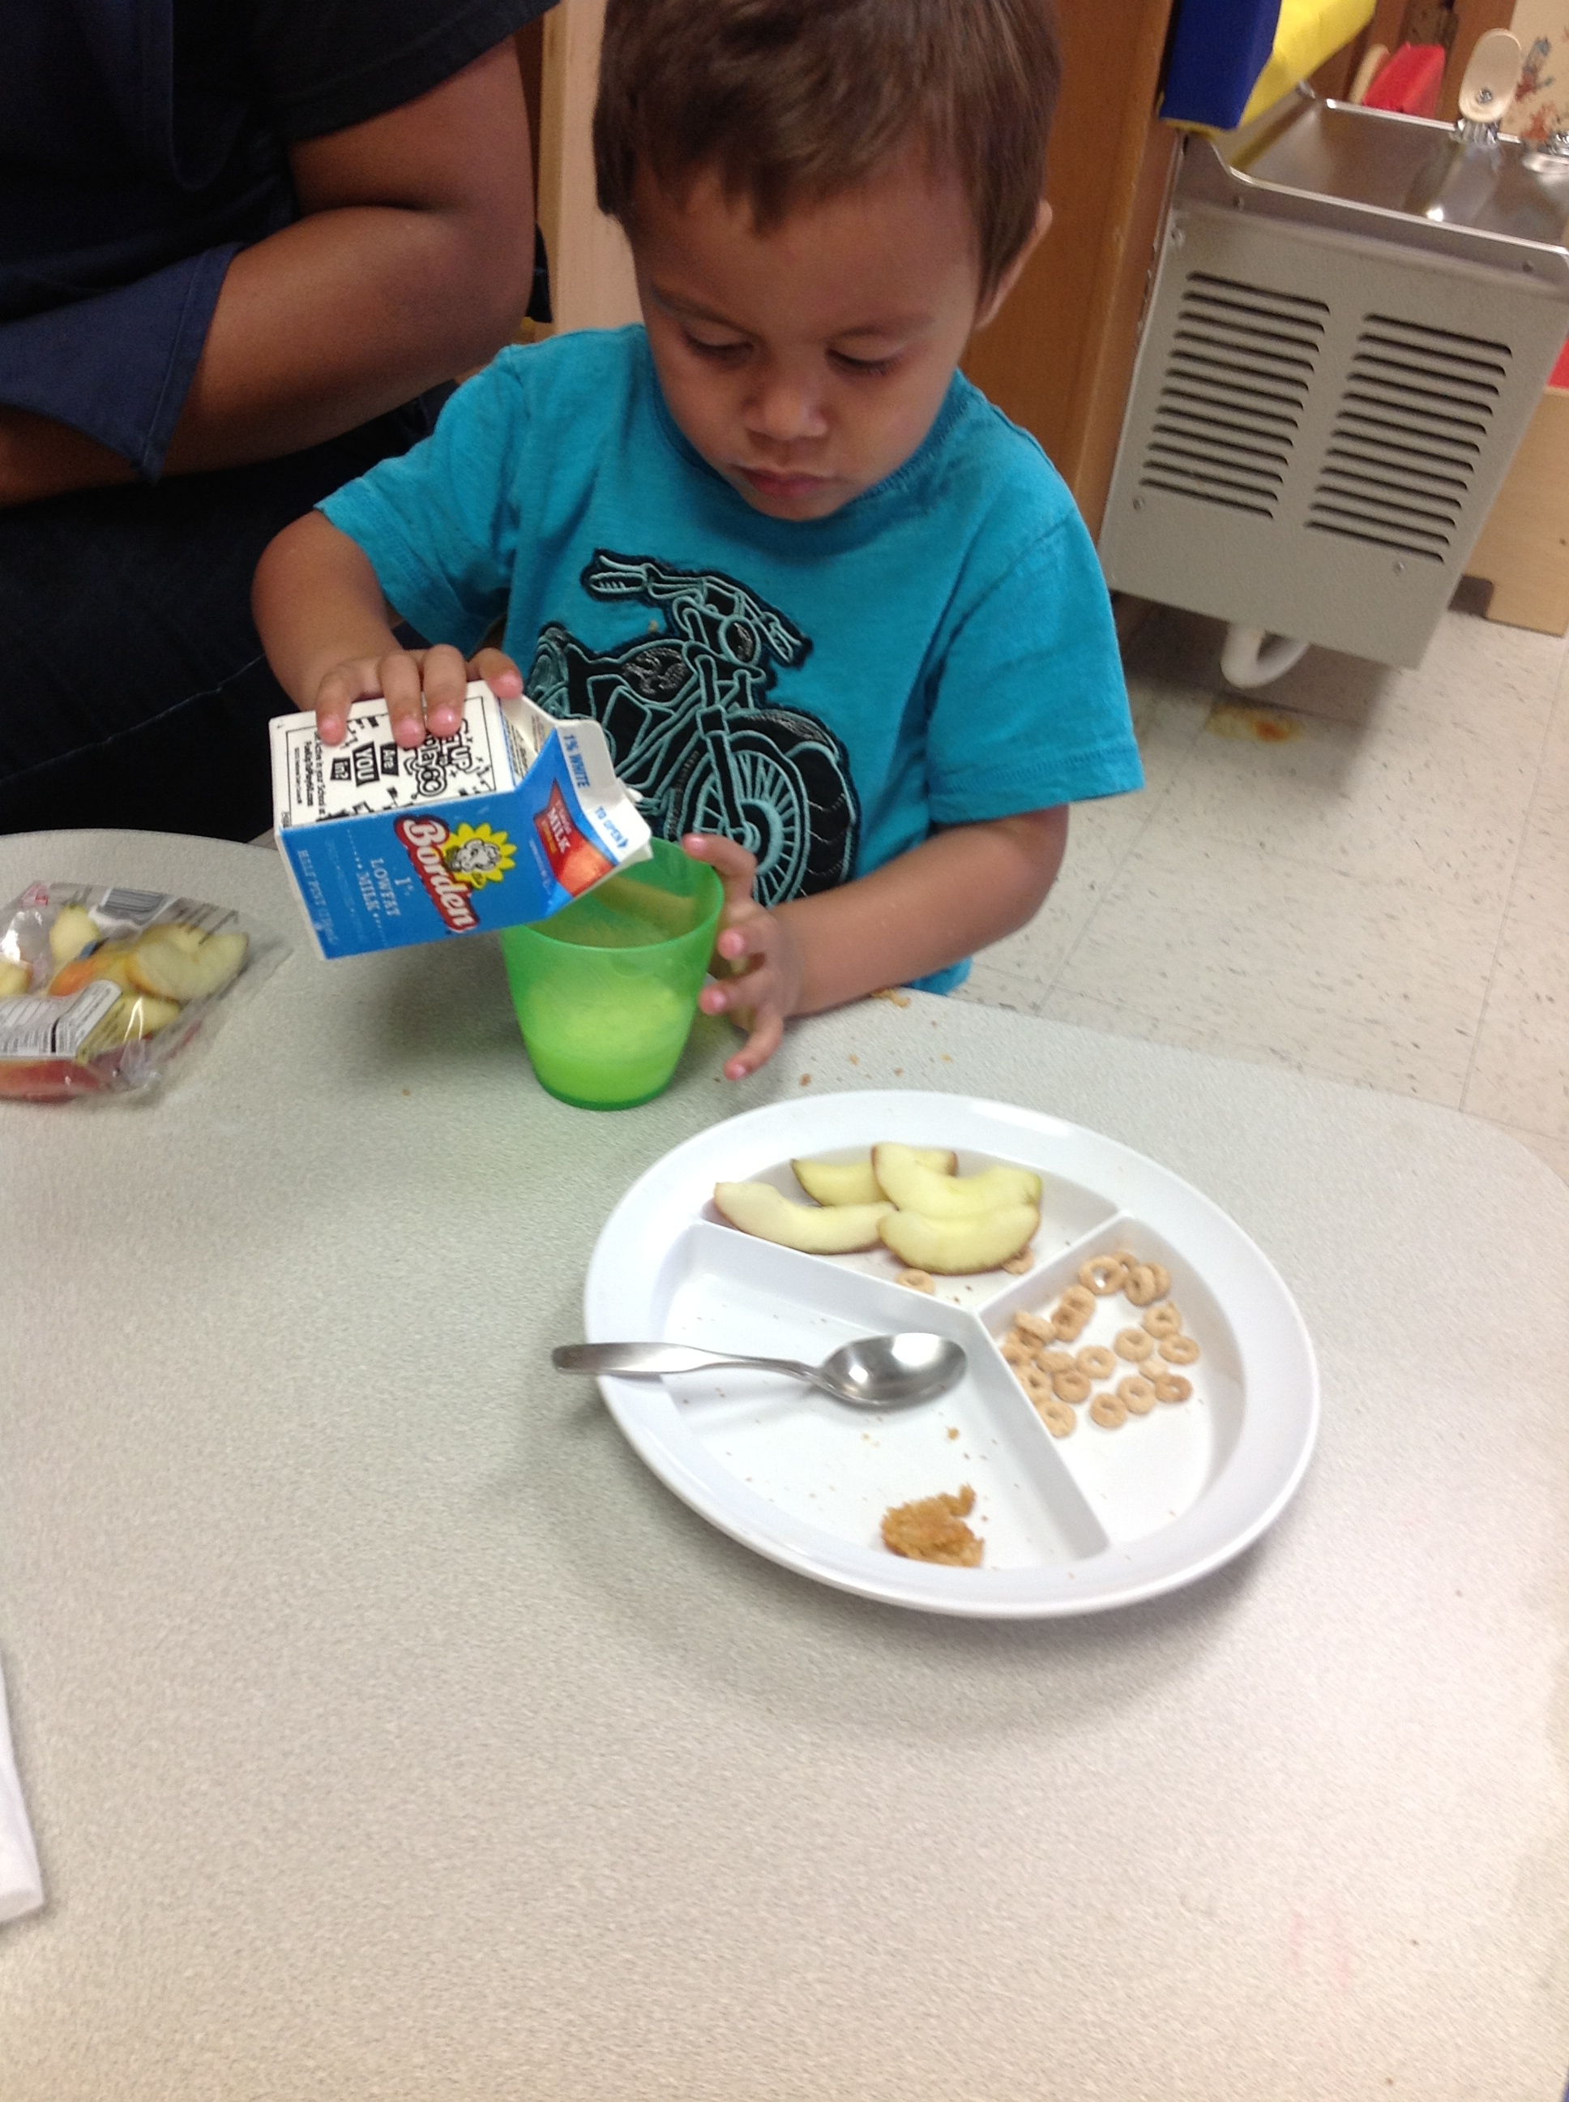
Who We Are & Who We Serve
The Families We Serve
- 38% Unemployed
- 7% Homeless
- 25% of families receive WIC
- 23% of parents have less education than high school diploma
- 51% single family homes

- 38% Hispanic
- 14% Black or African American
- 8% Biracial/Multi-Racial
- 21% Dual Language Learners (Spanish)
- 16% Children with Disabilities
- 16% Families on Public Assistance

- 100% of parents responded they were involved in developing educational goals for their child.
- 100% of parents reported that the classrooms/Early Head Start Socialization has an open/welcoming atmosphere.
- 98% of families felt the family engagement activities, speakers and handouts were valuable.
- 98% of parents reported that their children made social and emotional progress.
- 94% of parents reported that their children made progress in his/her mathematics skills.
- 97% of parents stated that their questions and concerns about services and resources for their family were addressed by program staff.
- 96% of parents reported making progress towards their family’s goals, as well as future goals.
- 98% of parents responded that, if needed, materials and interpreting in my home language were available for parent activities and home visits.

Parent
Survey Results
2015
Family Engagement

POLICY COUNCIL
One of the unique characteristics of Head Start/Early Head Start is that parents are partners in leading the program governance. The Policy Council is designed to provide parents the opportunity to participate in the shared governance of our program. Annually parents elect other parents to participate on the Policy Council as their school site representative. In addition to monthly meetings, School Readiness Advisory Committees are created to work on special projects, and review/approve policies & procedures.
VOLUNTEER OPPORTUNTIES
We welcome and encourage families to volunteer in the classrooms and participate in school activities with their children. Volunteers are celebrated at our annual volunteer appreciation luncheon.
PARENT ENGAGEMENT ACTIVITIES
Regularly scheduled Head Start/Early Head Start Parent Meetings are conducted at each site throughout the program year. These meetings allow families an opportunity to attend presentations by educational and community guest speakers. These presentations focus on children’s growth and development, as well as to provide educational experiences to transfer into the home setting. In addition, regional trainings are also offered based on the interest level and need of parent groups. Topics have included Active Parenting, Family Fiscal Literacy and English Language Survival Skills for Families classes. Finally, program staff created and facilitated regional educational parent support opportunities focused the Head Start Parent, Family and Community Engagement Framework (PFCE) including parent advocacy, parenting skills and family literacy skills.
FAMILY RESOURCE NIGHTS
Twice a year, the Head Start/Early Head Start program invites families and community members to attend our Family Resource Night. This year’s activities focused on nutritional meal planning with the importance of movement and music incorporated through I am Moving, I am Learning activities and resources to take home and play with both indoors and outdoors. Our Head Start/early Head Start Health Team facilitated the singing, dancing and gross-motor movement through a family-style indoor obstacle course that could be made at home! This event offers parents an opportunity to connect with community-based agencies, learn parenting techniques, and enjoy a family night out singing, dancing and experiencing healthy snack ideas together!

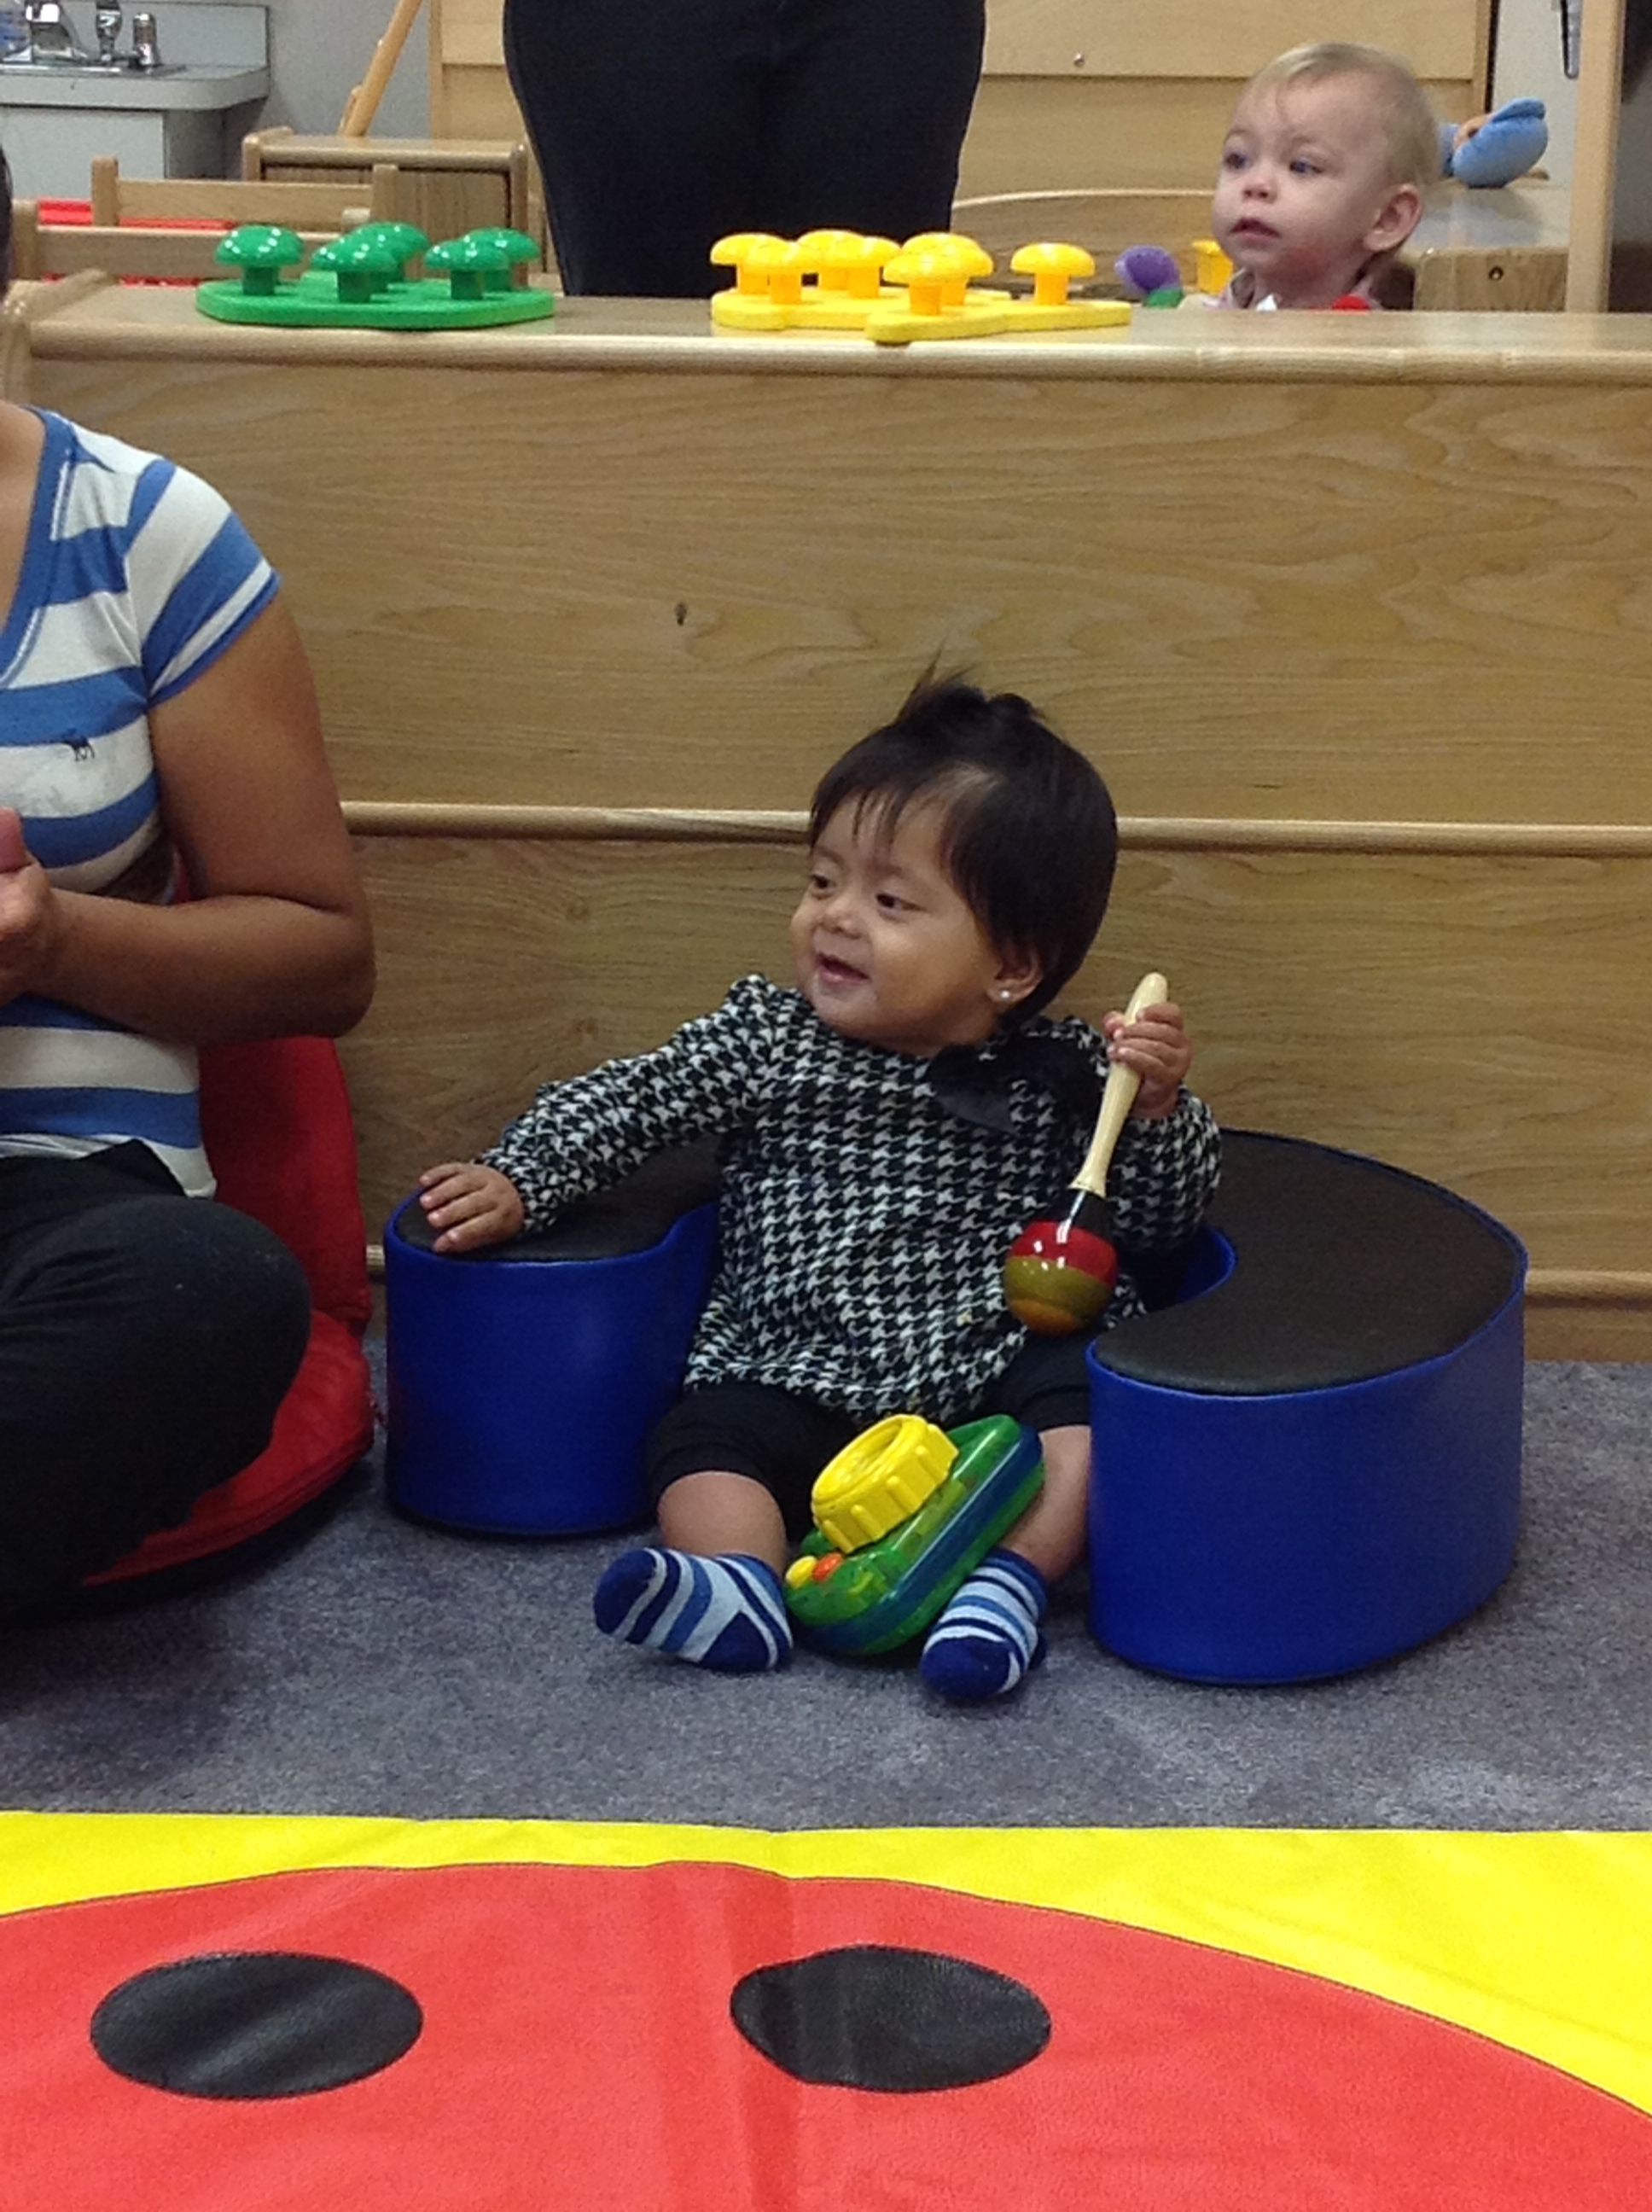
Fiscal Reporting – Single Audit Findings
- None Reported
Triennial Federal Monitoring Review Findings
- A triennial Federal Monitoring Review was conducted in March 2014.
- The program was acknowledged for being in full compliance within ALL areas.
- The areas examined within the Triennial Review were:
  - Program Governance
  - Management Systems
  - Fiscal Integrity
  - Eligibility, Recruitment, Selection, Enrollment & Attendance (ERSEA)
  - Child Health and Safety
  - Family and Community Engagement
  - Child Development and Education

Head Start/Early Head Start Grant $4,594,311
Early Head Start Grant $1,884,784
Total Program Funding $6,584,569

Total Non-Federal Share of Matching Funds $1,646,142
Florida Voluntary Prekindergarten (VPK) $1,372,650
Early Childhood Programs Funding FY 2014-2015
FY 2014-15Head Star/Early Head Start Program Budget Expenditures – PROJECTED AND ACTUAL
 | Head Start/Early Head Start  PROJECTED | Head Start/Early Head Start  ACTUAL | % of Federal Grant Funds  PROJECTED/ ACTUAL
Personnel | 3,672,057 | 3,724,528 | 55.7% / 56.56%
Fringe Benefits | 1,278,566 | 1,359,029 | 19.42% / 20.64%
Travel | 200 | 0 | 0% / 0%
Equipment | 92,800 | 88,500 | 1.14% / 1.34%
Supplies | 223,298 | 151,225 | 3.39% / 2.30%
Contractual | 424,500 | 398,443 | 6.45% / 6.05%
Other | 516,146 | 438,979 | 7.84% / 6.67%
Indirect Charges | 271,528 | 318,391 | 4.12% / 4.84%
Training & Technical Assistance | 105,474 | 105,474 | 1.60% / 1.60%
Total Direct/Indirect | 6,584,569 | 6,584,569 | 100%
Non-Federal Share | 1,646,143 | 1,646,143 | 20%
Total Budget 2014-2015 | 8,230,711 | 8,230,711
Art in Action! Process Art for Infants and Toddlers
In the fall of 2013, the Early Head Start program began providing after hours training opportunities for Caregivers and Home Services Workers. A topic that staff members particularly enjoyed and infused into daily process was Process Art.
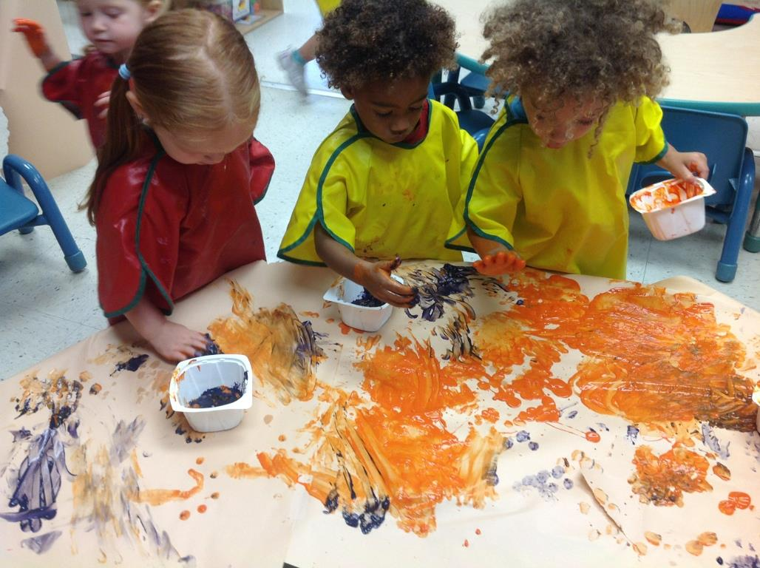
For infants and toddlers, art is a VERB, not a noun. It is all about the action and the experience, not about having a ‘finished’ product. Squeezing all of the glue out of the bottle, putting sticker after sticker on a piece of paper, smearing paint with their fingers are (and should be) satisfying experiences in and of themselves for our children. It is our program’s responsibility to provide children with a variety of art experiences every day to build a foundation for both appreciating and creating through art!
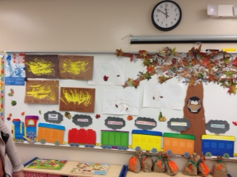
Keeping art alive in the lives of young children is key for providing the foundations for socio-emotional development and early writing skills!

English Survival Skills Course for Families
A tenet of the Head Start and Early Head Start programs is the ability to establish partnerships with families that focus on and promote school readiness of both children and adults. Within recent years, Social Services and English for Speakers of Other Languages (ESOL) staff members found through home visit information there was a need within the community for opportunities for parents to enhance their English speaking skills. Head Start/Early Head Start program staff collaborated with the Marchman Technical Education Center’s ESOL department to offer a course for our parents to become more integrated into society and feel more comfortable speaking with other English speaking individuals.
The pilot English Survival Skills Course (ESSC) was conducted in 2012-13 for 1 ½ hours each Friday for 6 weeks at Mittye P. Locke Elementary School. Curricular booklets with CD for home use, child care, refreshments, door prizes and a certificate of completion were provided for the 20 participants. Topics addressed within the course were:
- Health and Wellness
- Finance
- In the Workplace
- Education
- Citizenship and Civic Responsibility
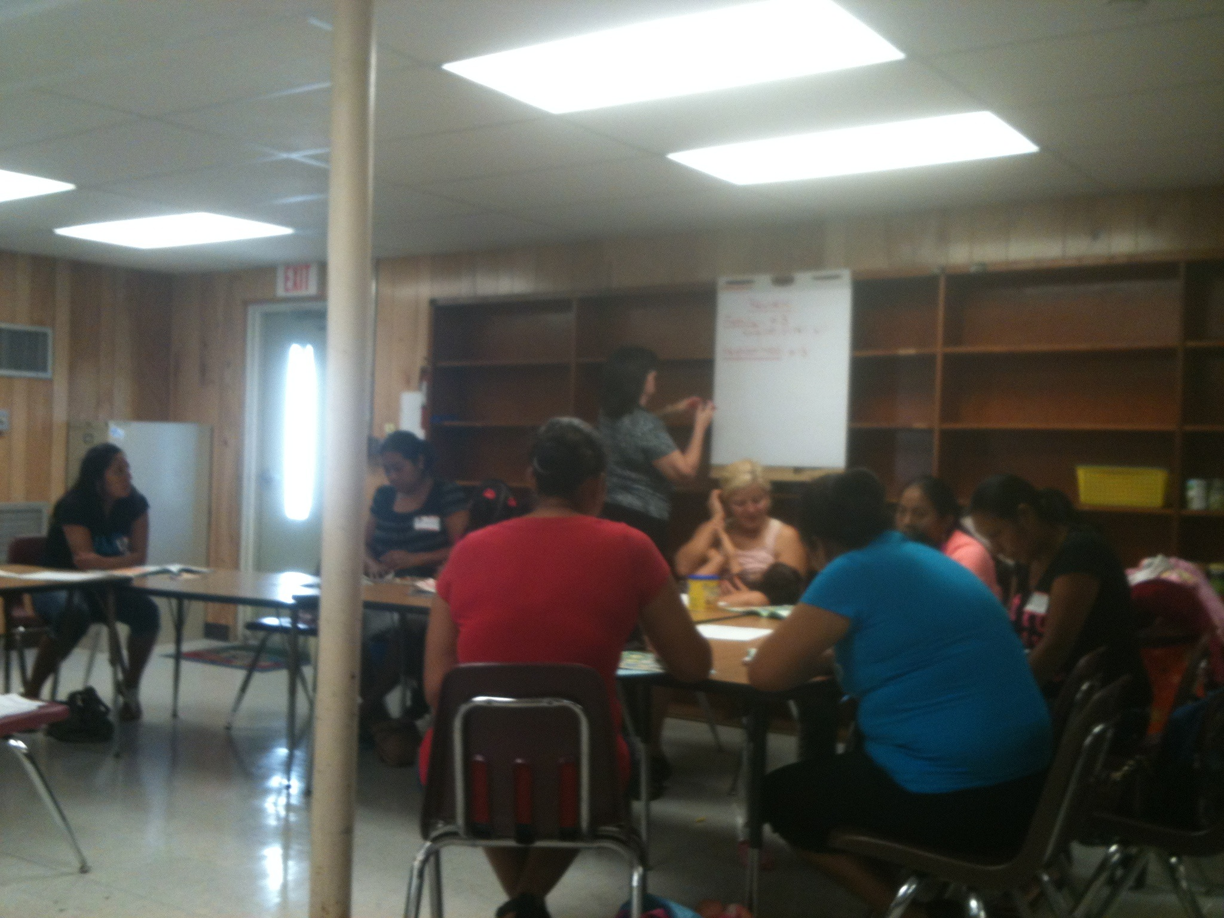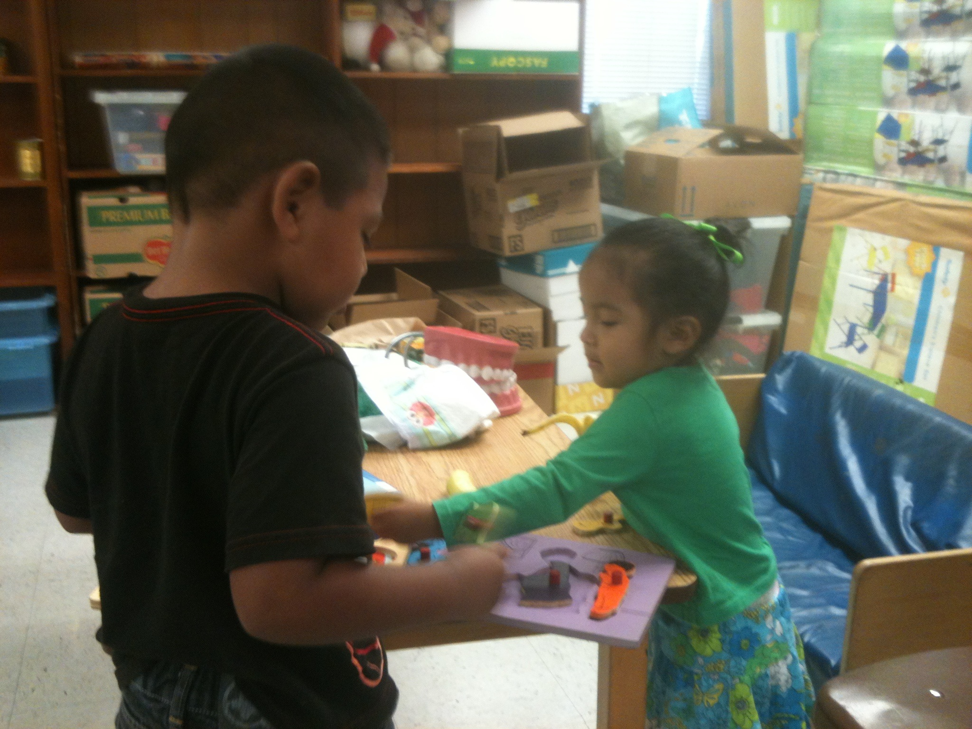
At the conclusion of the 6 week course, a cultural celebration was held to celebrate the parents’ accomplishments. Parents provided testimonials about how the class helped the parents become more engaged with their children and the educational process. Due to the success of this partnership, the ESSC was also extended thought the 2013-14 program year to parents at Pine View, Richey and Veterans Elementary Schools.
We are proud to share that in the 2014-15 program year, four more schools were able to provide this valuable resource to our Head Start/Early Head Start families across the ENTIRE service area. Future course offerings are currently being planned for the 2015-16 program year.

Special Initiatives
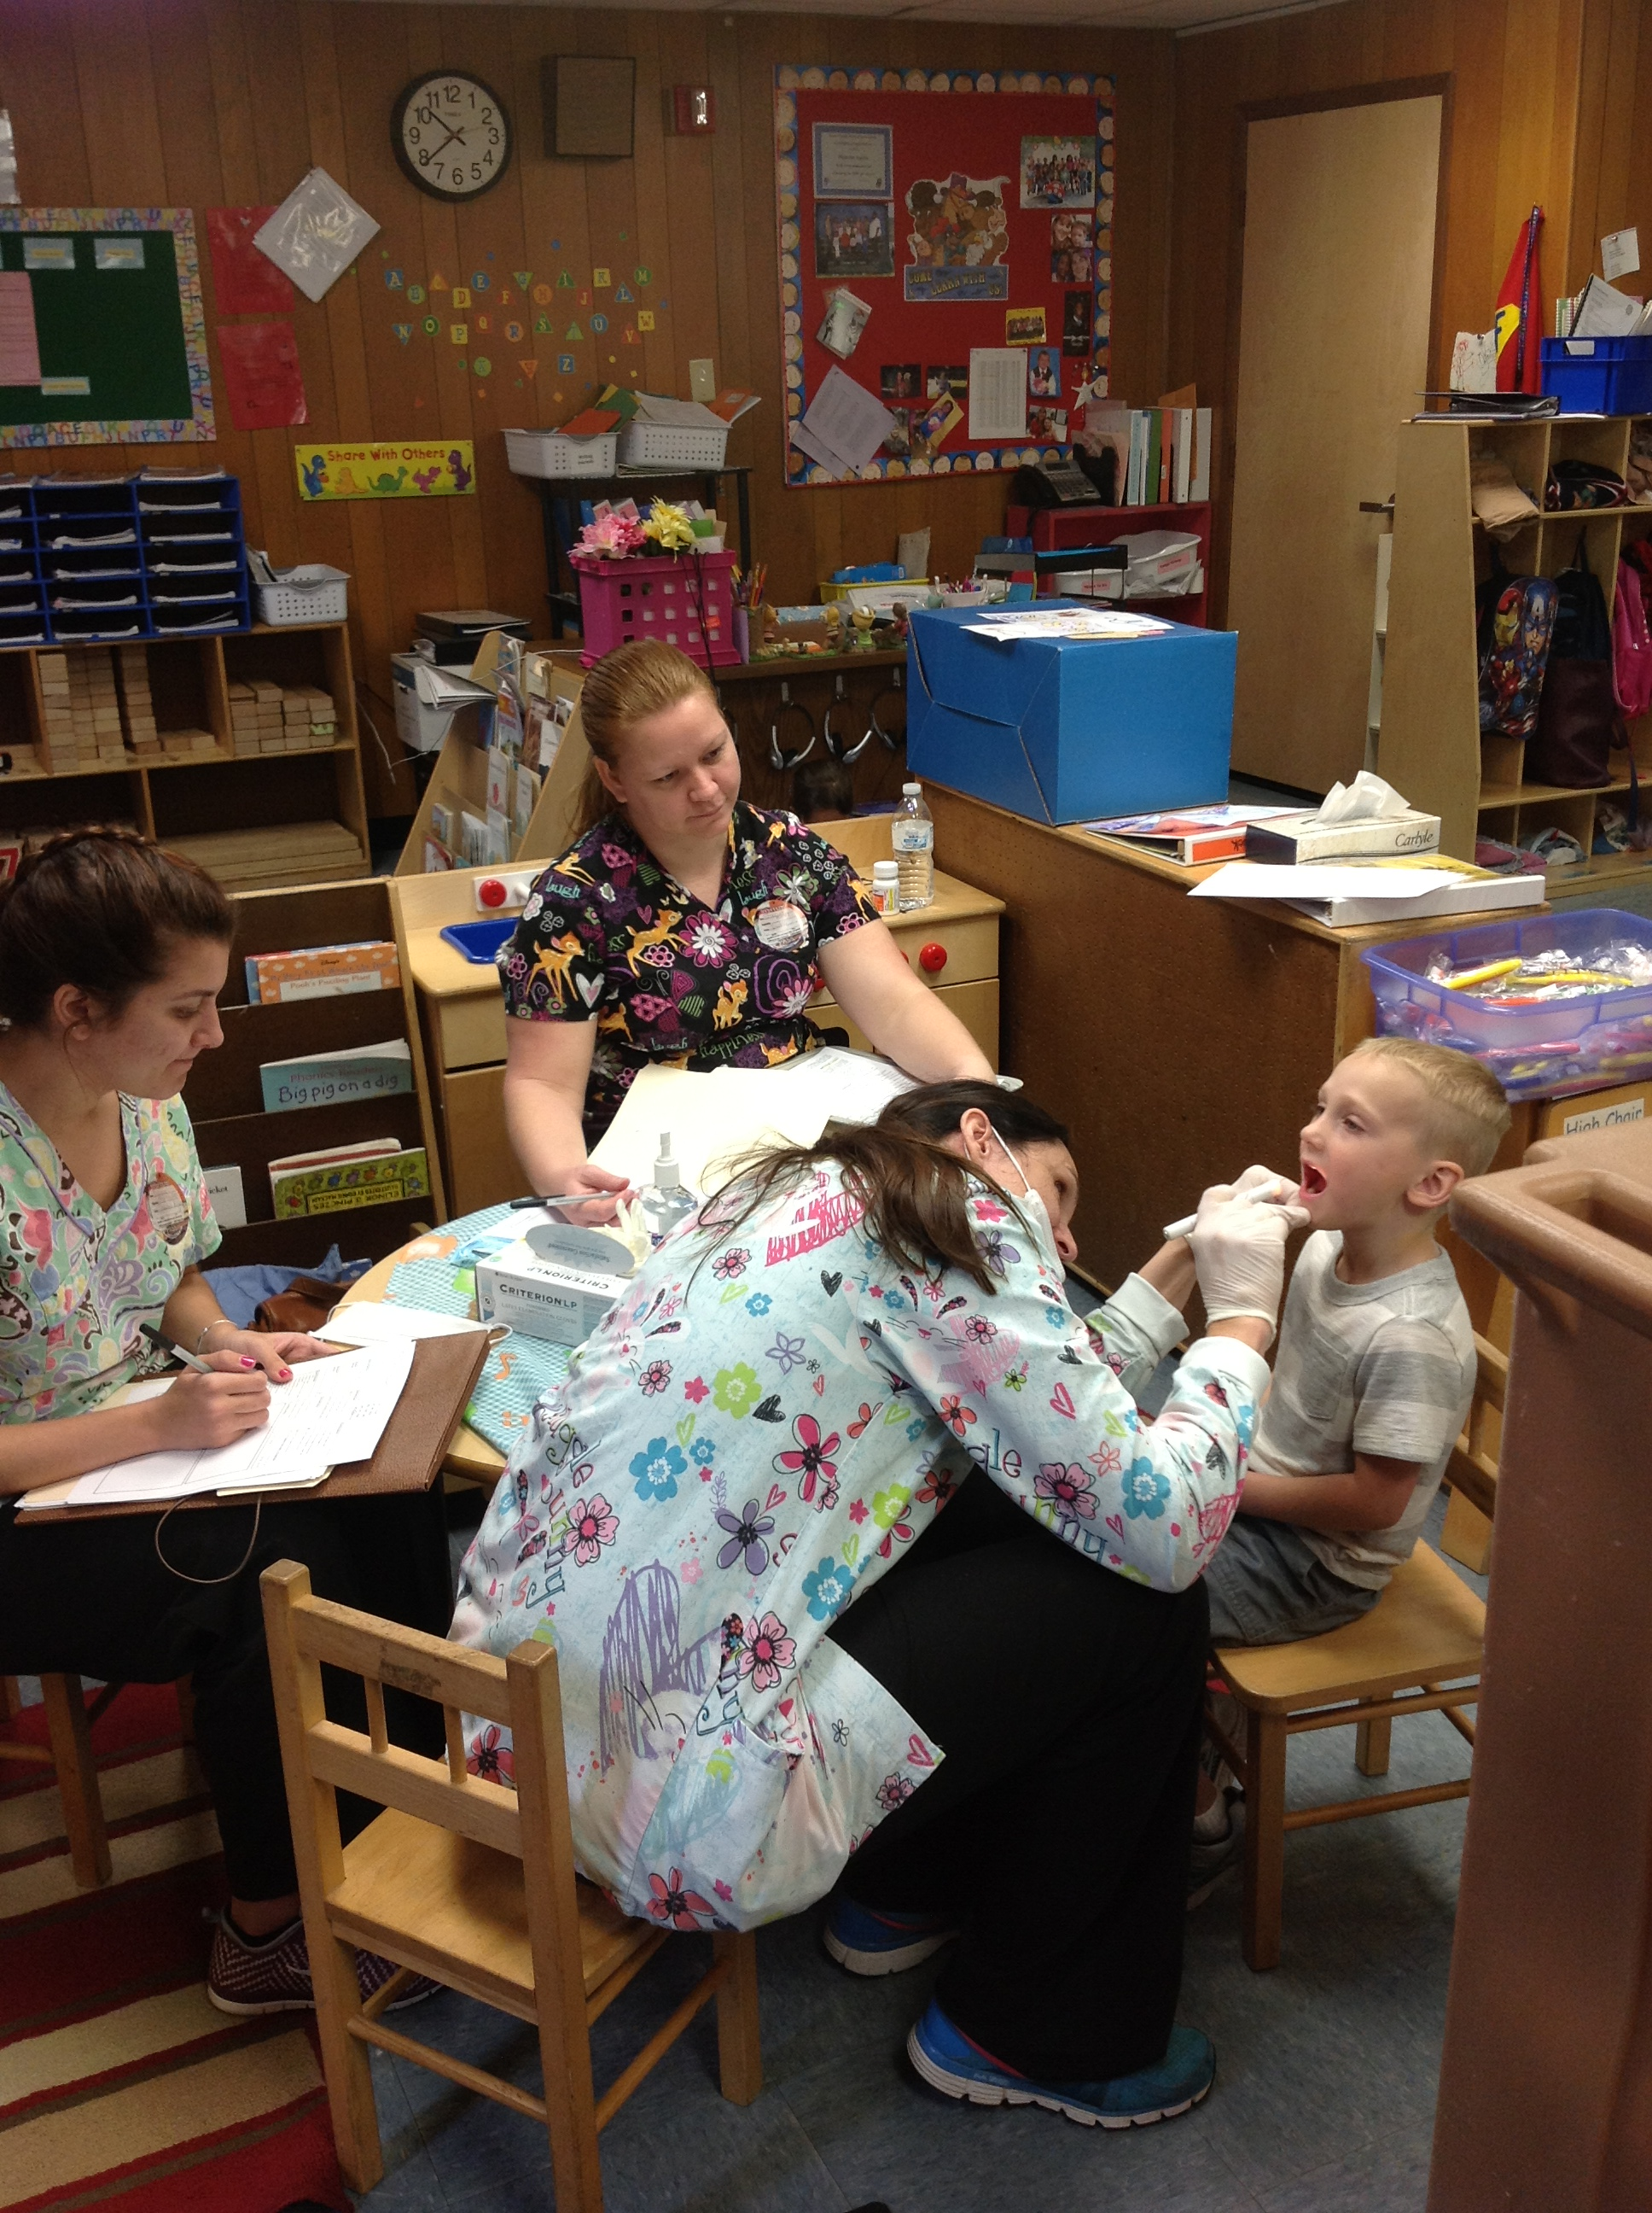
Hearing Outreach:
Early Childhood Hearing Outreach (ECHO)
According to the Centers for Disease Control and Prevention, nearly 5% of newborns in our country do not receive or pass a newborn hearing screening. For babies who do not pass the screening, further assessment is needed to determine whether the baby has hearing loss. Unfortunately, as many as half of these infants who need further screening or evaluation program are lost to follow-up as documented by state Early Hearing Detection and Intervention (EHDI) programs.
Since the fall of 2011, the Pasco County Early Head Start has partnered with the National Center for Hearing Assessment and Management on the Early Childhood Hearing Outreach (ECHO) initiative. This initiative requires trained Early Head Start staff members to complete the Octoacoustic Emissions (OAE) hearing screenings on all enrolled newborns and toddlers.
Overall in 2013-14, nearly 120 children were screened with the OAE tool while 78 toddlers were screened within the 2014-15 school year. Of the children screened with the OAE tool, 5% failed both screenings and received referrals for in-depth audiological services.
We are proud to report that Pasco County Early Head Start’s participation within the ECHO Hearing Outreach program has been cited in multiple professional journals. As such, the National Center for Hearing Assessment and Management has given permission for ALL Early Head Start AND Head Start children, birth through 5 years of age the ability to be screened through the ECHO program. All accepted Head Start and Early Head Start children will be screened with the OAE hearing assessment beginning summer 2015!

Dental Outreach
In the fall of 2011, the Pasco County Health Department began a dental outreach initiative with the District School Board of Pasco County. The Health Department provided a fluoride varnish program to children enrolled in 18 Head Start classrooms in the Dade City/Lacoochee area. For the past three program years, this outreach program occurred in all 38 Head Start classrooms. This special dental initiative helped protect our children’s teeth until their first molars appear at age 6 or 7. At this age, dentists are then able to provide dental sealants as a protective measure to promote healthy dental and physical health practices.

Special Initiatives

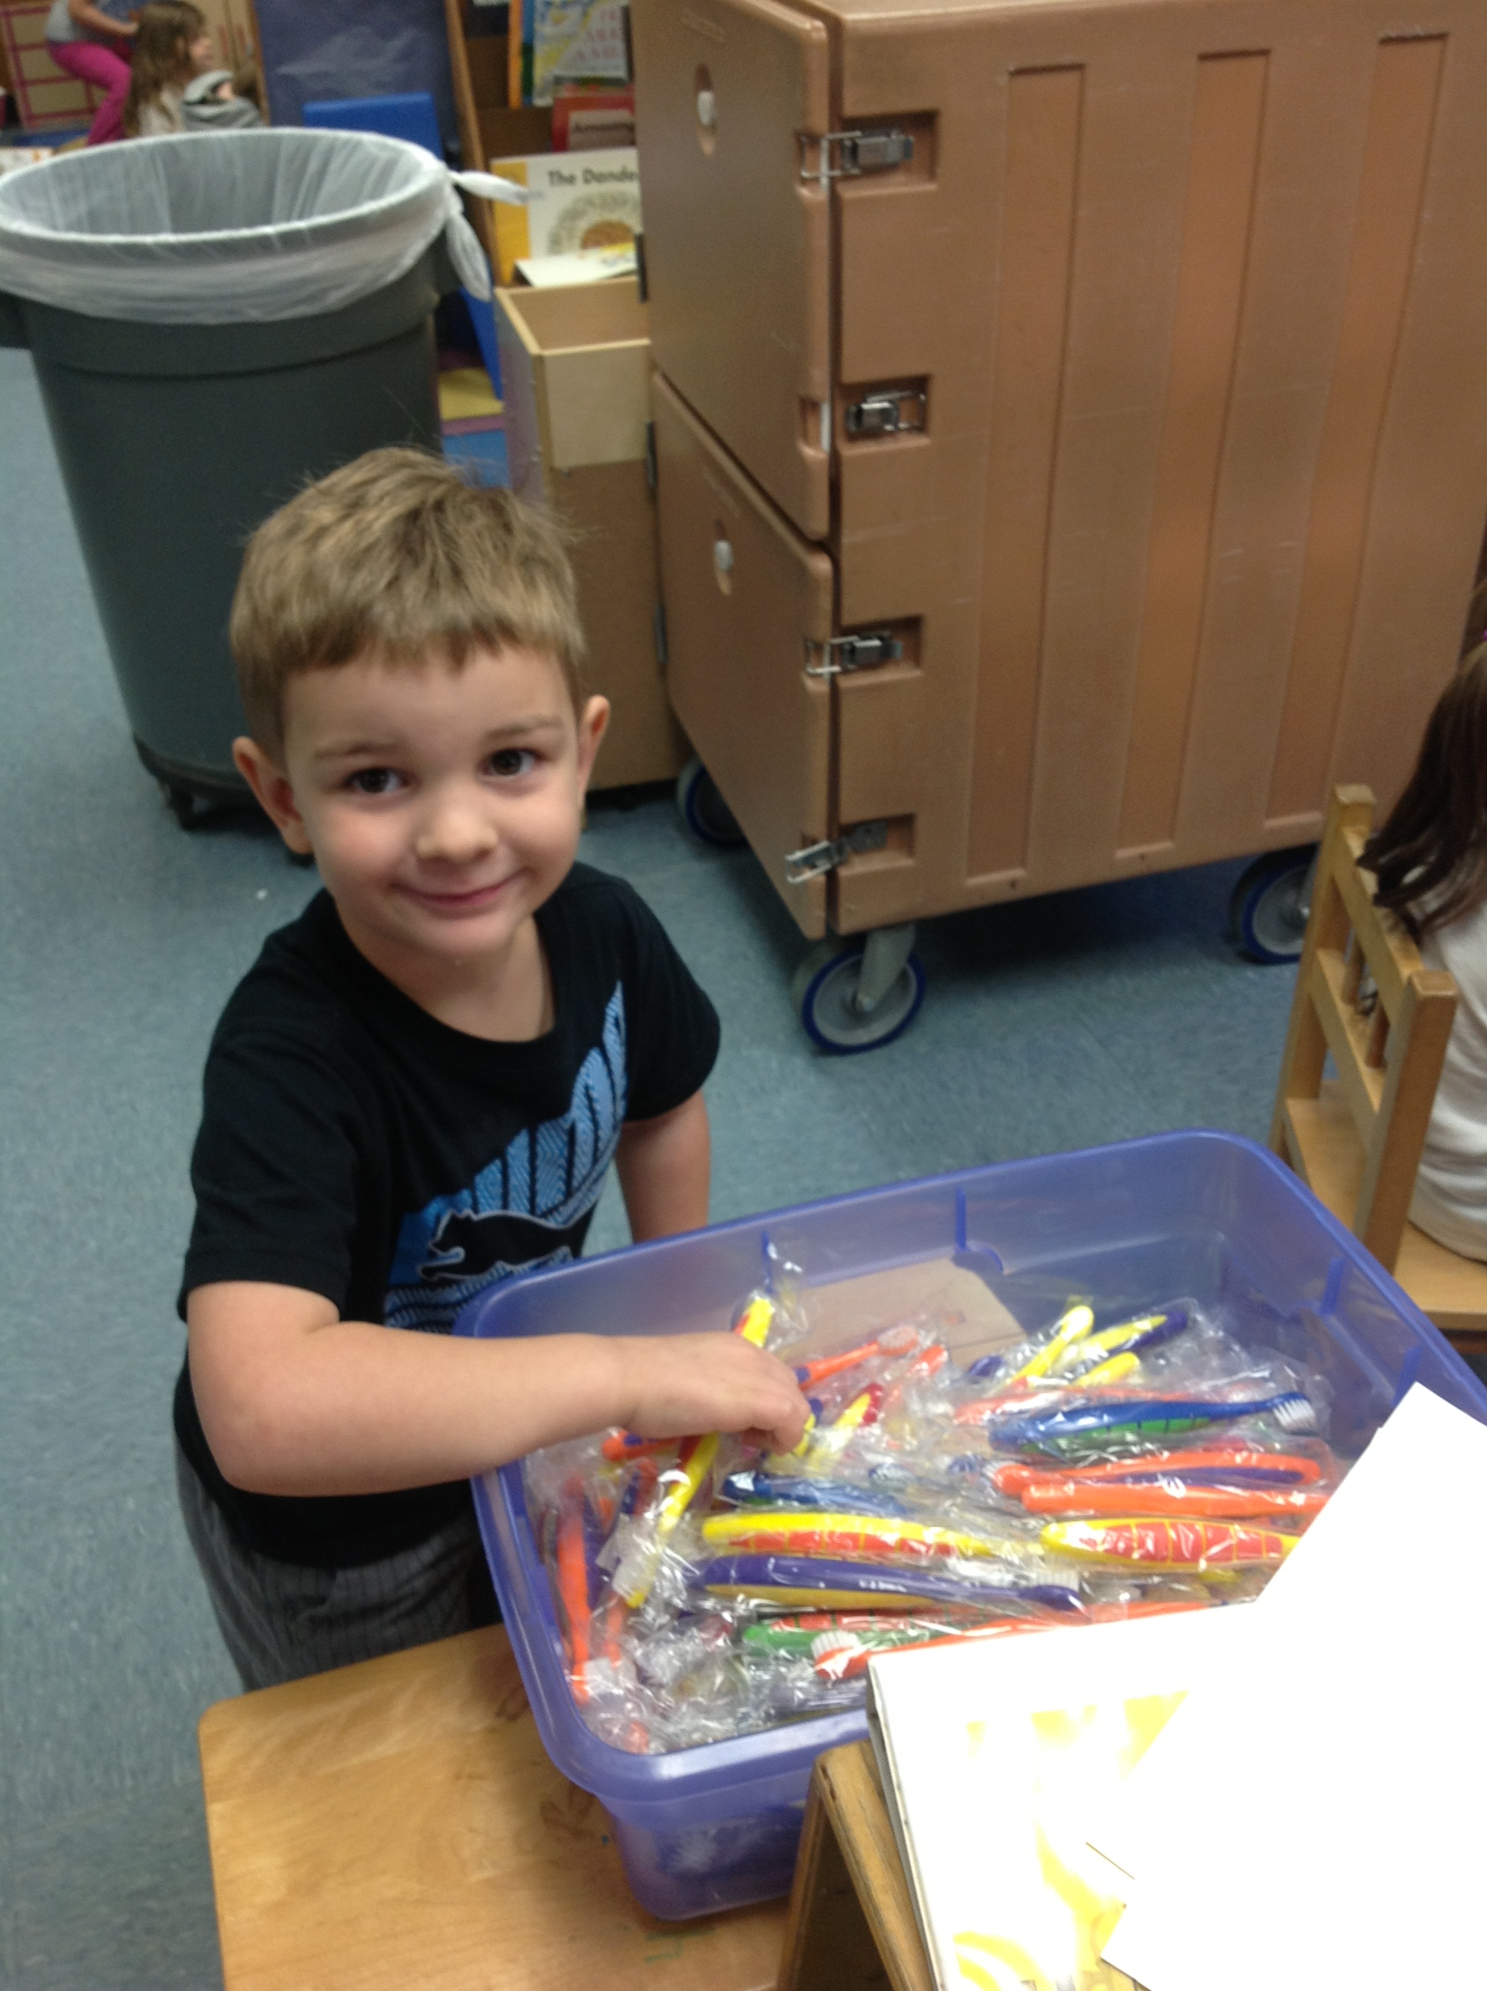

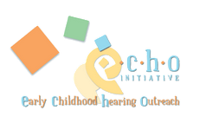

Baby Doll Circle Time Training
At the Early Head Start Preservice Meeting, staff were introduced this vital component of Conscious Discipline with toddlers. Baby Doll Circle Time processes are designed to intentionally help a child relive moments of attachment and bonding that they have experienced individually with either a caregiver or parent. The child and caregiver then recreate that experiences and feeling within the 10 minute Circle Time. Due to the detailed approach needed to model this process for toddlers, our Early Head Start staff are thrilled and eagerly awaiting their upcoming in-depth Baby Doll Circle Time training to be provided during the 2015-2016 program year.

Cardboard Challenge
Within the Teaching StrategiesTM Creative Curriculum, teachers/caregivers and children participate in active learning activities known as Investigations. Over the course of five weeks, children guide their learning of the investigation of a topic through their interests and questions about the topic.
During our Reduce, Reuse and Recycle Investigation, teachers/caregivers and children were asked to create a game children could play with out of recycled items. We celebrated their learning by coming together on each side of the county to interact and play with the games children created. The Cardboard Challenge provided children the opportunity to share with each other and their families not only their creation, but interact with additional provide recycled materials to create another individual or family project.

Special Initiatives

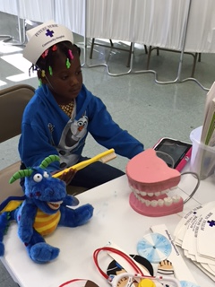
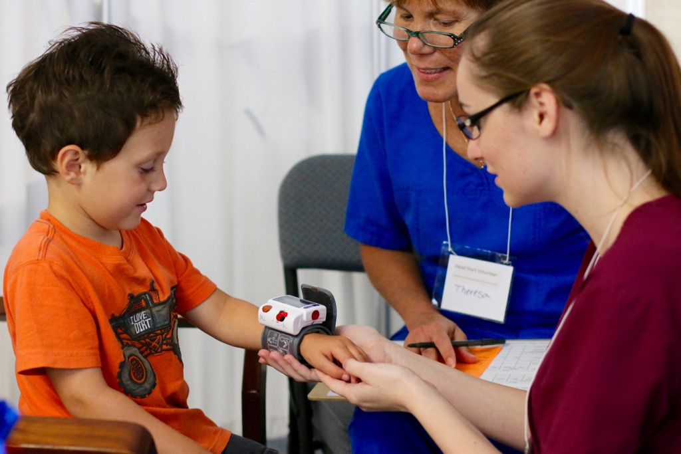
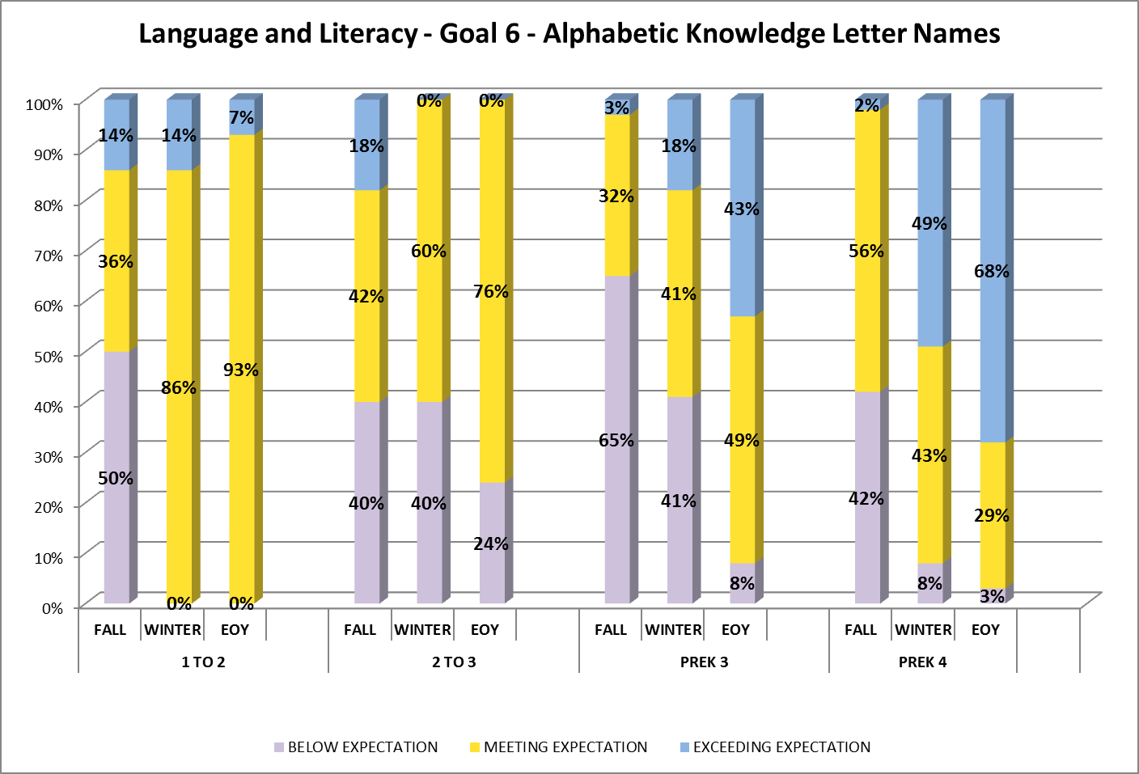
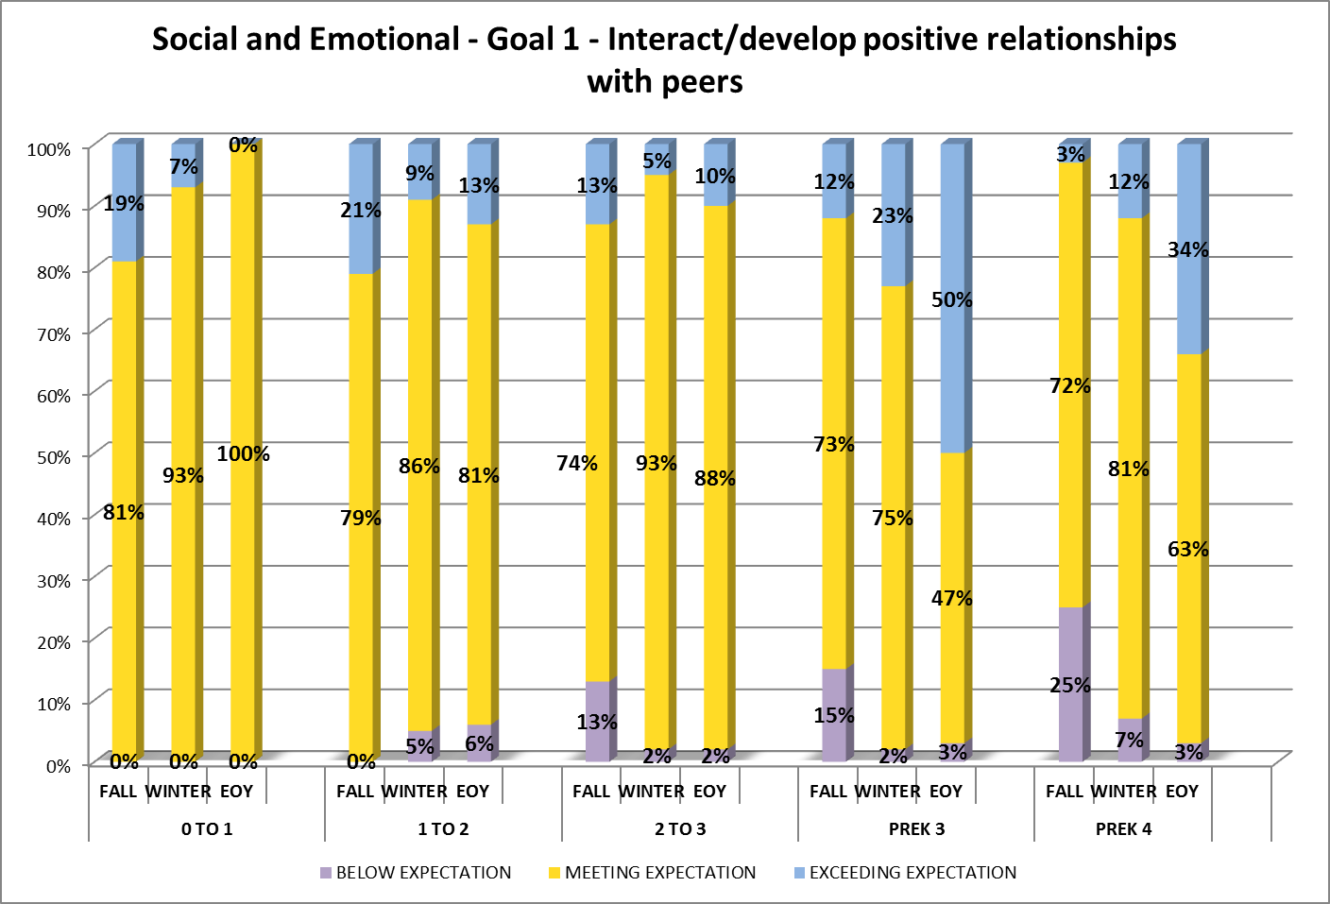
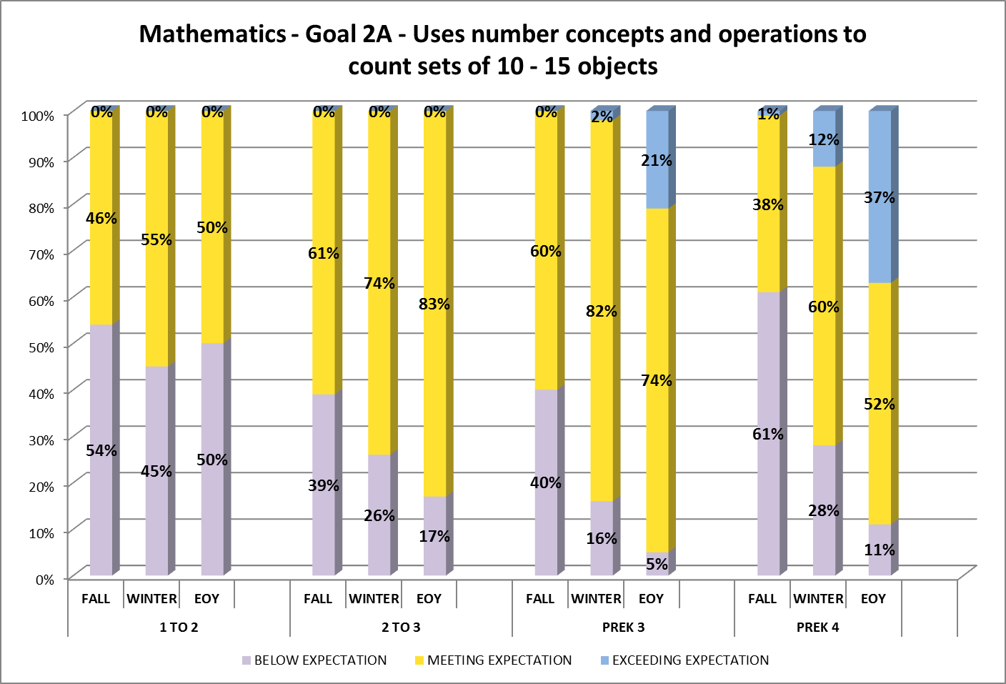
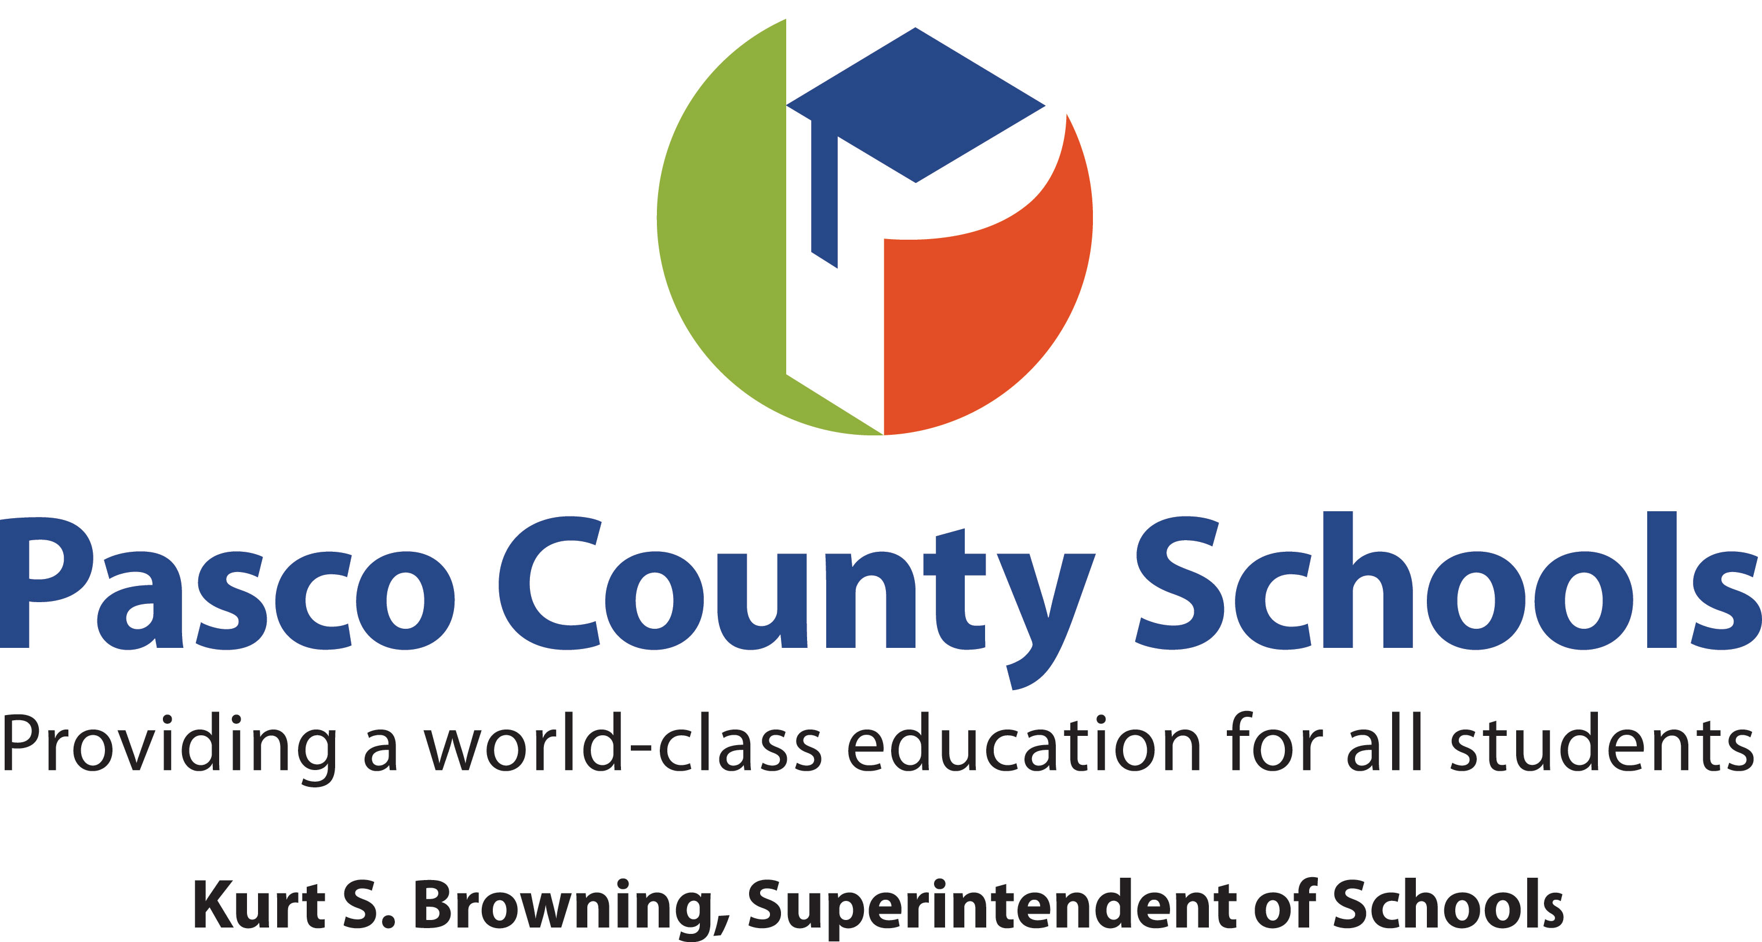
PILOT – Virtual Professional Development
To build teacher leaders within the Head Start program, a small group of teachers were given the opportunity to participate in a virtual professional development pilot. These teachers have been surveyed on topics that they would like to learn more about. Each month, there were given a choice of materials to view prior to their virtual meeting. The might have read an article or viewed a professional video related to the topic selected. After completing the pre-work, the teachers communicated with each other via a virtual discussion board. This provided teachers with an opportunity to collaborate and continue to build their skills as a teacher leader.

PILOT – Teaching StrategiesTM Creative Curriculum Supplemental Resource Materials
In the Spring of 2015, the Early Head Start program engaged two combination-based caregivers and one home-based home services worker to pilot the supplemental resources for infants and toddlers. After utilizing the materials for months, Donna Yetto, Jennifer Devine and Oretha Davis created a powerpoint of the materials complete with lesson plans and presented their experience to their peers.
They introduced each component of the materials and shared how they were able to use each to streamline the process of intentional planning/implementing individualized experiences for children at various levels of development. The staff appreciated being provided ‘real life’ application of the supplemental resources materials and are looking forward to full implementation of these materials in 2015-2016!

Summer Health Screenings
In order to meet the needs of our Head Start/Early Head Start families, we asked our parents/guardians to bring the accepted children to Summer Registration days to provide the children with health, dental and developmental screenings. The program’s hope was that by providing this opportunity to families, it would reduce the need for additional doctor/health department/dental visits, as well as potentially using critical classroom time at the beginning of the year to complete the screenings.
As a program, we were extremely pleased that over 70% of our children attended and were screened by our health team this summer in the following areas:
- Height
- Weight
- Eye muscle coordination
- Blood Pressure
- Hernia check
- Mouth check
- Hemoglobin
- Vision with spot vision (2 children who failed already received glasses prior to school starting)
- Hearing with Oto- Acoustic Emission (OAE)
- Current immunization card check
- Current physical check
- One-on-one consultation with our HS/EHS Health Coordinator, Kathie Luzader, for children with medical/dental/food allergy concerns
.
The program is proud of this pilot and the health team and volunteers that made this pilot a success. Our program will continue this model for Summer 2016.

Classroom Assessment Scoring System (CLASS) and Marzano Teacher Evaluation System Alignment
Over the summer of 2015, a small group of Head Start teachers and instructional coaches were selected to participate in a work group that reviewed the Marzano Framework for teacher evaluation and Head Start’s adopted coaching tool, CLASS. Members of this group reviewed each tool with a laser focus to find where the tools were the same and different. After reviewing the tools forwards and backwards, the group created a tool for teacher to use when trying to make connections through their teaching practices and interactions with children.

Special Initiatives
Emergent Literacy
Emergent literacy skills are developed through many opportunities for children to interact with print in a natural, developmentally appropriate learning environment. Young learners acquire literacy concepts and skills through active engagement, constructing their understanding of how written language works. Specific skills are embedded into daily activities using music, read aloud, big books, songs, charts, chants, games and environmental print. Skills in young literacy learners begin to emerge as their experiences are enriched. The onset and growth of these skills are captured through periodic and ongoing observations assessments.
Prioritized SR Goal 6 (FYO IV.F.3.d) focuses on the child showing alphabetic knowledge by naming most letters.
Early Mathematics
Math experiences include a variety of opportunities for young learners that actively engage them in their physical and social world to explore and utilize ideas and concepts. With an emphasis on problem solving, mathematics concepts are purposefully introduced and embedded into daily activities. Opportunities for exploration include measurement, pattern building, sequencing, numeracy, sorting & classifying, comparing, estimating, predicting, and spatial relationships. Growth in these areas is captured through periodic and ongoing
Prioritized SR Goal 2 (FYO V.A.a.2) focuses on the child showing an understanding of how to count and construct sets.

School Readiness Goals and Child Development
Head Start defines school readiness as children possessing the skills, knowledge and attitudes necessary for success in school and for later learning in life. Performance Standard 1307.2 and the Head Start Act of 2007 state that school readiness goals should articulate our program’s expectations of children’s status and progress of child development and early learning that will improve children’s readiness for kindergarten.
In the summer of 2012, the program adopted Teaching Strategies™ Creative Curriculum and assessment system GOLD. These curricular/assessment tools are used to collect and aggregate school readiness data four-times a year.
Program Wide Average
Emergent Literacy
School Readiness Outcomes

Steve Luikart, Chairman

Joanne Hurley, Vice Chairman

Allen Altman

Cynthia Armstrong

Alison Crumbley

