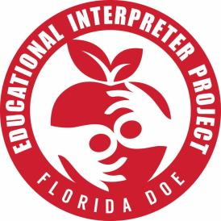 CEUs on the Go 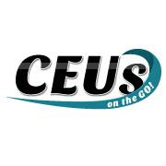

New Process and Rules!!
Hello everyone,

We at Educational Interpreter Project are thrilled to have CEUs on the Go offered again starting this week!

There will be a few changes to how an educational interpreter may request a workshop from CEUs on the Go. Please read carefully before putting in a request.

First rule is educational interpreters may only get 3 workshops per quarter.

Second rule is when an educational interpreter puts in requests for workshops, we will ask the interpreters to show us certificates of completion from prior workshops before new workshops can be issued. We want to ensure interpreters complete their workshops and implement what they learn into their jobs.

Third rule is we ask that all educational interpreters attend at least one to two in-person (or virtual) workshops throughout the year. There will be plenty of opportunities for interpreters to attend workshops, including the Summer Institute. Attending in-person workshops brings in a wealth of experience, practice, and networking that you cannot get from participating in online workshops.

We will be making adjustments and changes as we go.

Please contact Jennifer at jfrancis@pasco.k12.fl.us or Kathy at khuntzin@pasco.k12.fl.us if you have any questions.
Thank you!
Jennifer Francisco

