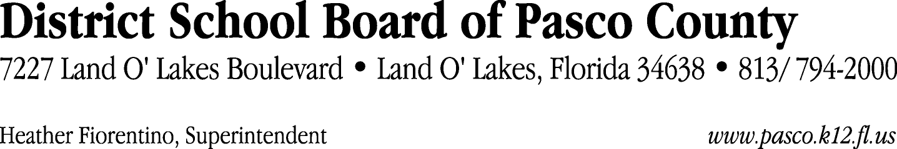

Finance Services Department
813/ 794-2268 Fax: 813/ 794-2266
727/ 774-2268 TDD: 813/ 794-2484
352/ 524-2268

MEMORANDUM

Date: March 20, 2012
To: School Board Members
From: Judith Zollo, Acting Director of Finance Services
Re: Attached Warrant List for the Week of March 20, 2012

Please review the current computerized list. These totals include computer generated, handwritten and cancelled checks.

Warrant numbers 839795 through 840304 1,915,543.57

Amounts disbursed in Fund 871 1,412.74
Amounts disbursed in Fund 379 57,886.23
Amounts disbursed in Fund 110 508,676.10
Amounts disbursed in Fund 421 53,892.24
Amounts disbursed in Fund 372 77,691.26
Amounts disbursed in Fund 398 130,533.18
Amounts disbursed in Fund 713 31,395.64
Amounts disbursed in Fund 393 1,772.50
Amounts disbursed in Fund 921 759.82
Amounts disbursed in Fund 370 57,875.26
Amounts disbursed in Fund 423 497.48
Amounts disbursed in Fund 422 2,469.64
Amounts disbursed in Fund 792 241,190.67
Amounts disbursed in Fund 371 320.00
Amounts disbursed in Fund 410 239,823.83
Amounts disbursed in Fund 390 239,100.52
Amounts disbursed in Fund 795 2,641.20
Amounts disbursed in Fund 793 32,347.94
Amounts disbursed in Fund 426 8,394.49
Amounts disbursed in Fund 715 222,563.04
Amounts disbursed in Fund 349 1,495.00
Amounts disbursed in Fund 711 2,180.63
Amounts disbursed in Fund 432 72.16
Amounts disbursed in Fund 140 552.00

Direct Deposit to Retirees:
ACH Numbers 6132 through 6312 60,867.76
Total amount disbursed 1,976,411.33

Confirmation of the approval of the March 20, 2012 warrants will be requested at the April 17, 2012 School Board meeting.

