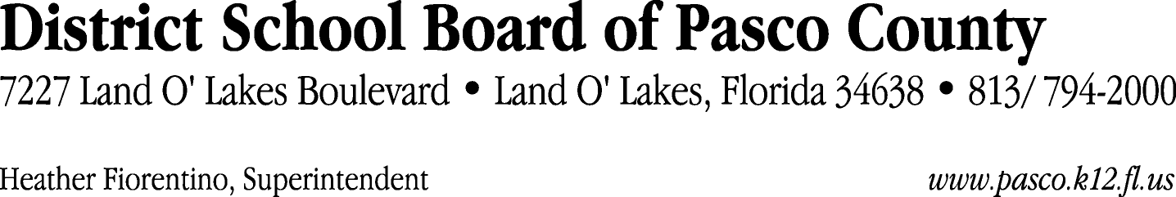

Finance Services Department
813/ 794-2294 Fax: 813/ 794-2266
727/ 774-2294 TDD: 813/ 794-2484
352/ 524-2294
MEMORANDUM

Date: November 12, 2012
To: School Board Members
From: Joanne Millovitsch, Director of Finance
Re: Attached Warrant List for November 6, 2012

Please review the current computerized list. These totals include computer generated, handwritten and cancelled checks.

Warrant numbers 853154 through 853529 4,858,975.59

Amounts disbursed in Fund 372 258,722.57
Amounts disbursed in Fund 379 123,877.30
Amounts disbursed in Fund 110 576,760.58
Amounts disbursed in Fund 130 58,534.00
Amounts disbursed in Fund 371 16,614.89
Amounts disbursed in Fund 410 343,067.83
Amounts disbursed in Fund 398 38,383.32
Amounts disbursed in Fund 373 320,384.43
Amounts disbursed in Fund 713 83,421.09
Amounts disbursed in Fund 421 145,277.69
Amounts disbursed in Fund 715 2,657,462.56
Amounts disbursed in Fund 921 6,496.79
Amounts disbursed in Fund 793 20,931.66
Amounts disbursed in Fund 390 49,416.86
Amounts disbursed in Fund 422 1,303.91
Amounts disbursed in Fund 370 55,607.00
Amounts disbursed in Fund 378 477.42
Amounts disbursed in Fund 393 600.00
Amounts disbursed in Fund 794 600.00
Amounts disbursed in Fund 810 214.13
Amounts disbursed in Fund 714 6,110.00
Amounts disbursed in Fund 425 1,910.90
Amounts disbursed in Fund 792 89,113.33
Amounts disbursed in Fund 711 1,721.95
Amounts disbursed in Fund 434 356.62
Amounts disbursed in Fund 293 350.00
Amounts disbursed in Fund 795 1,258.76

Confirmation of the approval of the November 6, 2012 warrants will be requested at the December 4, 2012 School Board meeting.

