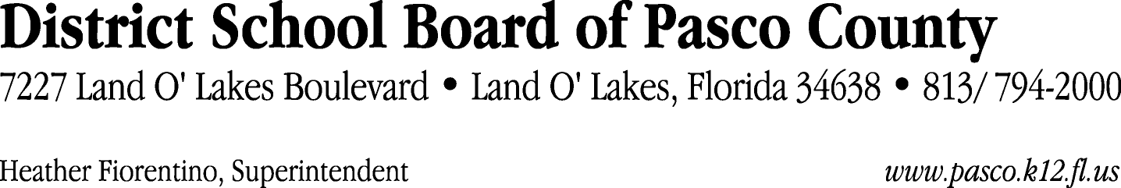

Finance Services Department
813/ 794-2294 Fax: 813/ 794-2266
727/ 774-2294 TDD: 813/ 794-2484
352/ 524-2294
MEMORANDUM

Date: August 21, 2012
To: School Board Members
From: Joanne Millovitsch, Director of Finance
Re: Attached Warrant List for August 21, 2012

Please review the current computerized list. These totals include computer generated, handwritten and cancelled checks.

Warrant numbers 849112 through 849115 4,129.89

Amounts disbursed in Fund 110 4,129.89

Confirmation of the approval of the August 21, 2012 warrants will be requested at the September 4, 2012 School Board meeting.

