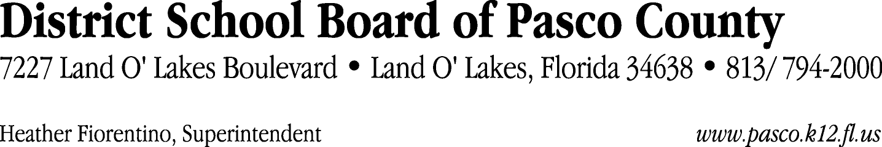

Finance Services Department
813/ 794-2294 Fax: 813/ 794-2266
727/ 774-2294 TDD: 813/ 794-2484
352/ 524-2294
MEMORANDUM

Date: August 17, 2012
To: School Board Members
From: Joanne Millovitsch, Director of Finance
Re: Attached Warrant List for July 10, 2012

Please review the current computerized list. These totals include computer generated, handwritten and cancelled checks.

Warrant numbers 846903 through 846907 1,075,419.00

Amounts disbursed in Fund 130 1,075,419.00

Confirmation of the approval of the July 10, 2012 warrants will be requested at the September 4, 2012 School Board meeting.

