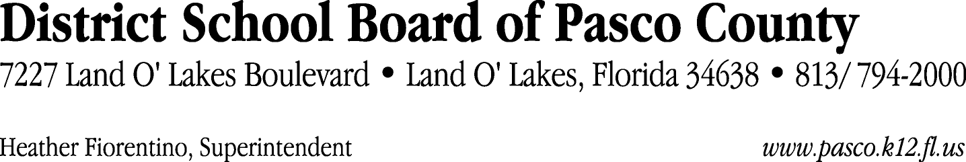

Finance Services Department
813/ 794-2294 Fax: 813/ 794-2266
727/ 774-2294 TDD: 813/ 794-2484
352/ 524-2294
MEMORANDUM

Date: July 9, 2012
To: School Board Members
From: Judith Zollo, Finance Services Manager
Re: Attached Warrant List for July 3, 2012

Please review the current computerized list. These totals include computer generated, handwritten and cancelled checks.

Warrant numbers 846080 through 846085 5500.00

Amounts disbursed in Fund 110 5500.00

Confirmation of the approval of the July 3, 2012 warrants will be requested at the July 24, 2012 School Board meeting.

