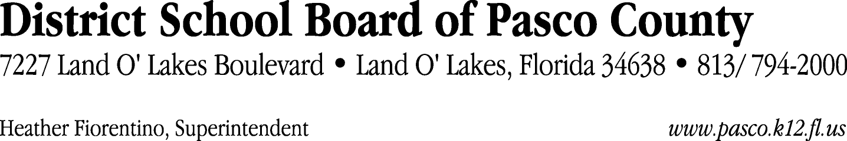

Finance Services Department
813/ 794-2268 Fax: 813/ 794-2266
727/ 774-2268 TDD: 813/ 794-2484
352/ 524-2268

MEMORANDUM

Date: October 13, 2011
To: School Board Members
From: Judith Zollo, Acting Director of Finance Services
Re: Attached Warrant List for the Week of October 18, 2011

Please review the current computerized list. These totals include computer generated, handwritten and cancelled checks.

Warrant numbers 831431 through 831806 1,753,715.55

Amounts disbursed in Fund 871 712.17
Amounts disbursed in Fund 372 68,251.79
Amounts disbursed in Fund 370 22,587.93
Amounts disbursed in Fund 341 17,817.92
Amounts disbursed in Fund 110 481,398.90
Amounts disbursed in Fund 421 120,254.83
Amounts disbursed in Fund 410 292,572.12
Amounts disbursed in Fund 391 12,025.27
Amounts disbursed in Fund 921 3,914.62
Amounts disbursed in Fund 422 23,567.92
Amounts disbursed in Fund 393 82,507.22
Amounts disbursed in Fund 433 3,067.12
Amounts disbursed in Fund 390 59,215.16
Amounts disbursed in Fund 371 50,537.63
Amounts disbursed in Fund 795 2,626.81
Amounts disbursed in Fund 793 65,823.66
Amounts disbursed in Fund 398 1,785.00
Amounts disbursed in Fund 39C 3,286.00
Amounts disbursed in Fund 821 1,424.50
Amounts disbursed in Fund 432 201.99
Amounts disbursed in Fund 792 428,555.32
Amounts disbursed in Fund 397 2,940.00
Amounts disbursed in Fund 713 7,666.67
Amounts disbursed in Fund 715 975.00

Direct Deposit to Retirees:
ACH Numbers 5233 through 5411 59,709.28
Total amount disbursed 1,813,424.83

Confirmation of the approval of the October 18, 2011 warrants will be requested at the November 1, 2011 School Board meeting.

