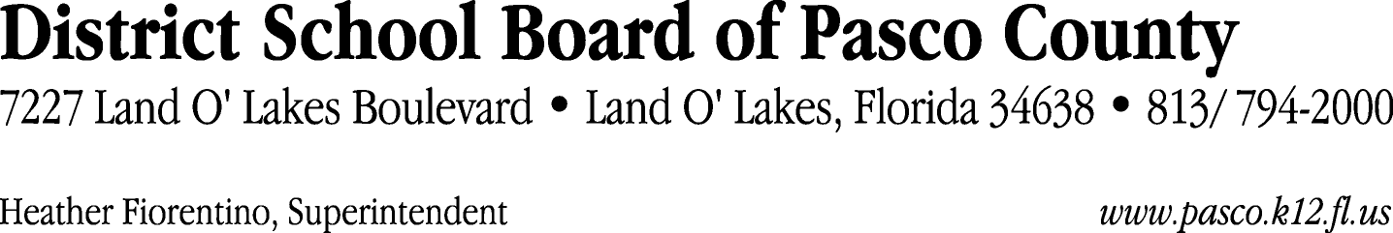

Finance Services Department
813/ 794-2268 Fax: 813/ 794-2266
727/ 774-2268 TDD: 813/ 794-2484
352/ 524-2268

MEMORANDUM

Date: September 15, 2011
To: School Board Members
From: Judith Zollo, Acting Director of Finance Services
Re: Attached Warrant List for the Week of September 20, 2011

Please review the current computerized list. These totals include computer generated, handwritten and cancelled checks.

Warrant numbers 829570 through 829905 2,135,694.18

Amounts disbursed in Fund 871 782.46
Amounts disbursed in Fund 110 1,268,468.41
Amounts disbursed in Fund 433 1,276.93
Amounts disbursed in Fund 421 100,930.83
Amounts disbursed in Fund 410 217,412.03
Amounts disbursed in Fund 378 14,689.80
Amounts disbursed in Fund 371 80,385.40
Amounts disbursed in Fund 425 176.45
Amounts disbursed in Fund 398 5,804.49
Amounts disbursed in Fund 370 2,893.58
Amounts disbursed in Fund 393 4,202.24
Amounts disbursed in Fund 422 9,456.88
Amounts disbursed in Fund 792 242,040.91
Amounts disbursed in Fund 921 3,032.35
Amounts disbursed in Fund 715 36,038.80
Amounts disbursed in Fund 372 23,531.40
Amounts disbursed in Fund 821 66.21
Amounts disbursed in Fund 793 33,095.37
Amounts disbursed in Fund 713 51,545.38
Amounts disbursed in Fund 294 2,135.00
Amounts disbursed in Fund 349 1,022.73
Amounts disbursed in Fund 432 243.00
Amounts disbursed in Fund 714 14,496.16
Amounts disbursed in Fund 379 3,575.00
Amounts disbursed in Fund 390 9,567.36
Amounts disbursed in Fund 711 17.34
Amounts disbursed in Fund 795 8,807.67

Direct Deposit to Retirees:
ACH Numbers 5054 through 5232 60,160.63
Total amount disbursed 2,195,854.81

Confirmation of the approval of the September 20, 2011 warrants will be requested at the October 4, 2011 School Board meeting.

