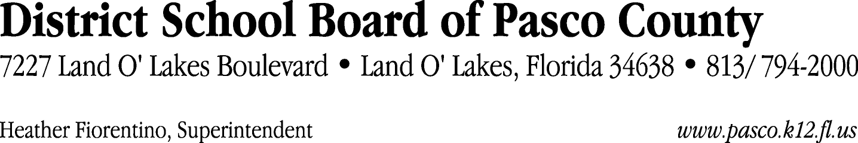

Finance Services Department
813/ 794-2294 Fax: 813/ 794-2266
727/ 774-2294 TDD: 813/ 794-2484
352/ 524-2294
MEMORANDUM

Date: November 22, 2011
To: School Board Members
From: Judith Zollo, Acting Director of Finance Services
Re: Attached Warrant List for November 29, 2011

Please review the current computerized list. These totals include computer generated, handwritten and cancelled checks.

Warrant numbers 834062 through 834405 2,996,888.17

Amounts disbursed in Fund 110 407,276.04
Amounts disbursed in Fund 130 65,297.00
Amounts disbursed in Fund 421 55,444.42
Amounts disbursed in Fund 410 145,948.36
Amounts disbursed in Fund 370 130,101.42
Amounts disbursed in Fund 921 1,996.73
Amounts disbursed in Fund 422 5,405.82
Amounts disbursed in Fund 372 11,642.83
Amounts disbursed in Fund 398 907.01
Amounts disbursed in Fund 795 4,160.80
Amounts disbursed in Fund 792 265,870.38
Amounts disbursed in Fund 793 53,977.17
Amounts disbursed in Fund 715 1,812,995.30
Amounts disbursed in Fund 432 199.56
Amounts disbursed in Fund 821 168.66
Amounts disbursed in Fund 713 17,176.48
Amounts disbursed in Fund 433 15,171.45
Amounts disbursed in Fund 434 131.86
Amounts disbursed in Fund 711 638.25
Amounts disbursed in Fund 379 2,378.63

Confirmation of the approval of the November 29, 2011 warrants will be requested at the December 20, 2011 School Board meeting.

