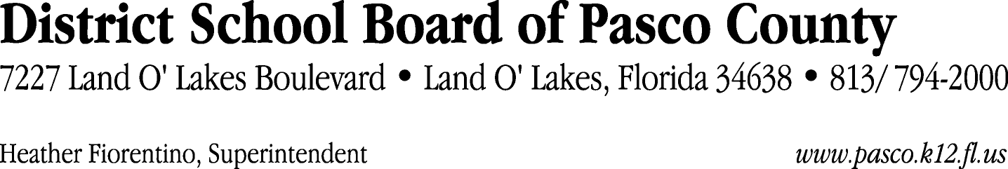

Finance Services Department
813/ 794-2294 Fax: 813/ 794-2266
727/ 774-2294 TDD: 813/ 794-2484
352/ 524-2294
MEMORANDUM

Date: November 21, 2011
To: School Board Members
From: Judith Zollo, Acting Director of Finance Services
Re: Attached Warrant List for November 22, 2011

Please review the current computerized list. These totals include computer generated, handwritten and cancelled checks.

Warrant numbers 833908 through 834056 837,471.28

Amounts disbursed in Fund 410 21,245.42
Amounts disbursed in Fund 110 753,823.29
Amounts disbursed in Fund 421 39,615.36
Amounts disbursed in Fund 714 286.55
Amounts disbursed in Fund 130 1,201.10
Amounts disbursed in Fund 140 2,307.19
Amounts disbursed in Fund 422 6,806.43
Amounts disbursed in Fund 921 9,105.71
Amounts disbursed in Fund 434 437.02
Amounts disbursed in Fund 432 210.82
Amounts disbursed in Fund 792 289.37
Amounts disbursed in Fund 425 142.66
Amounts disbursed in Fund 711 1,264.48
Amounts disbursed in Fund 713 587.52
Amounts disbursed in Fund 424 144.00
Amounts disbursed in Fund 795 4.36

Confirmation of the approval of the November 22, 2011 warrants will be requested at the December 20, 2011 School Board meeting.

