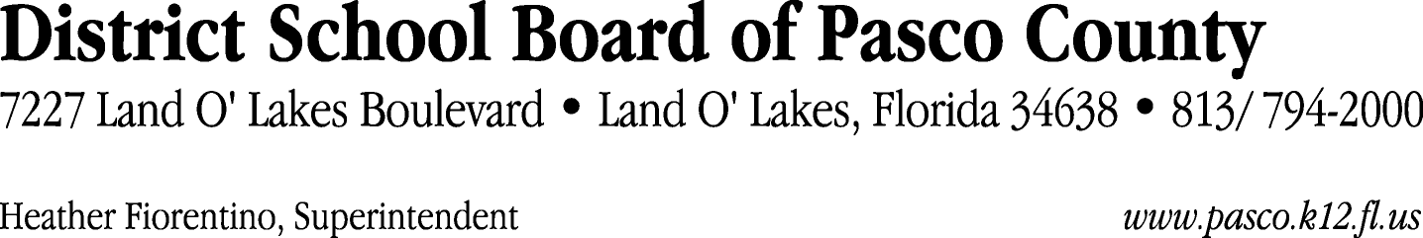

Finance Services Department
813/ 794-2294 Fax: 813/ 794-2266
727/ 774-2294 TDD: 813/ 794-2484
352/ 524-2294
MEMORANDUM

Date: October 28, 2011
To: School Board Members
From: Judith Zollo, Acting Director of Finance Services
Re: Attached Warrant List for November 1, 2011

Please review the current computerized list. These totals include computer generated, handwritten and cancelled checks.

Warrant numbers 832526 through 832628 365,597.94

Amounts disbursed in Fund 110 15,462.90
Amounts disbursed in Fund 410 310,959.35
Amounts disbursed in Fund 921 429.81
Amounts disbursed in Fund 715 36,116.19
Amounts disbursed in Fund 422 509.39
Amounts disbursed in Fund 421 1,230.69
Amounts disbursed in Fund 432 720.26
Amounts disbursed in Fund 821 169.35

Confirmation of the approval of the November 1, 2011 warrants will be requested at the November 22, 2011 School Board meeting.

