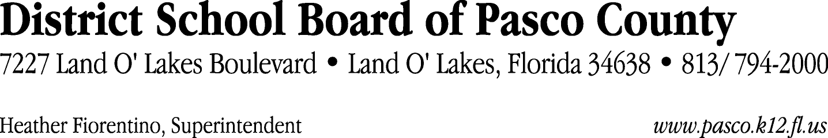

Finance Services Department
813/ 794-2294 Fax: 813/ 794-2266
727/ 774-2294 TDD: 813/ 794-2484
352/ 524-2294
MEMORANDUM

Date: October 20, 2011
To: School Board Members
From: Judith Zollo, Acting Director of Finance Services
Re: Attached Warrant List for October 25, 2011

Please review the current computerized list. These totals include computer generated, handwritten and cancelled checks.

Warrant numbers 831887 through 832213 1,470,872.06

Amounts disbursed in Fund 110 675,652.76
Amounts disbursed in Fund 421 50,256.35
Amounts disbursed in Fund 422 18,197.66
Amounts disbursed in Fund 921 2,246.11
Amounts disbursed in Fund 349 20,507.85
Amounts disbursed in Fund 792 238,935.55
Amounts disbursed in Fund 410 292,401.94
Amounts disbursed in Fund 372 70,888.79
Amounts disbursed in Fund 433 4,418.62
Amounts disbursed in Fund 793 24,775.09
Amounts disbursed in Fund 795 10,464.91
Amounts disbursed in Fund 371 4,137.99
Amounts disbursed in Fund 398 15,134.36
Amounts disbursed in Fund 378 4,720.98
Amounts disbursed in Fund 379 15,335.78
Amounts disbursed in Fund 713 1,393.54
Amounts disbursed in Fund 711 139.01
Amounts disbursed in Fund 432 93.14
Amounts disbursed in Fund 715 4,775.91
Amounts disbursed in Fund 39C 16,113.30
Amounts disbursed in Fund 821 282.42

Confirmation of the approval of the October 25, 2011 warrants will be requested at the November 22, 2011 School Board meeting.

