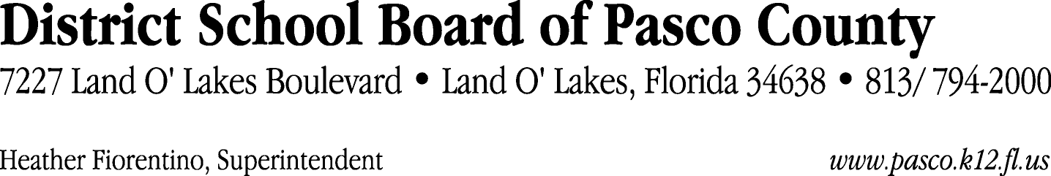

Finance Services Department
813/ 794-2294 Fax: 813/ 794-2266
727/ 774-2294 TDD: 813/ 794-2484
352/ 524-2294
MEMORANDUM

Date: October 13, 2011
To: School Board Members
From: Judith Zollo, Acting Director of Finance Services
Re: Attached Warrant List for October 18, 2011

Please review the current computerized list. These totals include computer generated, handwritten and cancelled checks.

Warrant numbers 831812 through 831881 820,151.30

Amounts disbursed in Fund 410 21,155.95
Amounts disbursed in Fund 110 733,181.83
Amounts disbursed in Fund 421 42,458.54
Amounts disbursed in Fund 714 256.55
Amounts disbursed in Fund 130 1,201.10
Amounts disbursed in Fund 140 2,373.19
Amounts disbursed in Fund 422 6,726.50
Amounts disbursed in Fund 434 362.54
Amounts disbursed in Fund 921 9,155.06
Amounts disbursed in Fund 792 289.37
Amounts disbursed in Fund 425 151.06
Amounts disbursed in Fund 433 839.23
Amounts disbursed in Fund 711 1,264.48
Amounts disbursed in Fund 713 587.52
Amounts disbursed in Fund 424 144.02
Amounts disbursed in Fund 795 4.36

Confirmation of the approval of the October 18, 2011 warrants will be requested at the November 1, 2011 School Board meeting.

