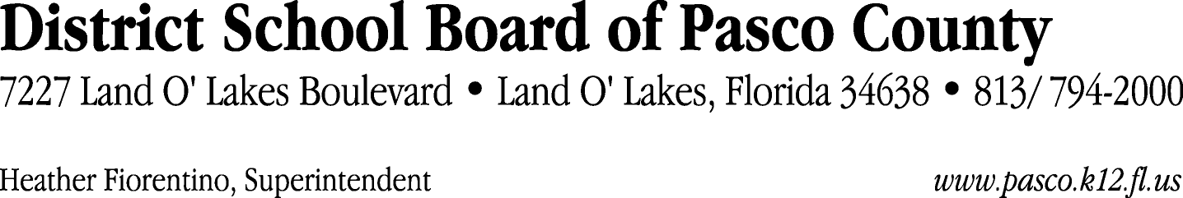

Finance Services Department
813/ 794-2294 Fax: 813/ 794-2266
727/ 774-2294 TDD: 813/ 794-2484
352/ 524-2294
MEMORANDUM

Date: October 7, 2011
To: School Board Members
From: Judith Zollo, Acting Director of Finance Services
Re: Attached Warrant List for October 11, 2011

Please review the current computerized list. These totals include computer generated, handwritten and cancelled checks.

Warrant numbers 831420 through 831425 614,459.28

Amounts disbursed in Fund 715 449,395.68
Amounts disbursed in Fund 110 139,256.76
Amounts disbursed in Fund 140 662.86
Amounts disbursed in Fund 410 7,663.75
Amounts disbursed in Fund 422 2,137.81
Amounts disbursed in Fund 921 3,049.99
Amounts disbursed in Fund 130 57.84
Amounts disbursed in Fund 421 11,402.91
Amounts disbursed in Fund 424 14.44
Amounts disbursed in Fund 425 20.64
Amounts disbursed in Fund 431 225.64
Amounts disbursed in Fund 432 127.24
Amounts disbursed in Fund 433 62.00
Amounts disbursed in Fund 434 77.04
Amounts disbursed in Fund 711 138.80
Amounts disbursed in Fund 713 72.34
Amounts disbursed in Fund 714 28.92
Amounts disbursed in Fund 792 26.06
Amounts disbursed in Fund 795 38.56

Confirmation of the approval of the October 11, 2011 warrants will be requested at the November 1, 2011 School Board meeting.

