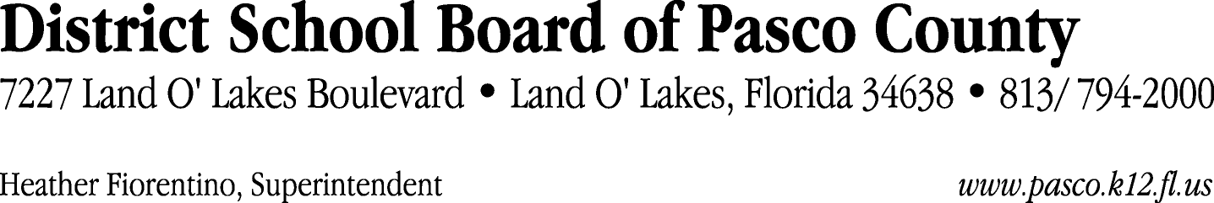

Finance Services Department
813/ 794-2294 Fax: 813/ 794-2266
727/ 774-2294 TDD: 813/ 794-2484
352/ 524-2294
MEMORANDUM

Date: September 30, 2011
To: School Board Members
From: Judith Zollo, Acting Director of Finance Services
Re: Attached Warrant List for October 4, 2011

Please review the current computerized list. These totals include computer generated, handwritten and cancelled checks.

Warrant numbers 830924 through 831068 782,843.46

Amounts disbursed in Fund 410 12,808.46
Amounts disbursed in Fund 110 716,949.69
Amounts disbursed in Fund 421 35,808.18
Amounts disbursed in Fund 130 171.10
Amounts disbursed in Fund 140 2,158.78
Amounts disbursed in Fund 422 5,802.40
Amounts disbursed in Fund 921 6,837.02
Amounts disbursed in Fund 434 464.55
Amounts disbursed in Fund 432 84.40
Amounts disbursed in Fund 433 777.24
Amounts disbursed in Fund 714 83.32
Amounts disbursed in Fund 424 58.96
Amounts disbursed in Fund 425 80.79
Amounts disbursed in Fund 711 339.13
Amounts disbursed in Fund 713 135.71
Amounts disbursed in Fund 792 279.37
Amounts disbursed in Fund 795 4.36

Confirmation of the approval of the October 4, 2011 warrants will be requested at the November 1, 2011 School Board meeting.

