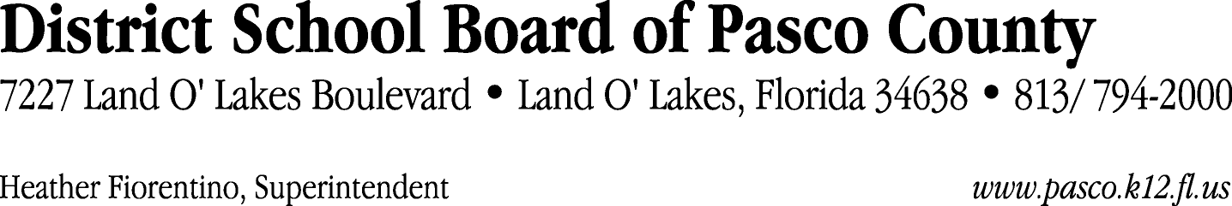

Finance Services Department
813/ 794-2294 Fax: 813/ 794-2266
727/ 774-2294 TDD: 813/ 794-2484
352/ 524-2294
MEMORANDUM

Date: September 8, 2011
To: School Board Members
From: Judith Zollo, Acting Director of Finance Services
Re: Attached Warrant List for September 13, 2011

Please review the current computerized list. These totals include computer generated, handwritten and cancelled checks.

Warrant numbers 829331 through 829553 6,795,632.13

Amounts disbursed in Fund 110 1,197,112.04
Amounts disbursed in Fund 130 1,044,784.69
Amounts disbursed in Fund 921 5,526.41
Amounts disbursed in Fund 371 1,559.46
Amounts disbursed in Fund 410 11,598.03
Amounts disbursed in Fund 421 14,205.13
Amounts disbursed in Fund 711 241.32
Amounts disbursed in Fund 715 4,121,824.34
Amounts disbursed in Fund 393 14,201.28
Amounts disbursed in Fund 398 12,004.27
Amounts disbursed in Fund 370 18,603.82
Amounts disbursed in Fund 792 231,456.88
Amounts disbursed in Fund 390 24,457.33
Amounts disbursed in Fund 425 327.96
Amounts disbursed in Fund 372 7,016.71
Amounts disbursed in Fund 713 63,567.58
Amounts disbursed in Fund 793 26,580.70
Amounts disbursed in Fund 795 564.18

Confirmation of the approval of the September 13, 2011 warrants will be requested at the October 4, 2011 School Board meeting.

