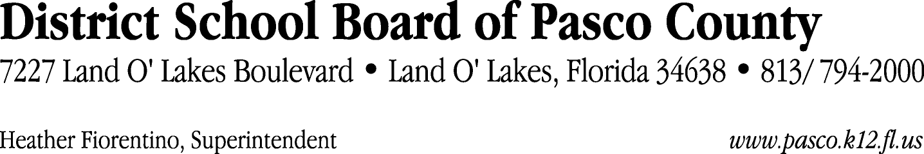

Finance Services Department
813/ 794-2294 Fax: 813/ 794-2266
727/ 774-2294 TDD: 813/ 794-2484
352/ 524-2294
MEMORANDUM

Date: July 28, 2011
To: School Board Members
From: Judith Zollo, Acting Director of Finance Services
Re: Attached Warrant List for August 2, 2011

Please review the current computerized list. These totals include computer generated, handwritten and cancelled checks.

Warrant numbers 827528 through 827747 1,711,112.47

Amounts disbursed in Fund 110 603,979.33
Amounts disbursed in Fund 390 90,151.70
Amounts disbursed in Fund 921 22,946.75
Amounts disbursed in Fund 410 2,378.16
Amounts disbursed in Fund 371 133,916.36
Amounts disbursed in Fund 421 20,462.89
Amounts disbursed in Fund 140 2,619.03
Amounts disbursed in Fund 391 1,400.00
Amounts disbursed in Fund 39C 451,205.70
Amounts disbursed in Fund 433 2,098.71
Amounts disbursed in Fund 711 544.95
Amounts disbursed in Fund 398 1,161.79
Amounts disbursed in Fund 422 490.86
Amounts disbursed in Fund 792 323,033.99
Amounts disbursed in Fund 793 39,834.92
Amounts disbursed in Fund 393 4,507.82
Amounts disbursed in Fund 397 2,106.45
Amounts disbursed in Fund 713 1,231.50
Amounts disbursed in Fund 871 3,256.77
Amounts disbursed in Fund 318 949.79
Amounts disbursed in Fund 379 2,835.00

Confirmation of the approval of the August 2, 2011 warrants will be requested at the August 16, 2011 School Board meeting.

